CS-349 NETWORKS ASSIGNMENT-4

-ABHISHEK JAISWAL (170101002) MAYANK WADHWANI (170101038) ANKUR INGALE (170123007)

#### APPLICATION #2

# WIRED CONNECTION

### Conclusions from the graphs

* It was observed that on increase of packet size, there is an increase in throughput which becomes lower and lower as we continue to increase the size. So for instance the difference in throughput when the packet size is increased from 40 to 44 bytes is greater than the case when we increase the size from 1420 to 1500 bytes.
* TCP Westwood and TCP Veno show a greater throughput as compared to TCP Vegas.
* For all cases, we got the value of Fairness Index to be 1.

## TCP WESTWOOD

|  |  |  |
| --- | --- | --- |
| Packet Size(Bytes) | Throughput (Kbps) | Fairness Index |
| 40 | 2085.567260 | 1 |
| 44 | 3295.696687 | 1 |
| 48 | 3328.333043 | 1 |
| 52 | 3360.662126 | 1 |
| 60 | 3325.090131 | 1 |
| 250 | 3390.297151 | 1 |
| 300 | 3301.825896 | 1 |
| 552 | 3405.036632 | 1 |
| 576 | 3415.798894 | 1 |
| 628 | 3439.550993 | 1 |
| 1420 | 3732.406380 | 1 |
| 1500 | 3770.797060 | 1 |

### TCP VEGAS

|  |  |  |
| --- | --- | --- |
| Packet Size(Bytes) | Throughput (Kbps) | Fairness Index |
| 40 | 58.988826 | 1 |
| 44 | 61.543859 | 1 |
| 48 | 64.098715 | 1 |
| 52 | 66.653397 | 1 |
| 60 | 71.762233 | 1 |
| 250 | 192.890714 | 1 |
| 300 | 224.700950 | 1 |
| 552 | 384.609348 | 1 |
| 576 | 399.802590 | 1 |
| 628 | 432.699810 | 1 |
| 1420 | 902.376271 | 1 |
| 1500 | 902.376271 | 1 |

## TCP VENO

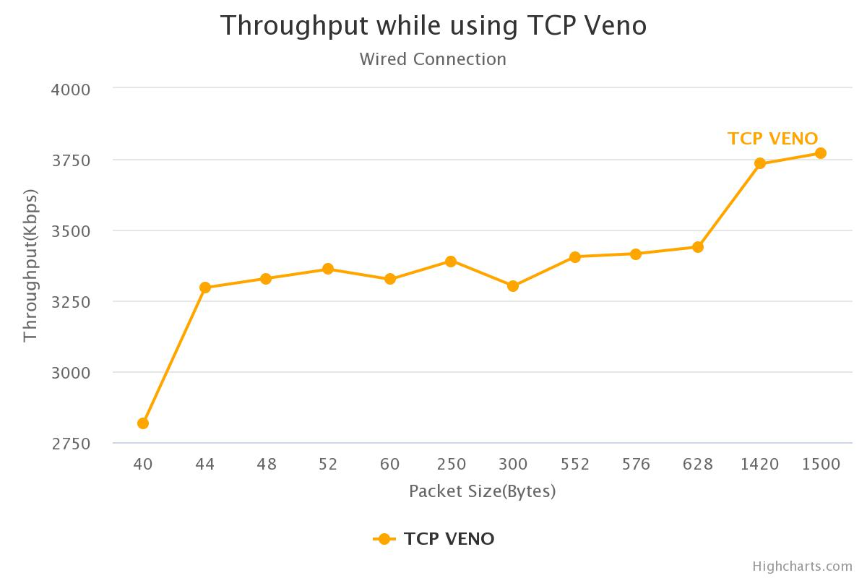

|  |  |  |
| --- | --- | --- |
| Packet Size(Bytes) | Throughput (Kbps) | Fairness Index |
| 40 | 2818.349558 | 1 |
| 44 | 3295.696687 | 1 |
| 48 | 3328.333043 | 1 |
| 52 | 3360.662126 | 1 |
| 60 | 3325.090131 | 1 |
| 250 | 3390.297151 | 1 |
| 300 | 3301.825896 | 1 |
| 552 | 3405.036632 | 1 |
| 576 | 3415.798894 | 1 |
| 628 | 3439.550993 | 1 |
| 1420 | 3732.406380 | 1 |
| 1500 | 3770.797060 | 1 |

# WIRELESS CONNECTION

### Conclusions from the graphs

* Just like the case of wired connection, here also the throughput increases with increase in the packet size. And TCP Vegas shows a lower throughput as compared to the other TCP Agents (TCP Westwood and TCP Veno).
* We also observe that the throughput for all packet sizes is considerably lower than the wired components ie. TCP Westwood Wireless has a lower throughput than TCP Westwood Wired.
* It was observed that the value of Fairness Index for all cases came out to be 1.

## TCP Westwood

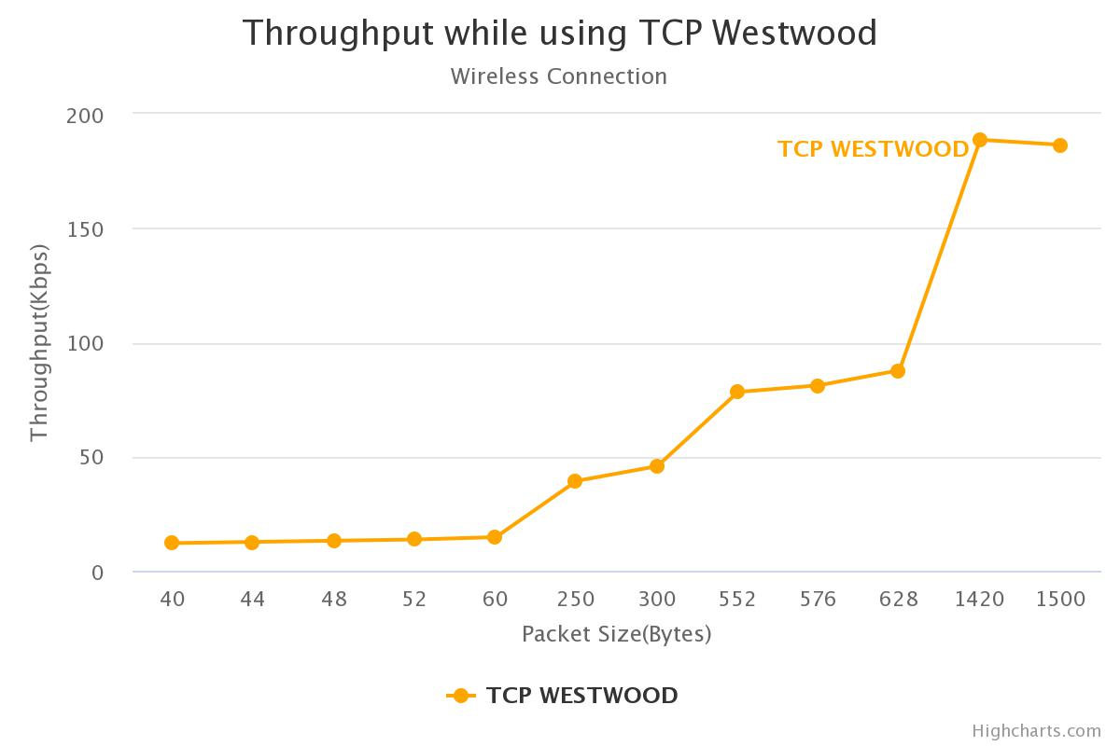

|  |  |  |
| --- | --- | --- |
| Packet Size(Bytes) | Throughput (Kbps) | Fairness Index |
| 40 | 12.069501 | 1 |
| 44 | 12.605346 | 1 |
| 48 | 13.132350 | 1 |
| 52 | 13.655610 | 1 |
| 60 | 14.681366 | 1 |
| 250 | 39.304154 | 1 |
| 300 | 45.744838 | 1 |
| 552 | 78.237620 | 1 |
| 576 | 81.134178 | 1 |
| 628 | 87.733800 | 1 |
| 1420 | 188.623222 | 1 |
| 1500 | 186.419813 | 1 |

## TCP VEGAS

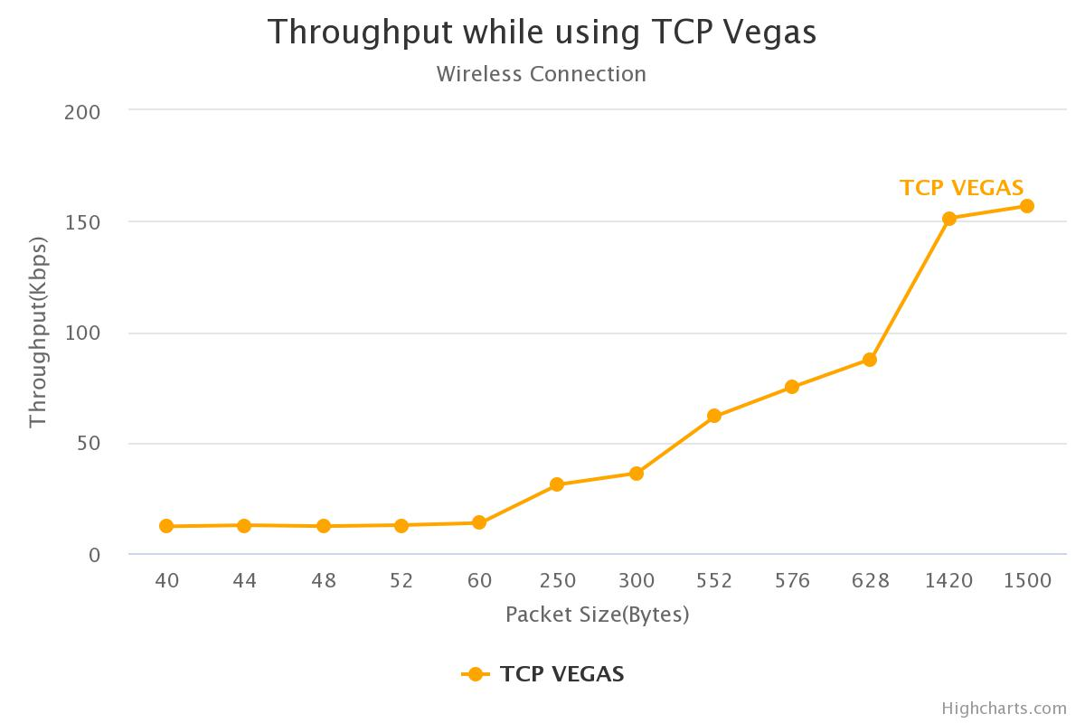

|  |  |  |
| --- | --- | --- |
| Packet Size(Bytes) | Throughput (Kbps) | Fairness Index |
| 40 | 12.069501 | 1 |
| 44 | 12.605346 | 1 |
| 48 | 12.166187 | 1 |
| 52 | 12.650205 | 1 |
| 60 | 13.601185 | 1 |
| 250 | 31.009883 | 1 |
| 300 | 36.092578 | 1 |
| 552 | 61.744960 | 1 |
| 576 | 75.114307 | 1 |
| 628 | 87.733800 | 1 |
| 1420 | 151.321665 | 1 |
| 1500 | 156.830465 | 1 |

## TCP VENO



|  |  |  |
| --- | --- | --- |
| Packet Size(Bytes) | Throughput (Kbps) | Fairness Index |
| 40 | 12.069501 | 1 |
| 44 | 12.605346 | 1 |
| 48 | 13.132350 | 1 |
| 52 | 13.655610 | 1 |
| 60 | 14.681366 | 1 |
| 250 | 39.304154 | 1 |
| 300 | 45.744838 | 1 |
| 552 | 78.237620 | 1 |
| 576 | 81.134178 | 1 |
| 628 | 87.733800 | 1 |
| 1420 | 188.623222 | 1 |
| 1500 | 186.419813 | 1 |

# JAINS FAIRNESS INDEX

We notice that in all the above cases (wired and wireless) for all agents, we have only on network connection.

Thus the value of Jain’s Fairness Index is equal to 1.

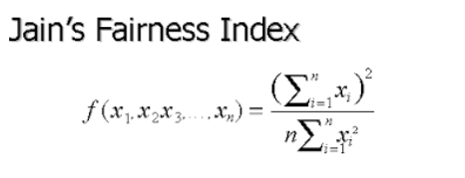

In the above formula xi represents the throughput of the ith connection.

Here is the plot of the same.

