CS-431 PROGRAMMING LANGUAGES LAB PROJECT README

# TASK-1 SOCK MATCHING ROBOT

#### Instructions to run

1. 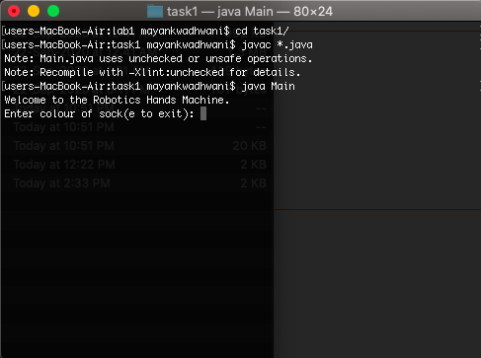cd task1
2. javac *.java
3. java Main

#### General Instructions

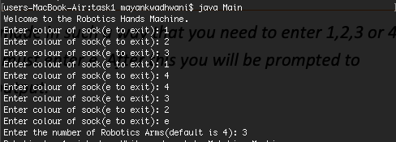Once the program starts, it asks for inputs of socks (now the input has been made in such a way that you need to enter 1,2,3 or 4 corresponding to the colours white, black, blue and grey. When finished you must enter e. After this you will be prompted to enter the number of robotic arms in the system. After that, you will see the output.

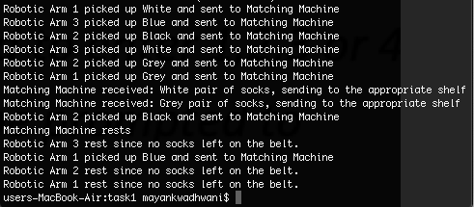

Figure 1 The desired output

Figure 2 Giving input

# TASK-2 DATA MODIFICATION IN DISTRIBUTED SYSTEM

#### Instructions to run

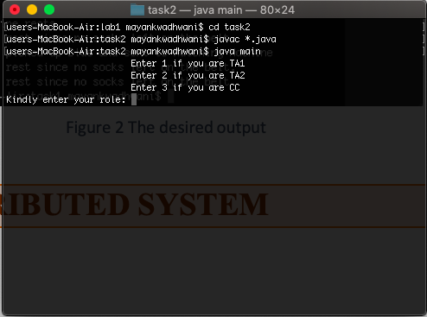

1. cd task2
2. javac *.java
3. java main

#### General Instructions

Once the program starts, you will be asked to enter your role (like press 1 if you are TA1, etc). Following this, you will be asked to choose the operation that you may wish to perform. Choose the appropriate operation.

**NOTE:** Since we are using multithreading here for different operations, we may see interleaved output in the terminal.

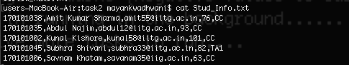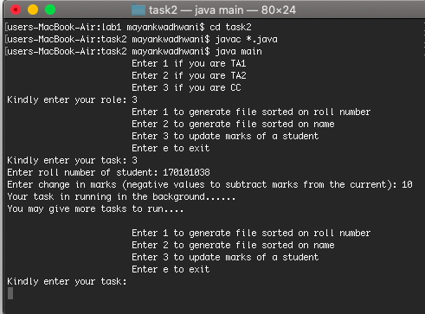Attached screenshots:

Figure 3 Contents of the file after running the input in Fig 5

Figure 4 Contents of file before running in the input in Fig 5

Figure 5 Giving input to program

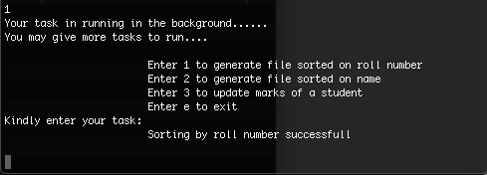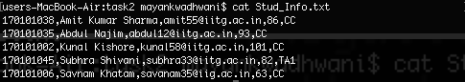

Figure 6 Generating Sorted File

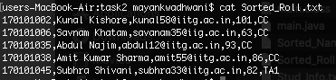

Figure 7 Contents of sorted file by roll

# TASK-3 CALCULATOR FOR DIFFERENTLY ABLED

#### Instructions to run Part A

1. 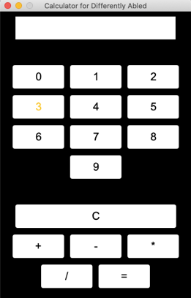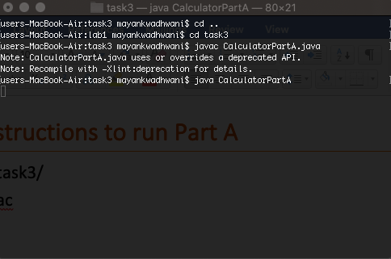cd task3/
2. javac CalculatorPartA.java
3. java CalculatorPartA

#### Instructions to run Part B

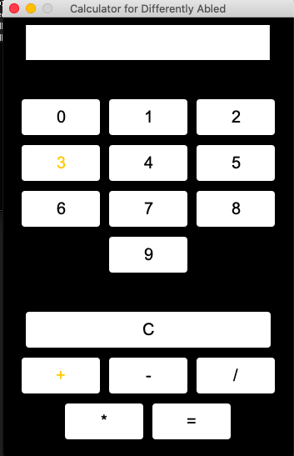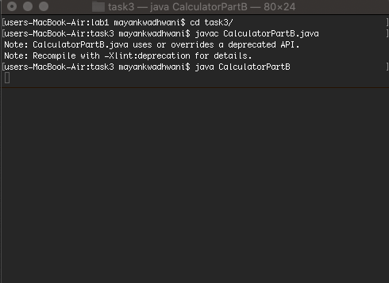

1. cd task3/
2. javac CalculatorPartB.java
3. java CalculatorPartB

#### General Instructions

For both the parts, we do as mentioned in the question. Wait for the desired number or operator, press spacebar or enter depending on the part.

Here are screenshots showing working of part B for 16+17.

