* Summary of Apriori Algorithm

Apriori algorithm tries to find out frequent sets from given data sets, and from those sets, it tries to figure out the correlation of its subsets.
First, the transactions are given in a text file format. Each line represents each transaction.
After reading the file and storing the data, count each elements from transactions - if every element of a set is in transaction's item id list, it counts. Then, we should 'prune' sets. If the portion of a set we've counted before is less then expected minimum support, that set should be eliminated from list.
Finally we've got all sets that are in transactions more than we've expected. The last thing we should do is to get whole sub-sets from the sets we've got. For now, the sub-sets are called 'S'. For every element 'T' in 'S', we would get confidence and support between T and S-T.

* Description of Code

This is the main data structure of the code.
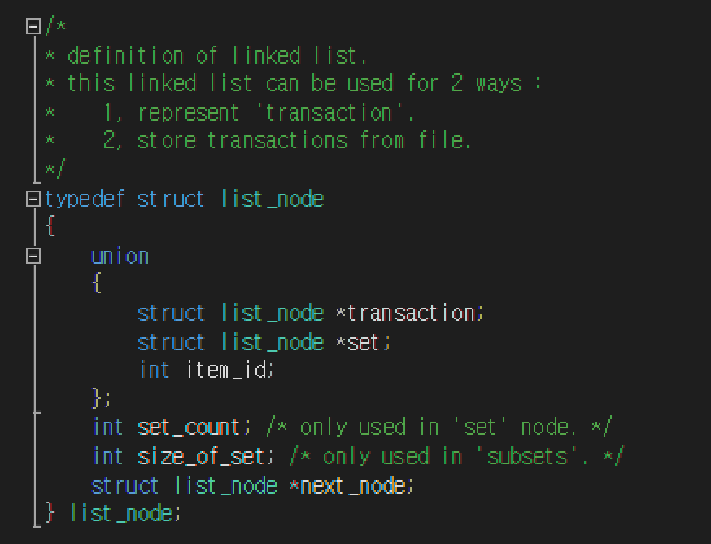
Basic linked list is used to store 'transactions', or 'sets'.

This is the main function of the code.
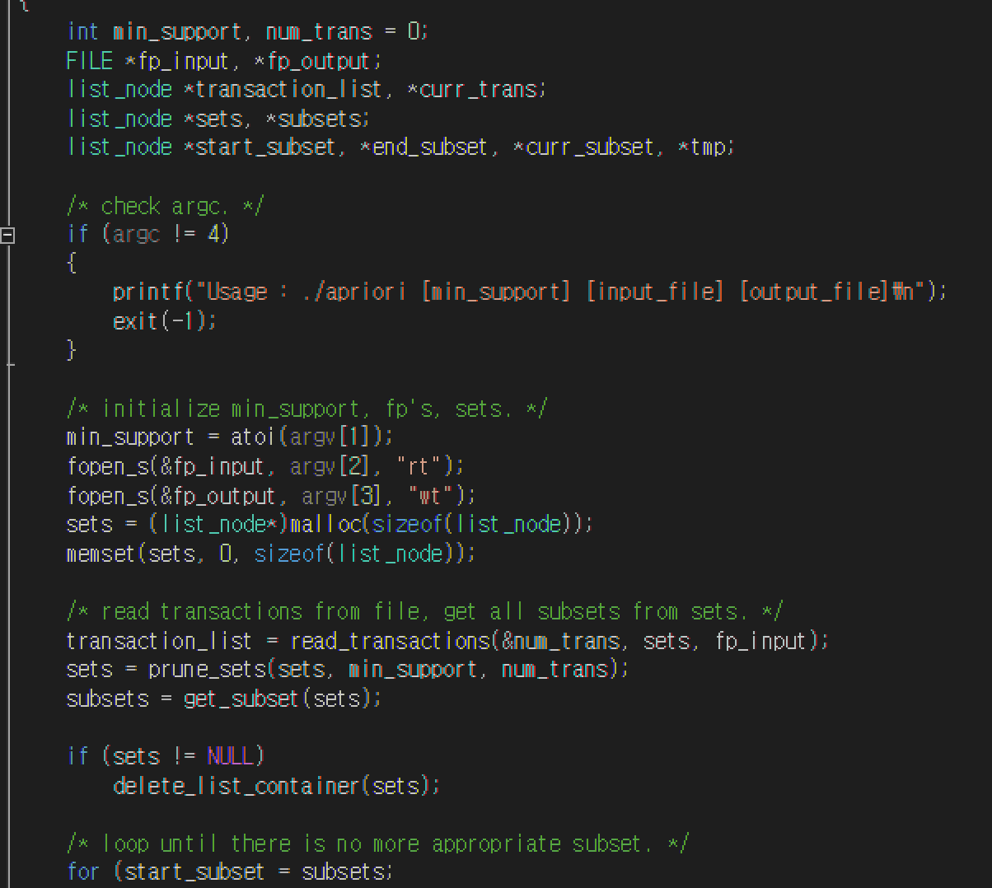
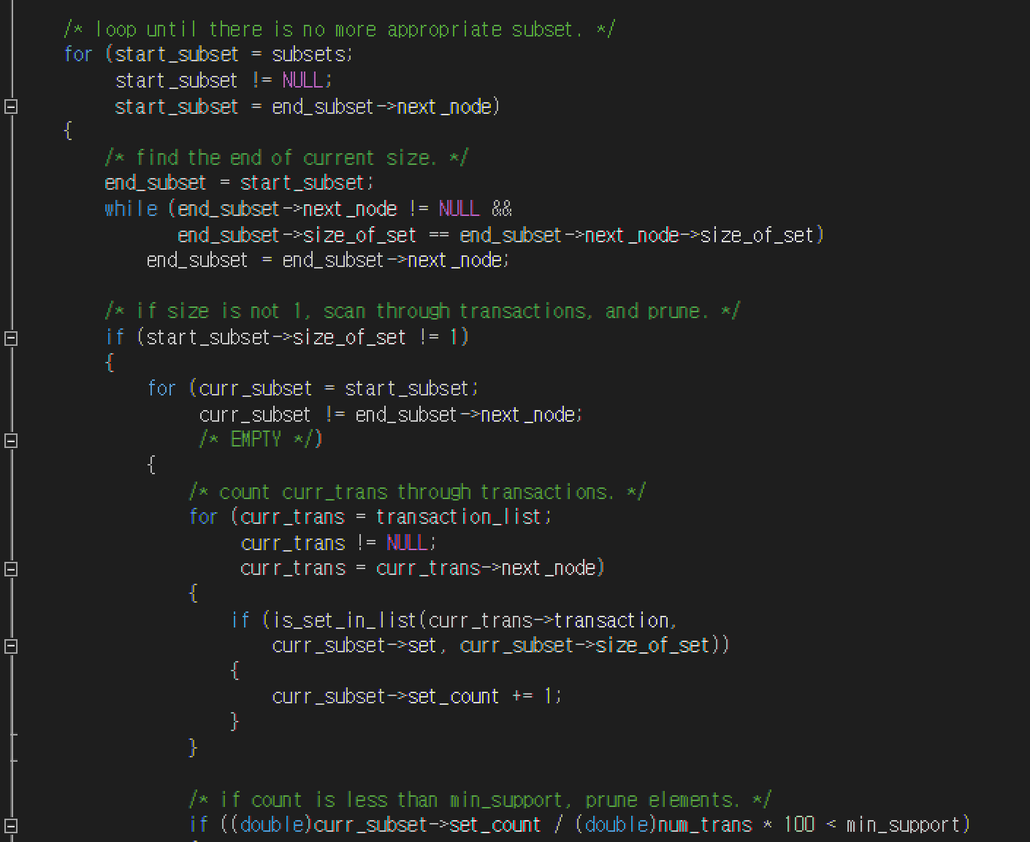
The function read_transactions() reads from input file, and returns the linked list that has whole transactions. ALSO, it stores each ELEMENT that are in transactions into 'sets' parameter. It also counts how many of those elements are in transactions.

The function prune_sets() eliminates the elements that has less portion than given minimum support.

The loop below continues until there is no appropriate 'sets' left.
If a set is in transactions more than given minimum support, call print_subsets() function to get support and confidence of that set's subsets. If less than minimum support, eliminate that set from list.

Finally, frees all resources and end the program.

* Instruction for testing program

As given instruction, you can execute this way :
Apriori.exe [min_support] [input_file] [output_file]
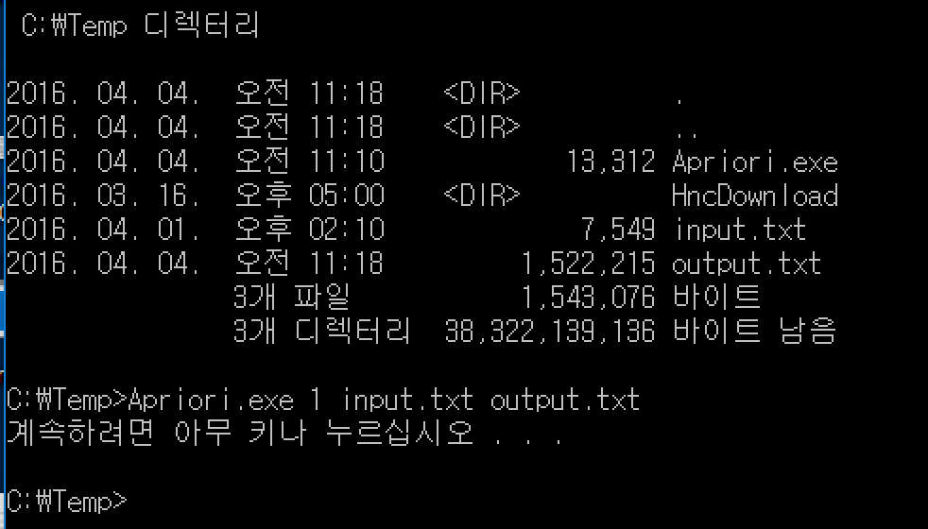
When input was given txt file and min_support was 1, the output file had 57976 lines.
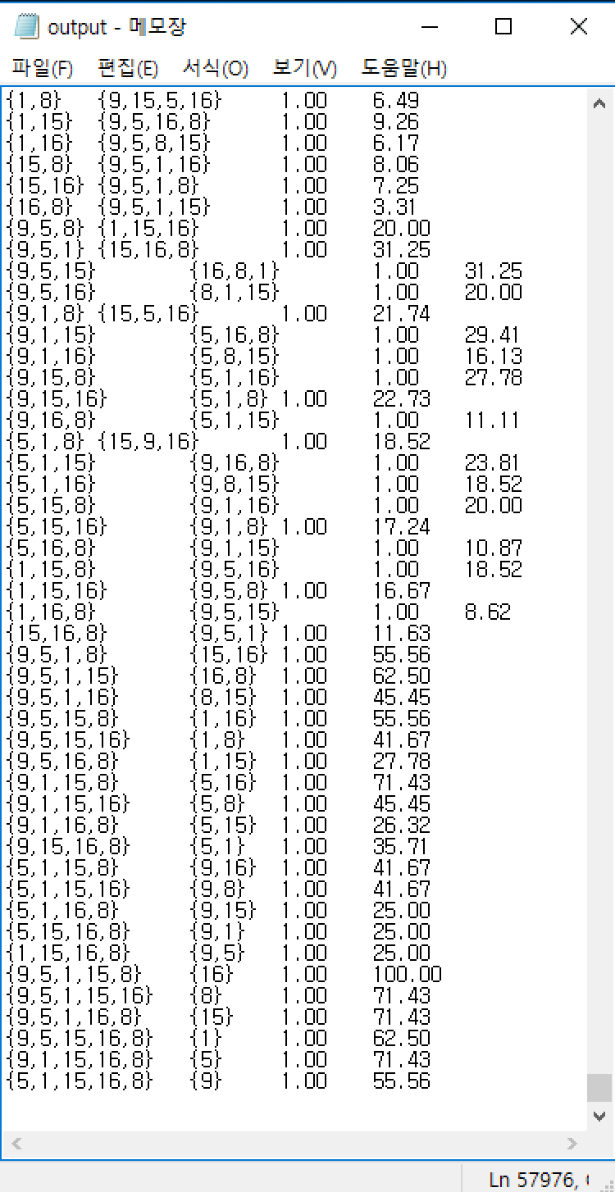
* Specification of testing

Executable file submitted is compiled by Visual Studio 2015, which requires some extra DLL files. If the executable file doesn't work on machine, please re-compile the VS Project and execute the output executable file.

