BERITA ACARA SERAH TERIMA INVENTARIS
PT. JAKARTA PRIMA CRANES
Wisma JPC, Jl. Mampang Prapatan Raya No.20

No. Dokumen : IT/BAST/2024/04/10
No. Inventaris : MMT-2024-001
DEPARTEMEN GA-IT

Hari Jumat, 26 April 2024
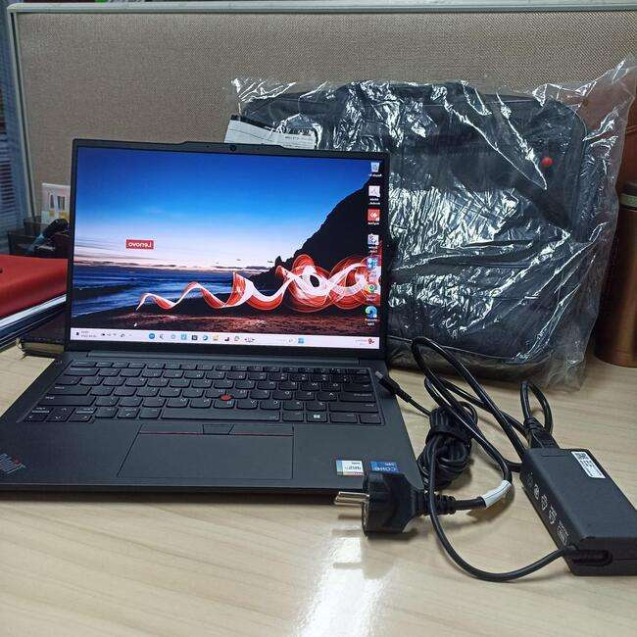Telah diserahkan inventaris sebagai berikut :
- Laptop LENOVO (ThinkPad) E14 Gen 5 (1 Unit)
  - Processor : 13th Generation Intel® Core™ i7-1355U
  - Display : 14" WUXGA Intel® Iris® Xe Graphics
  - RAM : 16 GB
  - Storage : 500GB
  - SN : PF4N7V3A
  - Warna : Black
- Charger Laptop (1 Unit)
- Tas Laptop HP (1 Unit)

Kondisi : 100% (Baru)
Kepada :

Nama : M Taufiqu Rahman
Divisi : PE Kone
NIK :
Notes :
Laptop baru untuk user, Inc Office Pro Plus 2021
Reff PWR: 2024/JKT-0163; PO: 2024/JKT-L-0107; PO: 2024/JKT-L-0111

Menerima,

M Taufiqu Rahman
Menyetujui,

Bramantya Zain

Mengetahui,

Ali Rakhman

Menyerahkan,

Rudi Ibrahim
BERITA ACARA SERAH TERIMA INVENTARIS
PT. JAKARTA PRIMA CRANES
Wisma JPC, Jl. Mampang Prapatan Raya No.20

No. Dokumen : IT/BAST/2024/04/10
No. Inventaris : MMT-2024-001
DEPARTEMEN GA-IT

Hari Jumat, 26 April 2024
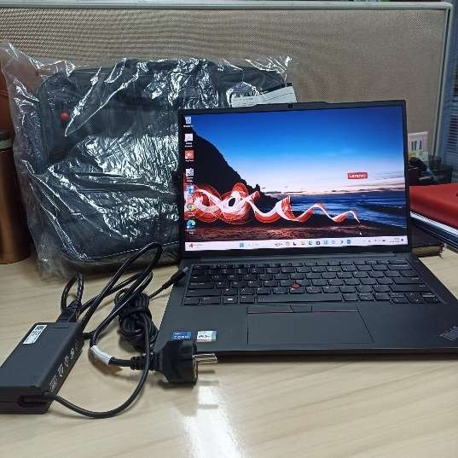
Telah diserahkan inventaris sebagai berikut :
- Laptop LENOVO (ThinkPad) E14 Gen 5 (1 Unit)
  - Processor : 13th Generation Intel® Core™ i7-1355U
  - Display : 14" WUXGA Intel® Iris® Xe Graphics
  - RAM : 16 GB
  - Storage : 500GB
  - SN : PF4N7V3A
  - Warna : Black
- Charger Laptop (1 Unit)
- Tas Laptop HP (1 Unit)

Kondisi : 100% (Baru)
Kepada :

Nama : M Taufiqu Rahman
Divisi : PE Kone
NIK :
Notes :
Laptop baru untuk user, Inc Office Pro Plus 2021
Reff PWR: 2024/JKT-0163; PO: 2024/JKT-L-0107; PO: 2024/JKT-L-0111

Menerima,

M Taufiqu Rahman
Menyetujui,

Bramantya Zain

Mengetahui,

Ali Rakhman

Menyerahkan,

Rudi Ibrahim
------------------
System Information
------------------
Time of this report: 4/26/2024, 08:25:53
Machine name: TAUFIQ
Machine Id: {57340AF0-7378-4BCF-A157-3D42F53C276F}
Operating System: Windows 11 Pro 64-bit (10.0, Build 22631) (22621.ni_release.220506-1250)
Language: English (Regional Setting: English)
System Manufacturer: LENOVO
System Model: 21JK00AVID
BIOS: R2AET51W(1.26) (type: UEFI)
Processor: 13th Gen Intel(R) Core(TM) i7-1355U (12 CPUs), ~1.7GHz
Memory: 16384MB RAM
Available OS Memory: 16058MB RAM
Page File: 12370MB used, 6631MB available
Windows Dir: C:\Windows
DirectX Version: DirectX 12
---------------
Display Devices
---------------
Card name: Intel(R) Iris(R) Xe Graphics
Manufacturer: Intel Corporation
Chip type: Intel(R) Iris(R) Xe Graphics Family
DAC type: Internal
Device Type: Full Device (POST)
Device Key: Enum\PCI\VEN_8086&DEV_A7A1&SUBSYS_50D117AA&REV_04
Device Status: 0180200A [DN_DRIVER_LOADED|DN_STARTED|DN_DISABLEABLE|DN_NT_ENUMERATOR|DN_NT_DRIVER]
Device Problem Code: No Problem
Driver Problem Code: Unknown
Display Memory: 8156 MB
Dedicated Memory: 128 MB
Shared Memory: 8028 MB
Current Mode: 1920 x 1200 (32 bit) (60Hz)
------------------------
Disk & DVD/CD-ROM Drives
------------------------
Drive: C:
Free Space: 115.5 GB
Total Space: 186.1 GB
File System: NTFS
Model: WD PC SN740 SDDQMQD-512G-1201

Drive: D:
Free Space: 297.3 GB
Total Space: 300.0 GB
File System: NTFS
Model: WD PC SN740 SDDQMQD-512G-1201

LABEL DI BELAKANG LAPTOP

NO INVENTARIS
MMT | - | 2024 | - | 001
NO INVENTARIS
MMT | - | 2024 | - | 001

EMAIL MS | pf4n7v3a@outlook.com
PASS | JpcOffice2024
DATE | 26 / 04 / 2024
BAST | IT/BAST/2024/04/10
USER | M TAUFIQU RAHMAN
EMAIL MS | pf4n7v3a@outlook.com
PASS | JpcOffice2024
DATE | 26 / 04 / 2024
BAST | IT/BAST/2024/04/10
USER | M TAUFIQU RAHMAN

PWR | 2024/JKT-0163
PO | 2024/JKT-L-0107; 2024/JKT-L-0111
PWR | 2024/JKT-0163
PO | 2024/JKT-L-0107; 2024/JKT-L-0111

LABEL DI CHARGER
NO INVENTARIS
MMT | - | 2024 | - | 001

LABEL DI BOX LAPTOP
NO INVENTARIS
MMT | - | 2024 | - | 001

EMAIL MS | pf4n7v3a@outlook.com
PASS | JpcOffice2024
DATE | 26 / 04 / 2024
BAST | IT/BAST/2024/04/10
USER | M TAUFIQU RAHMAN

PWR | 2024/JKT-0163
PO | 2024/JKT-L-0107; 2024/JKT-L-0111

LABEL DI KARTU GARANSI
NO INVENTARIS
MMT | - | 2024 | - | 001

EMAIL MS | pf4n7v3a@outlook.com
PASS | JpcOffice2024
DATE | 26 / 04 / 2024
BAST | IT/BAST/2024/04/10
USER | M TAUFIQU RAHMAN

PWR | 2024/JKT-0163
PO | 2024/JKT-L-0107; 2024/JKT-L-0111

LABEL DI LISENSI OFFICE

