BERITA ACARA SERAH TERIMA INVENTARIS
PT. JAKARTA PRIMA CRANES
Wisma JPC, Jl. Mampang Prapatan Raya No.20

No. Dokumen : IT/BAST/2024/04/02
No. Inventaris : IT/REG/2024/04/002,
IT/REG/2024/04/004
DEPARTEMEN GA-IT

Hari ………………, ……. ………… 2024,
Telah diserahkan inventaris sebagai berikut :
- SET PC (1 Set)
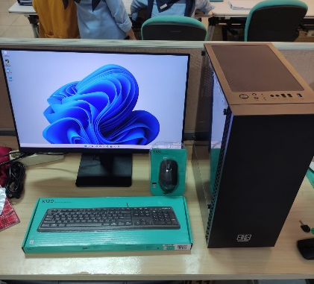
  - No. Inv : IT/REG/2024/04/002
  - CPU : AMD Ryzen 7 5700X 8-Core Processor (16 CPUs), ~3.4GHz
  - RAM : 2x 8GB DDR4-3200 (16GB)
  - Storage : 1x 1 TB SSD M2 NVME
  - GPU/VGA : NVIDIA GeForce RTX 4060 8GB GDDR6

  - No. Inv : IT/REG/2024/04/004
  - Monitor : MONITOR LG 24MR400
  - Display : 24” FHD

- Mouse Logitech M190
- Keyboard Logitech K120
Kondisi : 100% (Baru)
Kepada :
Nama : Ilham
Divisi : Engineering
NIK :
Notes :
PC Baru untuk User, Inc Lisensi Office Pro Plus 2021

Menerima,

Ilham
Menyetujui,

Bramantya Zain

Mengetahui,

Ali Rakhman
Menyerahkan,

M N Mahmudi

BERITA ACARA SERAH TERIMA INVENTARIS
PT. JAKARTA PRIMA CRANES
Wisma JPC, Jl. Mampang Prapatan Raya No.20

No. Dokumen : IT/BAST/2024/04/02
No. Inventaris : IT/REG/2024/04/002,
IT/REG/2024/04/004
DEPARTEMEN GA-IT

Hari ………………, ……. ………… 2024,
Telah diserahkan inventaris sebagai berikut :
- SET PC (1 Set)
  - No. Inv : IT/REG/2024/04/002
  - CPU : AMD Ryzen 7 5700X 8-Core Processor (16 CPUs), ~3.4GHz
  - RAM : 2x 8GB DDR4-3200 (16GB)
  - Storage : 1x 1 TB SSD M2 NVME
  - GPU/VGA : NVIDIA GeForce RTX 4060 8GB GDDR6

  - No. Inv : IT/REG/2024/04/004
  - Monitor : MONITOR LG 24MR400
  - Display : 24” FHD

- Mouse Logitech M190
- Keyboard Logitech K120
Kondisi : 100% (Baru)
Kepada :
Nama : Ilham
Divisi : Engineering
NIK :
Notes :
PC Baru untuk User, Inc Lisensi Office Pro Plus 2021

Menerima,

Ilham
Menyetujui,

Bramantya Zain

Mengetahui,

Ali Rakhman
Menyerahkan,

M N Mahmudi

------------------
System Information
------------------
Time of this report: 4/3/2024, 12:52:05
Machine name: DESKTOP-0U09R5B
Machine Id: {22A4F1B3-837E-405B-AA79-349EBA469774}
Operating System: Windows 11 Pro 64-bit (10.0, Build 22000) (22000.co_release.210604-1628)
Language: English (Regional Setting: English)
System Manufacturer: Micro-Star International Co., Ltd.
System Model: MS-7C56
BIOS: A.E0 (type: UEFI)
Processor: AMD Ryzen 7 5700X 8-Core Processor (16 CPUs), ~3.4GHz
Memory: 16384MB RAM
Available OS Memory: 16310MB RAM
Page File: 4289MB used, 14964MB available
Windows Dir: C:\Windows
DirectX Version: DirectX 12
---------------
Display Devices
---------------
Card name: NVIDIA GeForce RTX 4060
Manufacturer: NVIDIA
Chip type: NVIDIA GeForce RTX 4060
DAC type: Integrated RAMDAC
Device Type: Full Device (POST)
Device Key: Enum\PCI\VEN_10DE&DEV_2882&SUBSYS_51611462&REV_A1
Device Status: 0180200A [DN_DRIVER_LOADED|DN_STARTED|DN_DISABLEABLE|DN_NT_ENUMERATOR|DN_NT_DRIVER]
Device Problem Code: No Problem
Driver Problem Code: Unknown
Display Memory: 16112 MB
Dedicated Memory: 7957 MB
Shared Memory: 8155 MB
------------------------
Disk & DVD/CD-ROM Drives
------------------------
Drive: C:
Free Space: 169.6 GB
Total Space: 199.3 GB
File System: NTFS
Model: KINGSTON SKC3000S1024G

Drive: D:
Free Space: 748.5 GB
Total Space: 776.8 GB
File System: NTFS
Model: KINGSTON SKC3000S1024G

