BERITA ACARA SERAH TERIMA INVENTARIS
PT. JAKARTA PRIMA CRANES
Wisma JPC, Jl. Mampang Prapatan Raya No.20

No. Dokumen : IT/BAST/2024/07/02
No. Inventaris : GDN-2024-001
DEPARTEMEN GA-IT

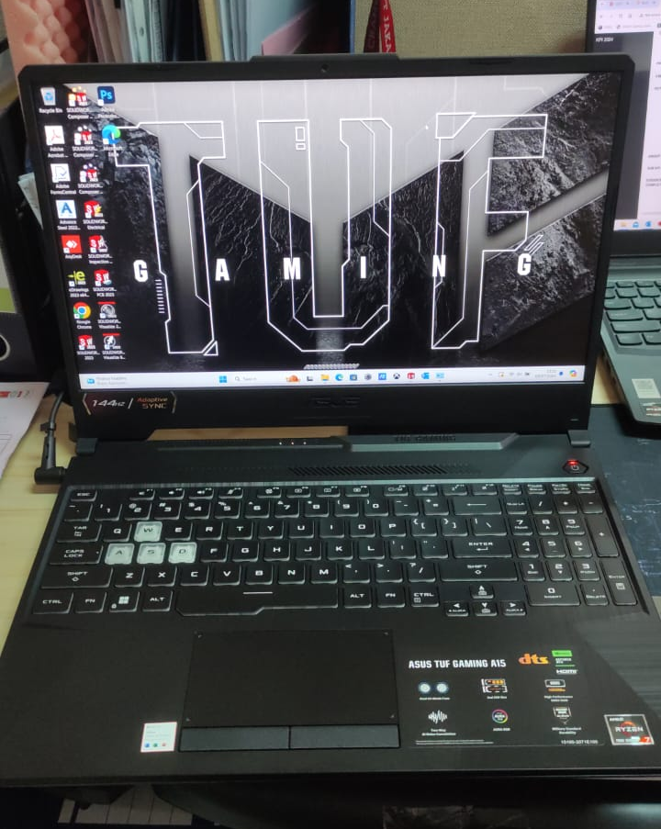
Hari ………………, ……. ………… 2024,
Telah diserahkan inventaris sebagai berikut :
- Laptop ASUS TUF R7 FA506NCR-R735B6T-O (1 Unit)
- CPU : AMD Ryzen 7 7435HS 3.2 GHz Max Up to 4.7 GHz
- RAM : 1x 16GB DDR5
- Storage : 1x 512GB SSD NVMe M.2
- Display : NVIDIA GeForce RTX 3050, 4GB 15.6" FHD, 144Hz
- SN : S5NRCX025977209
- Warna : Graphite Black
- Charger Laptop Asus

Kondisi : 100% (Baru)
Kepada :

Nama : Gidion Tri Prakosa
Divisi : Technical Support
NIK :

Notes :
Laptop baru Gidion untuk Mobile;
REFF PWR 2024/JKT-0457; REFF PO 2024/JKT-L-0277

Menyetujui,

Bramantya Zain

Menyerahkan,

M N Mahmudi
Menerima,

Gidion Tri Prakosa
Mengetahui,

Ali Rakhman

BERITA ACARA SERAH TERIMA INVENTARIS
PT. JAKARTA PRIMA CRANES
Wisma JPC, Jl. Mampang Prapatan Raya No.20

No. Dokumen : IT/BAST/2024/07/02
No. Inventaris : GDN-2024-001
DEPARTEMEN GA-IT

Hari ………………, ……. ………… 2024,
Telah diserahkan inventaris sebagai berikut :
- Laptop ASUS TUF R7 FA506NCR-R735B6T-O (1 Unit)
- CPU : AMD Ryzen 7 7435HS 3.2 GHz Max Up to 4.7 GHz
- RAM : 1x 16GB DDR5
- Storage : 1x 512GB SSD NVMe M.2
- Display : NVIDIA GeForce RTX 3050, 4GB 15.6" FHD, 144Hz
- SN : S5NRCX025977209
- Warna : Graphite Black
- Charger Laptop Asus

Kondisi : 100% (Baru)
Kepada :

Nama : Gidion Tri Prakosa
Divisi : Technical Support
NIK :

Notes :
Laptop baru Gidion untuk Mobile;
REFF PWR 2024/JKT-0457; REFF PO 2024/JKT-L-0277

Menyetujui,

Bramantya Zain

Menyerahkan,

M N Mahmudi
Menerima,

Gidion Tri Prakosa
Mengetahui,

Ali Rakhman

------------------
System Information
------------------
Time of this report: 6/13/2024, 15:29:15
Machine name: RCF-2024-001
Machine Id: {9E282279-D2BC-41E9-AF54-C059868C40F9}
Operating System: Windows 11 Home Single Language 64-bit (10.0, Build 22631) (22621.ni_release.220506-1250)
Language: English (Regional Setting: English)
System Manufacturer: LENOVO
System Model: 82XD
BIOS: LACN33WW (type: UEFI)
Processor: 13th Gen Intel(R) Core(TM) i7-13620H (16 CPUs), ~2.4GHz
Memory: 16384MB RAM
Available OS Memory: 16108MB RAM
Page File: 8246MB used, 10805MB available
Windows Dir: C:\Windows
DirectX Version: DirectX 12
---------------
Display Devices
---------------
Card name: Intel(R) UHD Graphics
Manufacturer: Intel Corporation
Chip type: Intel(R) UHD Graphics Family
DAC type: Internal
Device Type: Full Device (POST)
Device Key: Enum\PCI\VEN_8086&DEV_A7A8&SUBSYS_3C4417AA&REV_04
Device Status: 0180200A [DN_DRIVER_LOADED|DN_STARTED|DN_DISABLEABLE|DN_NT_ENUMERATOR|DN_NT_DRIVER]
Device Problem Code: No Problem
Driver Problem Code: Unknown
Display Memory: 8181 MB
Dedicated Memory: 128 MB
Shared Memory: 8053 MB
Current Mode: 1920 x 1200 (32 bit) (60Hz)
------------------------
Disk & DVD/CD-ROM Drives
------------------------
Drive: C:
Free Space: 118.3 GB
Total Space: 226.1 GB
File System: NTFS
Model: SKHynix_HFS512GEJ4X112N
Drive: E:
Free Space: 259.9 GB
Total Space: 260.0 GB
File System: NTFS
Model: SKHynix_HFS512GEJ4X112N

LABEL DI BELAKANG LAPTOP

NO INVENTARIS
GDN | - | 2024 | - | 001
NO INVENTARIS
GDN | - | 2024 | - | 001

EMAIL MS | s5nrcx025977209@outlook.com
PASS | JpcOffice2024
DATE | 09 / 07 / 2024
BAST | IT/BAST/2024/07/002
USER | GIDION TRI PRAKOSA
EMAIL MS | s5nrcx025977209@outlook.com
PASS | JpcOffice2024
DATE | 09 / 07 / 2024
BAST | IT/BAST/2024/07/002
USER | GIDION TRI PRAKOSA

PWR | 2024/JKT-0457
PO | 2024/JKT-L- 0277
PWR | 2024/JKT-0457
PO | 2024/JKT-L- 0277

LABEL DI CHARGER
NO INVENTARIS
GDN | - | 2024 | - | 001

LABEL DI BOX LAPTOP
NO INVENTARIS
GDN | - | 2024 | - | 001

EMAIL MS | s5nrcx025977209@outlook.com
PASS | JpcOffice2024
DATE | 09 / 07 / 2024
BAST | IT/BAST/2024/07/002
USER | GIDION TRI PRAKOSA

PWR | 2024/JKT-0457
PO | 2024/JKT-L- 0277

LABEL DI KARTU GARANSI
NO INVENTARIS
GDN | - | 2024 | - | 001

EMAIL MS | s5nrcx025977209@outlook.com
PASS | JpcOffice2024
DATE | 09 / 07 / 2024
BAST | IT/BAST/2024/07/002
USER | GIDION TRI PRAKOSA

PWR | 2024/JKT-0457
PO | 2024/JKT-L- 0277

