BERITA ACARA SERAH TERIMA INVENTARIS
PT. JAKARTA PRIMA CRANES
Wisma JPC, Jl. Mampang Prapatan Raya No.20

No. Dokumen : IT/BAST/2024/04/09
No. Inventaris : AGM-2024-001
DEPARTEMEN GA-IT

Hari Selasa, 23 April 2024
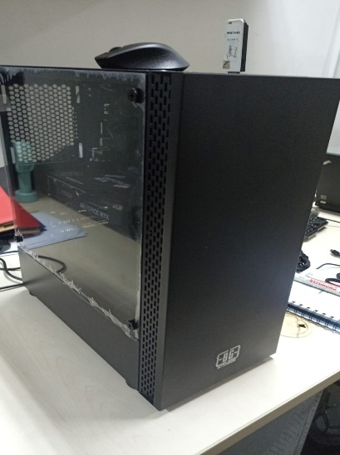
Telah diserahkan inventaris sebagai berikut :
- PC Rakitan (1 Set)
  - Processor : 11th Gen Intel(R) Core(TM) i7-11700 @ 2.50GHz (16 CPUs), ~2.5GHz
  - Motherboard ASUS H510M-K R2.0
  - RAM VGEN 16GB DDR4-3200 Long DIMM
  - Samsung SSD 970 M2 Evo Plus 1TB NVME
  - NVIDIA GEFORCE RTX 3050 8GB GDDR6
- Mouse Logitech M331 (1 Unit)

Kondisi : 100% (Baru)
Kepada :

Nama : Angga Mega
Divisi : Engineering
NIK :
Notes :
PC baru untuk user, Inc Office Pro Plus 2021
Reff PWR: 2024/JKT-0148; PO: 2024/JKT-L-0108; PO: 2024/JKT-L-0111

Menerima,

Angga Mega
Menyetujui,

Bramantya Zain

Mengetahui,

Ali Rakhman

Menyerahkan,

Rudi Ibrahim
BERITA ACARA SERAH TERIMA INVENTARIS
PT. JAKARTA PRIMA CRANES
Wisma JPC, Jl. Mampang Prapatan Raya No.20

No. Dokumen : IT/BAST/2024/04/09
No. Inventaris : AGM-2024-001
DEPARTEMEN GA-IT

Hari Selasa, 23 April 2024
Telah diserahkan inventaris sebagai berikut :
- PC Rakitan (1 Set)
  - Processor : 11th Gen Intel(R) Core(TM) i7-11700 @ 2.50GHz (16 CPUs), ~2.5GHz
  - Motherboard ASUS H510M-K R2.0
  - RAM VGEN 16GB DDR4-3200 Long DIMM
  - Samsung SSD 970 M2 Evo Plus 1TB NVME
  - NVIDIA GEFORCE RTX 3050 8GB GDDR6
- Mouse Logitech M331 (1 Unit)

Kondisi : 100% (Baru)
Kepada :

Nama : Angga Mega
Divisi : Engineering
NIK :
Notes :
PC baru untuk user, Inc Office Pro Plus 2021
Reff PWR: 2024/JKT-0148; PO: 2024/JKT-L-0108; PO: 2024/JKT-L-0111

Menerima,

Angga Mega
Menyetujui,

Bramantya Zain

Mengetahui,

Ali Rakhman

Menyerahkan,

Rudi Ibrahim
------------------
System Information
------------------
Time of this report: 4/23/2024, 09:09:41
Machine name: DESKTOP-ARIOLU5
Machine Id: {92A4D250-1950-495B-8663-64B611883836}
Operating System: Windows 11 Pro 64-bit (10.0, Build 22631) (22621.ni_release.220506-1250)
Language: English (Regional Setting: English)
System Manufacturer: ASUS
System Model: System Product Name
BIOS: 0806 (type: UEFI)
Processor: 11th Gen Intel(R) Core(TM) i7-11700 @ 2.50GHz (16 CPUs), ~2.5GHz
Memory: 16384MB RAM
Available OS Memory: 16250MB RAM
Page File: 7459MB used, 11733MB available
Windows Dir: C:\WINDOWS
DirectX Version: DirectX 12
---------------
Display Devices
---------------
Card name: NVIDIA GeForce RTX 3050
Manufacturer: NVIDIA
Chip type: NVIDIA GeForce RTX 3050
DAC type: Integrated RAMDAC
Device Type: Full Device (POST)
Device Key: Enum\PCI\VEN_10DE&DEV_2582&SUBSYS_8D9D1462&REV_A1
Device Status: 0180200A [DN_DRIVER_LOADED|DN_STARTED|DN_DISABLEABLE|DN_NT_ENUMERATOR|DN_NT_DRIVER]
Device Problem Code: No Problem
Driver Problem Code: Unknown
Display Memory: 16166 MB
Dedicated Memory: 8042 MB
Shared Memory: 8124 MB
Current Mode: 1440 x 900 (32 bit) (60Hz)
------------------------
Disk & DVD/CD-ROM Drives
------------------------
Drive: C:
Free Space: 85.0 GB
Total Space: 199.2 GB
File System: NTFS
Model: Samsung SSD 970 EVO Plus 1TB

Drive: D:
Free Space: 733.9 GB
Total Space: 753.9 GB
File System: NTFS
Model: Samsung SSD 970 EVO Plus 1TB

LABEL DI BELAKANG LAPTOP

NO INVENTARIS
AGM | - | 2024 | - | 001
NO INVENTARIS
AGM | - | 2024 | - | 001

EMAIL MS | angga.jpc@outlook.com
PASS | JpcOffice2024
DATE | 23 / 04 / 2024
BAST | IT/BAST/2024/04/009
USER | ANGGA MEGA
EMAIL MS | angga.jpc@outlook.com
PASS | JpcOffice2024
DATE | 23 / 04 / 2024
BAST | IT/BAST/2024/04/009
USER | ANGGA MEGA

PWR | 2024/JKT-0148
PO | 2024/JKT-L-0108; 2024/JKT-L-0111
PWR | 2024/JKT-0148
PO | 2024/JKT-L-0108; 2024/JKT-L-0111

LABEL DI CHARGER
NO INVENTARIS
AGM | - | 2024 | - | 001

LABEL DI BOX LAPTOP
NO INVENTARIS
AGM | - | 2024 | - | 001

EMAIL MS | angga.jpc@outlook.com
PASS | JpcOffice2024
DATE | 23 / 04 / 2024
BAST | IT/BAST/2024/04/009
USER | ANGGA MEGA

PWR | 2024/JKT-0148
PO | 2024/JKT-L-0108; 2024/JKT-L-0111

LABEL DI KARTU GARANSI
NO INVENTARIS
AGM | - | 2024 | - | 001

EMAIL MS | angga.jpc@outlook.com
PASS | JpcOffice2024
DATE | 23 / 04 / 2024
BAST | IT/BAST/2024/04/009
USER | ANGGA MEGA

PWR | 2024/JKT-0148
PO | 2024/JKT-L-0108; 2024/JKT-L-0111

LABEL DI LISENSI OFFICE

