BERITA ACARA SERAH TERIMA INVENTARIS
PT. JAKARTA PRIMA CRANES
Wisma JPC, Jl. Mampang Prapatan Raya No.20

No. Dokumen : IT/BAST/2024/04/11
No. Inventaris : BGA-2024-001
DEPARTEMEN GA-IT

Hari Jumat, 26 April 2024
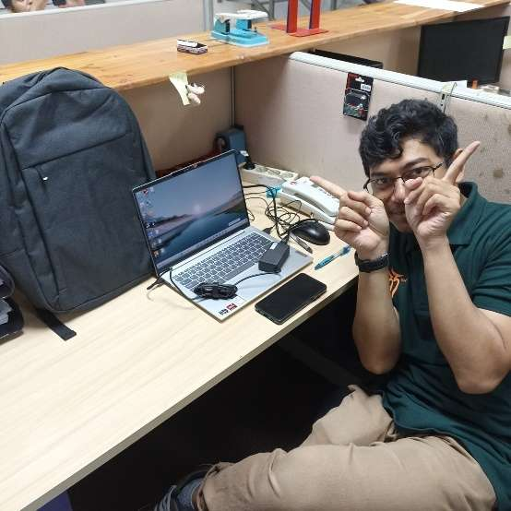
Telah diserahkan inventaris sebagai berikut :
- Laptop LENOVO IdeaPad Skim 5 – 14ABR8 (1 Unit)
  - Processor : AMD Ryzen 5 7530U
  - Display : 14" WUXGA
  - RAM : 16 GB
  - Storage : 500GB
  - SN : MP2LJS0J
  - Warna : Cloud Grey
- Charger Laptop (1 Unit)
- Tas Laptop HP (1 Unit)

Kondisi : 100% (Baru)
Kepada :

Nama : Bagus Aditya Muslim
Divisi : PE Kone
NIK :
Notes :
Laptop baru untuk user, Inc Office Pro Plus 2021
Reff PWR: 2024/JKT-0163; PO: 2024/JKT-L-0108; PO: 2024/JKT-L-0111

Menerima,

Bagus Aditya Muslim
Menyetujui,

Bramantya Zain

Mengetahui,

Ali Rakhman

Menyerahkan,

Rudi Ibrahim
BERITA ACARA SERAH TERIMA INVENTARIS
PT. JAKARTA PRIMA CRANES
Wisma JPC, Jl. Mampang Prapatan Raya No.20

No. Dokumen : IT/BAST/2024/04/11
No. Inventaris : BGA-2024-001
DEPARTEMEN GA-IT

Hari Jumat, 26 April 2024
Telah diserahkan inventaris sebagai berikut :
- Laptop LENOVO IdeaPad Skim 5 – 14ABR8 (1 Unit)
  - Processor : AMD Ryzen 5 7530U
  - Display : 14" WUXGA
  - RAM : 16 GB
  - Storage : 500GB
  - SN : MP2LJS0J
  - Warna : Cloud Grey
- Charger Laptop (1 Unit)
- Tas Laptop HP (1 Unit)

Kondisi : 100% (Baru)
Kepada :

Nama : Bagus Aditya Muslim
Divisi : PE Kone
NIK :
Notes :
Laptop baru untuk user, Inc Office Pro Plus 2021
Reff PWR: 2024/JKT-0163; PO: 2024/JKT-L-0108; PO: 2024/JKT-L-0111

Menerima,

Bagus Aditya Muslim
Menyetujui,

Bramantya Zain

Mengetahui,

Ali Rakhman

Menyerahkan,

Rudi Ibrahim
------------------
System Information
------------------
Time of this report: 4/25/2024, 08:32:03
Machine name: ADITYA
Machine Id: {4CD58849-130C-4DBC-B07C-88722E7BE1C6}
Operating System: Windows 11 Home Single Language 64-bit (10.0, Build 22631) (22621.ni_release.220506-1250)
Language: English (Regional Setting: English)
System Manufacturer: LENOVO
System Model: 82XE
BIOS: L9CN22WW (type: UEFI)
Processor: AMD Ryzen 5 7530U with Radeon Graphics (12 CPUs), ~2.0GHz
Memory: 16384MB RAM
Available OS Memory: 14188MB RAM
Page File: 9129MB used, 7746MB available
Windows Dir: C:\Windows
DirectX Version: DirectX 12
---------------
Display Devices
---------------
Card name: AMD Radeon (TM) Graphics
Manufacturer: Advanced Micro Devices, Inc.
Chip type: AMD Radeon Graphics Processor (0x15E7)
DAC type: Internal DAC(400MHz)
Device Type: Full Device (POST)
Device Key: Enum\PCI\VEN_1002&DEV_15E7&SUBSYS_380717AA&REV_C5
Device Status: 0180200A [DN_DRIVER_LOADED|DN_STARTED|DN_DISABLEABLE|DN_NT_ENUMERATOR|DN_NT_DRIVER]
Device Problem Code: No Problem
Driver Problem Code: Unknown
Display Memory: 9125 MB
Dedicated Memory: 2031 MB
Shared Memory: 7094 MB
Current Mode: 1920 x 1200 (32 bit) (60Hz)
------------------------
Disk & DVD/CD-ROM Drives
------------------------
Drive: C:
Free Space: 117.3 GB
Total Space: 185.1 GB
File System: NTFS
Model: WD PC SN740 SDDPMQD-512G-1101

Drive: D:
Free Space: 232.0 GB
Total Space: 301.0 GB
File System: NTFS
Model: WD PC SN740 SDDPMQD-512G-1101

LABEL DI BELAKANG LAPTOP

NO INVENTARIS
BGA | - | 2024 | - | 001
NO INVENTARIS
BGA | - | 2024 | - | 001

EMAIL MS | mp2ljs0j@outlook.com
PASS | JpcOffice2024
DATE | 26 / 04 / 2024
BAST | IT/BAST/2024/04/11
USER | BAGUS ADITYA MUSLIM
EMAIL MS | mp2ljs0j@outlook.com
PASS | JpcOffice2024
DATE | 26 / 04 / 2024
BAST | IT/BAST/2024/04/11
USER | BAGUS ADITYA MUSLIM

PWR | 2024/JKT-0163
PO | 2024/JKT-L-0108; 2024/JKT-L-0111
PWR | 2024/JKT-0163
PO | 2024/JKT-L-0108; 2024/JKT-L-0111

LABEL DI CHARGER
NO INVENTARIS
BGA | - | 2024 | - | 001

LABEL DI BOX LAPTOP
NO INVENTARIS
BGA | - | 2024 | - | 001

EMAIL MS | mp2ljs0j@outlook.com
PASS | JpcOffice2024
DATE | 26 / 04 / 2024
BAST | IT/BAST/2024/04/11
USER | BAGUS ADITYA MUSLIM

PWR | 2024/JKT-0163
PO | 2024/JKT-L-0108; 2024/JKT-L-0111

LABEL DI KARTU GARANSI
NO INVENTARIS
BGA | - | 2024 | - | 001

EMAIL MS | mp2ljs0j@outlook.com
PASS | JpcOffice2024
DATE | 26 / 04 / 2024
BAST | IT/BAST/2024/04/11
USER | BAGUS ADITYA MUSLIM

PWR | 2024/JKT-0163
PO | 2024/JKT-L-0108; 2024/JKT-L-0111

LABEL DI LISENSI OFFICE

