BERITA ACARA SERAH TERIMA INVENTARIS
PT. JAKARTA PRIMA CRANES
Wisma JPC, Jl. Mampang Prapatan Raya No.20

No. Dokumen : IT/BAST/2024/06/04
No. Inventaris : RCF-2024-001
DEPARTEMEN GA-IT

Hari ………………, ……. ………… 2024,
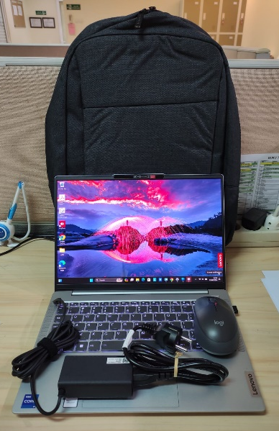
Telah diserahkan inventaris sebagai berikut :
- Laptop LENOVO IdeaPad Slim 5 14IRL8 - Type 82XD (1 Unit)
- CPU : 13th Generation Intel® Core™ i7-13620H Processor(Core™ i7-13620H)
- RAM : 1x 16GBLPDDR5-5200
- Storage : 1x 512 GB SSD PCIe
- Display : Intel® UHD Graphics 14" WUXGA
- SN : MP2NLTAS
- Warna Silver
- Charger Laptop Asus
- Tas Laptop Asus
- Wireless Mouse Logitech M190
  - SN : 2338LV01D1S9

Kondisi : 100% (Baru)
Kepada :
Nama : Rico Fernandes
Divisi :
NIK :

Notes :
Laptop baru rico; pengadaan laptop karena pindah ke posisi baru.

Menyetujui,

Bramantya Zain

Menyerahkan,

M N Mahmudi
Menerima,

Rico Fernandes
Mengetahui,

Ali Rakhman

BERITA ACARA SERAH TERIMA INVENTARIS
PT. JAKARTA PRIMA CRANES
Wisma JPC, Jl. Mampang Prapatan Raya No.20

No. Dokumen : IT/BAST/2024/06/04
No. Inventaris : RCF-2024-001
DEPARTEMEN GA-IT

Hari ………………, ……. ………… 2024,
Telah diserahkan inventaris sebagai berikut :
- Laptop LENOVO IdeaPad Slim 5 14IRL8 - Type 82XD (1 Unit)
- CPU : 13th Generation Intel® Core™ i7-13620H Processor(Core™ i7-13620H)
- RAM : 1x 16GBLPDDR5-5200
- Storage : 1x 512 GB SSD PCIe
- Display : Intel® UHD Graphics 14" WUXGA
- SN : MP2NLTAS
- Warna Silver
- Charger Laptop Asus
- Tas Laptop Asus
- Wireless Mouse Logitech M190
  - SN : 2338LV01D1S9

Kondisi : 100% (Baru)
Kepada :
Nama : Rico Fernandes
Divisi :
NIK :

Notes :
Laptop baru rico; pengadaan laptop karena pindah ke posisi baru.

Menyetujui,

Bramantya Zain

Menyerahkan,

M N Mahmudi
Menerima,

Rico Fernandes
Mengetahui,

Ali Rakhman

------------------
System Information
------------------
Time of this report: 6/13/2024, 15:29:15
Machine name: RCF-2024-001
Machine Id: {9E282279-D2BC-41E9-AF54-C059868C40F9}
Operating System: Windows 11 Home Single Language 64-bit (10.0, Build 22631) (22621.ni_release.220506-1250)
Language: English (Regional Setting: English)
System Manufacturer: LENOVO
System Model: 82XD
BIOS: LACN33WW (type: UEFI)
Processor: 13th Gen Intel(R) Core(TM) i7-13620H (16 CPUs), ~2.4GHz
Memory: 16384MB RAM
Available OS Memory: 16108MB RAM
Page File: 8246MB used, 10805MB available
Windows Dir: C:\Windows
DirectX Version: DirectX 12
---------------
Display Devices
---------------
Card name: Intel(R) UHD Graphics
Manufacturer: Intel Corporation
Chip type: Intel(R) UHD Graphics Family
DAC type: Internal
Device Type: Full Device (POST)
Device Key: Enum\PCI\VEN_8086&DEV_A7A8&SUBSYS_3C4417AA&REV_04
Device Status: 0180200A [DN_DRIVER_LOADED|DN_STARTED|DN_DISABLEABLE|DN_NT_ENUMERATOR|DN_NT_DRIVER]
Device Problem Code: No Problem
Driver Problem Code: Unknown
Display Memory: 8181 MB
Dedicated Memory: 128 MB
Shared Memory: 8053 MB
Current Mode: 1920 x 1200 (32 bit) (60Hz)
------------------------
Disk & DVD/CD-ROM Drives
------------------------
Drive: C:
Free Space: 118.3 GB
Total Space: 226.1 GB
File System: NTFS
Model: SKHynix_HFS512GEJ4X112N
Drive: E:
Free Space: 259.9 GB
Total Space: 260.0 GB
File System: NTFS
Model: SKHynix_HFS512GEJ4X112N

