BERITA ACARA SERAH TERIMA INVENTARIS
PT. JAKARTA PRIMA CRANES
Wisma JPC, Jl. Mampang Prapatan Raya No.20

No. Dokumen : IT/BAST/2024/09/07
No. Inventaris : 6.2024/LT59.2/WS1LT1
DEPARTEMEN GA-PBAP

Hari ………………, ……. ………… 2024
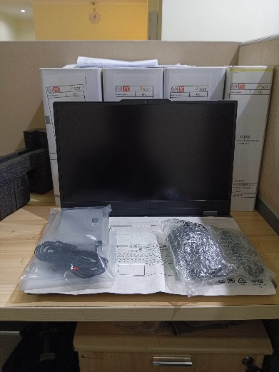
Telah diserahkan inventaris sebagai berikut :
- Laptop LOQ 15IRX9 - Type 83DV (1 Unit)
  - Processor : 13th Generation Intel® Core™ i5-13450HX Processor(Core™ i5-13450HX)
  - Display : 15.6'' NVIDIA® GeForce RTX™ 3050 6GB GPU
  - RAM : 1x 12 GB DDR5-4800
  - Storage : 1x 512 GB SSD PCIe
  - SN : MP2P0ZQY
  - Warna : LUNAR_GREY
- Charger Laptop (1 Unit)
- Lenovo LOQ M1000 RGB Mouse (1 Unit)

Kondisi : 100% (Baru)
Kepada :

Nama : Lanang Diwani Sakti
Divisi : PBAP
NIK :

Notes :
Laptop Baru untuk Lanang Diwani Sakti, REFF PWR :……………….; REFF PO ……………..;

Menerima,

Lanang Diwani Sakti
Mengetahui,

Saibun Sirait

Menyetujui,

Bramantya Zain

Menyerahkan,

Ali Rakhman
BERITA ACARA SERAH TERIMA INVENTARIS
PT. JAKARTA PRIMA CRANES
Wisma JPC, Jl. Mampang Prapatan Raya No.20

No. Dokumen : IT/BAST/2024/09/07
No. Inventaris : 6.2024/LT59.2/WS1LT1
DEPARTEMEN GA-PBAP

Hari ………………, ……. ………… 2024
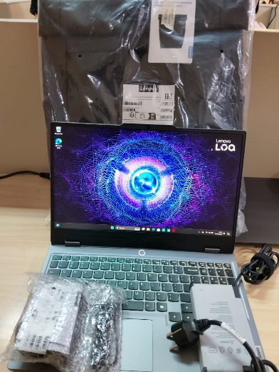
Telah diserahkan inventaris sebagai berikut :
- Laptop LOQ 15IRX9 - Type 83DV (1 Unit)
  - Processor : 13th Generation Intel® Core™ i5-13450HX Processor(Core™ i5-13450HX)
  - Display : 15.6'' NVIDIA® GeForce RTX™ 3050 6GB GPU
  - RAM : 1x 12 GB DDR5-4800
  - Storage : 1x 512 GB SSD PCIe
  - SN : MP2P0ZQY
  - Warna : LUNAR_GREY
- Charger Laptop (1 Unit)
- Lenovo LOQ M1000 RGB Mouse (1 Unit)

Kondisi : 100% (Baru)
Kepada :

Nama : Lanang Diwani Sakti
Divisi : PBAP
NIK :

Notes :
Laptop Baru untuk Lanang Diwani Sakti, REFF PWR :……………….; REFF PO ……………..;

Menerima,

Lanang Diwani Sakti
Mengetahui,

Saibun Sirait

Menyetujui,

Bramantya Zain

Menyerahkan,

Ali Rakhman
------------------
System Information
------------------
Time of this report: 9/12/2024, 09:37:23
Machine name: LAPTOP-ESM0I3OC
Machine Id: {E5465E2D-C940-4C2B-9F02-643237C121BA}
Operating System: Windows 11 Home Single Language 64-bit (10.0, Build 22631) (22621.ni_release.220506-1250)
Language: English (Regional Setting: English)
System Manufacturer: LENOVO
System Model: 83DV
BIOS: NECN34WW (type: UEFI)
Processor: 13th Gen Intel(R) Core(TM) i5-13450HX (16 CPUs), ~2.4GHz
Memory: 20480MB RAM
Available OS Memory: 20188MB RAM
Page File: 4623MB used, 19020MB available
Windows Dir: C:\Windows
DirectX Version: DirectX 12
---------------
Display Devices
---------------
Card name: Intel(R) UHD Graphics
Manufacturer: Intel Corporation
Chip type: Intel(R) RaptorLake-S Mobile Graphics Controller
DAC type: Internal
Device Type: Full Device (POST)
Device Key: Enum\PCI\VEN_8086&DEV_A78B&SUBSYS_3D0617AA&REV_04
Device Status: 0180200A [DN_DRIVER_LOADED|DN_STARTED|DN_DISABLEABLE|DN_NT_ENUMERATOR|DN_NT_DRIVER]
Device Problem Code: No Problem
Driver Problem Code: Unknown
Display Memory: 10221 MB
Dedicated Memory: 128 MB
Shared Memory: 10093 MB
------------------------
Disk & DVD/CD-ROM Drives
------------------------
Drive: C:
Free Space: 416.5 GB
Total Space: 486.1 GB
File System: NTFS
Model: WD PC SN740 SDDPMQD-512G-1101

LABEL DI BELAKANG LAPTOP

NO INVENTARIS
6.2024/LT59.1/WS1LT1
NO INVENTARIS
6.2024/LT59.1/WS1LT1

EMAIL MS | MP2NY5TZ@outlook.com
PASS | JpcOffice2024
DATE | 04 / 09 / 2024
BAST | IT/BAST/2024/09/06
USER
EMAIL MS | MP2NY5TZ@outlook.com
PASS | JpcOffice2024
DATE | 04 / 09 / 2024
BAST | IT/BAST/2024/09/06
USER

PWR | 2024/JKT-0623 R1
PO | 2024/JKT-L0382
PWR | 2024/JKT-0623 R1
PO | 2024/JKT-L0382

LABEL DI CHARGER
NO INVENTARIS
6.2024/LT59.1/WS1LT1

LABEL DI BOX LAPTOP
NO INVENTARIS
6.2024/LT59.1/WS1LT1

EMAIL MS | MP2NY5TZ@outlook.com
PASS | JpcOffice2024
DATE | 04 / 09 / 2024
BAST | IT/BAST/2024/09/06
USER

PWR | 2024/JKT-0623 R1
PO | 2024/JKT-L0382

LABEL DI KARTU GARANSI
NO INVENTARIS
6.2024/LT59.1/WS1LT1

EMAIL MS | MP2NY5TZ@outlook.com
PASS | JpcOffice2024
DATE | 04 / 09 / 2024
BAST | IT/BAST/2024/09/06
USER

PWR | 2024/JKT-0623 R1
PO | 2024/JKT-L0382

LABEL DI LISENSI OFFICE

