BERITA ACARA SERAH TERIMA INVENTARIS
PT. JAKARTA PRIMA CRANES
Wisma JPC, Jl. Mampang Prapatan Raya No.20

No. Dokumen : IT/BAST/2024/03/03
No. Inventaris : DVS-2024-001
DEPARTEMEN GA-IT

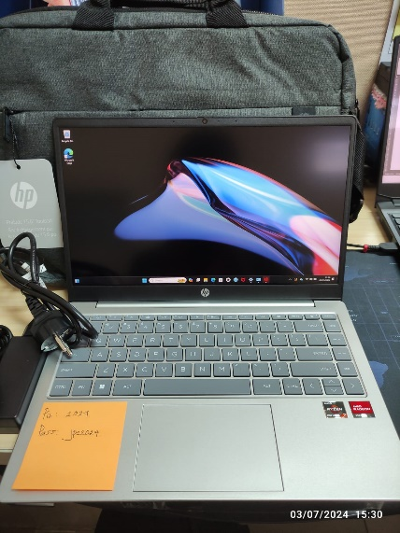
Hari ………………, ……. ………… 2024
Telah diserahkan inventaris sebagai berikut :
- Laptop HP Type 14-em0017AU (7L9C8PA) (1 Unit)
  - Processor : AMD Ryzen™ 7 7730U (up to 4.5 GHz max boost clock, 16 MB L3 cache, 8 cores, 16 threads)
  - Display : 14" diagonal, FHD (1920 x 1080), IPS, micro-edge, anti-glare, 250 nits, low power, 45% NTSC
  - RAM : 216 GB DDR4-3200 MHz RAM (2 x 8 GB) Transfer rates up to 3200 MT/s. 2 x 8 GB
  - Storage : 512 GB PCIe® NVMe™ M.2 SSD
  - SN : 5CG3114JCX
  - Warna : Silver
- Charger Laptop (1 Unit)
- Tas Laptop ASUS (1 Unit)

Kondisi : 100% (Baru)
Kepada :

Nama : Devi Sagita
Divisi : Project Control
NIK :
Notes :
Laptop baru untuk user, laptop lama sudah sering bermasalah,
Reff PWR: 2024/JKT-0114; PO: 2024/JKT-L-0083

Menerima,

Devi Sagita

Menyetujui,

Bramantya Zain

Mengetahui,

Ali Rakhman

Menyerahkan,

M N Mahmudi
BERITA ACARA SERAH TERIMA INVENTARIS
PT. JAKARTA PRIMA CRANES
Wisma JPC, Jl. Mampang Prapatan Raya No.20

No. Dokumen : IT/BAST/2024/03/03
No. Inventaris : DVS-2024-001
DEPARTEMEN GA-IT

Hari ………………, ……. ………… 2024
Telah diserahkan inventaris sebagai berikut :
- Laptop HP Type 14-em0017AU (7L9C8PA) (1 Unit)
  - Processor : AMD Ryzen™ 7 7730U (up to 4.5 GHz max boost clock, 16 MB L3 cache, 8 cores, 16 threads)
  - Display : 14" diagonal, FHD (1920 x 1080), IPS, micro-edge, anti-glare, 250 nits, low power, 45% NTSC
  - RAM : 216 GB DDR4-3200 MHz RAM (2 x 8 GB) Transfer rates up to 3200 MT/s. 2 x 8 GB
  - Storage : 512 GB PCIe® NVMe™ M.2 SSD
  - SN : 5CG3114JCX
  - Warna : Silver
- Charger Laptop (1 Unit)
- Tas Laptop ASUS (1 Unit)

Kondisi : 100% (Baru)
Kepada :

Nama : Devi Sagita
Divisi : Project Control
NIK :
Notes :
Laptop baru untuk user, laptop lama sudah sering bermasalah,
Reff PWR: 2024/JKT-0114; PO: 2024/JKT-L-0083

Menerima,

Devi Sagita

Menyetujui,

Bramantya Zain

Mengetahui,

Ali Rakhman

Menyerahkan,

M N Mahmudi
------------------
System Information
------------------
Time of this report: 3/7/2024, 22:12:00
Machine name: DVS-2024-001
Machine Id: {26E96B0B-9DD7-4B3B-8128-DF7C73A896C5}
Operating System: Windows 11 Home Single Language 64-bit (10.0, Build 22631) (22621.ni_release.220506-1250)
Language: English (Regional Setting: English)
System Manufacturer: HP
System Model: HP Laptop 14-em0xxx
BIOS: F.02 (type: UEFI)
Processor: AMD Ryzen 7 7730U with Radeon Graphics (16 CPUs), ~2.0GHz
Memory: 16384MB RAM
Available OS Memory: 15722MB RAM
Page File: 5751MB used, 12915MB available
Windows Dir: C:\windows
DirectX Version: DirectX 12
---------------
Display Devices
---------------
Card name: AMD Radeon (TM) Graphics
Manufacturer: Advanced Micro Devices, Inc.
Chip type: AMD Radeon Graphics Processor (0x15E7)
DAC type: Internal DAC(400MHz)
Device Type: Full Device (POST)
Device Key: Enum\PCI\VEN_1002&DEV_15E7&SUBSYS_8B28103C&REV_C4
Device Status: 0180200A [DN_DRIVER_LOADED|DN_STARTED|DN_DISABLEABLE|DN_NT_ENUMERATOR|DN_NT_DRIVER]
Device Problem Code: No Problem
Driver Problem Code: Unknown
Display Memory: 8357 MB
Dedicated Memory: 495 MB
Shared Memory: 7861 MB
Current Mode: 1920 x 1080 (32 bit) (60Hz)
------------------------
Disk & DVD/CD-ROM Drives
------------------------
Drive: C:
Free Space: 432.6 GB
Total Space: 487.5 GB
File System: NTFS
Model: SAMSUNG MZVL4512HBLU-00BH1

LABEL DI BELAKANG LAPTOP

NO INVENTARIS
DVS | - | 2024 | - | 001
NO INVENTARIS
DVS | - | 2024 | - | 001

EMAIL MS | cg3114jcx@outlook.com
PASS | JpcOffice2024
DATE | 07 / 03 / 2024
BAST | IT/BAST/2024/03/003
USER | DEVI SAGITA
EMAIL MS | cg3114jcx@outlook.com
PASS | JpcOffice2024
DATE | 07 / 03 / 2024
BAST | IT/BAST/2024/03/003
USER | DEVI SAGITA

PWR | 2024/JKT-0114
PO | 2024/JKT-L-0083
PWR | 2024/JKT-0114
PO | 2024/JKT-L-0083

LABEL DI CHARGER
NO INVENTARIS
DVS | - | 2024 | - | 001

LABEL DI BOX LAPTOP
NO INVENTARIS
DVS | - | 2024 | - | 001

EMAIL MS | cg3114jcx@outlook.com
PASS | JpcOffice2024
TGL | 07 / 03 / 2024
BA | IT/BAST/2024/03/003
USER | DEVI SAGITA

PWR | 2024/JKT-0114
PO | 2024/JKT-L-0083

LABEL DI KARTU GARANSI
NO INVENTARIS
DVS | - | 2024 | - | 001

EMAIL MS | cg3114jcx@outlook.com
PASS | JpcOffice2024
TGL | 07 / 03 / 2024
BA | IT/BAST/2024/03/003
USER | DEVI SAGITA

PWR | 2024/JKT-0114
PO | 2024/JKT-L-0083

LABEL DI BELAKANG LAPTOP

