BERITA ACARA SERAH TERIMA INVENTARIS
PT. JAKARTA PRIMA CRANES
Wisma JPC, Jl. Mampang Prapatan Raya No.20

No. Dokumen : IT/BAST/2024/03/05
No. Inventaris : RNS-2024-001
DEPARTEMEN GA-IT

Hari ………………, ……. ………… 2024
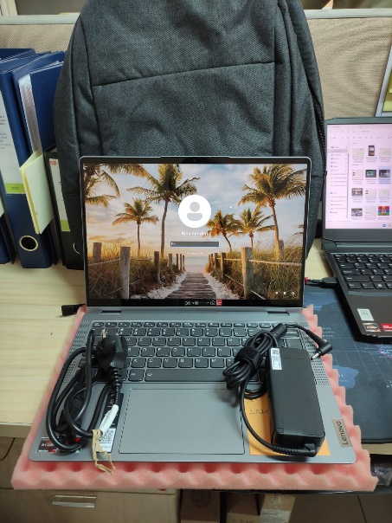
Telah diserahkan inventaris sebagai berikut :
- Laptop LENOVO IdeaPad Flex 5 14ABR8 - Type 82XX (1 Unit)
  - Processor : AMD Ryzen™ 7 7730U Processor(Ryzen™ 7 7730U)
  - Display : 14" WUXGA AMD Radeon™ Graphics
  - RAM : 1x 16GB LPD4X-4266
  - Storage : 1x 512 GB SSD PCIe
  - SN : PW09AAZC
  - Warna : Silver
- Charger Laptop (1 Unit)
- Sylus Pen Touch (1 Unit)
- Tas Laptop ASUS (1 Unit)
- Mouse Logitech M190 (1 Unit)
  - SN : 2349AP01X1J9

Kondisi : 100% (Baru)
Kepada :

Nama : Rina Sandari
Divisi : JPC PKU
NIK :
Notes :
Laptop baru untuk user, laptop lama sudah sering mati karena overheat,
Reff PWR: 2024/JKT-0116; PO: 2024/JKT-L-0086

Menerima,

Rina Sandari
Menyetujui,

Bramantya Zain

Mengetahui,

Ali Rakhman

Menyerahkan,

M N Mahmudi
BERITA ACARA SERAH TERIMA INVENTARIS
PT. JAKARTA PRIMA CRANES
Wisma JPC, Jl. Mampang Prapatan Raya No.20

No. Dokumen : IT/BAST/2024/03/05
No. Inventaris : RNS-2024-001
DEPARTEMEN GA-IT

Hari ………………, ……. ………… 2024
Telah diserahkan inventaris sebagai berikut :
- Laptop LENOVO IdeaPad Flex 5 14ABR8 - Type 82XX (1 Unit)
  - Processor : AMD Ryzen™ 7 7730U Processor(Ryzen™ 7 7730U)
  - Display : 14" WUXGA AMD Radeon™ Graphics
  - RAM : 1x 16GB LPD4X-4266
  - Storage : 1x 512 GB SSD PCIe
  - SN : PW09AAZC
  - Warna : Silver
- Charger Laptop (1 Unit)
- Sylus Pen Touch (1 Unit)
- Tas Laptop ASUS (1 Unit)
- Mouse Logitech M190 (1 Unit)
  - SN : 2349AP01X1J9

Kondisi : 100% (Baru)
Kepada :

Nama : Rina Sandari
Divisi : JPC PKU
NIK :
Notes :
Laptop baru untuk user, laptop lama sudah sering mati karena overheat,
Reff PWR: 2024/JKT-0116; PO: 2024/JKT-L-0086

Menerima,

Rina Sandari
Menyetujui,

Bramantya Zain

Mengetahui,

Ali Rakhman

Menyerahkan,

M N Mahmudi
------------------
System Information
------------------
Time of this report: 3/18/2024, 10:56:59
Machine name: RNS-2024-001
Machine Id: {BE64057F-3336-4750-898B-D8DEA723DC84}
Operating System: Windows 11 Home Single Language 64-bit (10.0, Build 22631) (22621.ni_release.220506-1250)
Language: English (Regional Setting: English)
System Manufacturer: LENOVO
System Model: 82XX
BIOS: L7CN19WW (type: UEFI)
Processor: AMD Ryzen 7 7730U with Radeon Graphics (16 CPUs), ~2.0GHz
Memory: 16384MB RAM
Available OS Memory: 14190MB RAM
Page File: 7252MB used, 9626MB available
Windows Dir: C:\Windows
DirectX Version: DirectX 12
---------------
Display Devices
---------------
Card name: AMD Radeon (TM) Graphics
Manufacturer: Advanced Micro Devices, Inc.
Chip type: AMD Radeon Graphics Processor (0x15E7)
DAC type: Internal DAC(400MHz)
Device Type: Full Device (POST)
Device Key: Enum\PCI\VEN_1002&DEV_15E7&SUBSYS_380617AA&REV_C4
Device Status: 0180200A [DN_DRIVER_LOADED|DN_STARTED|DN_DISABLEABLE|DN_NT_ENUMERATOR|DN_NT_DRIVER]
Device Problem Code: No Problem
Driver Problem Code: Unknown
Display Memory: 9126 MB
Dedicated Memory: 2031 MB
Shared Memory: 7095 MB
Current Mode: 1920 x 1200 (32 bit) (60Hz)
------------------------
Disk & DVD/CD-ROM Drives
------------------------
Drive: C:
Free Space: 135.6 GB
Total Space: 206.1 GB
File System: NTFS
Model: WD PC SN740 SDDPMQD-512G-1101

Drive: E:
Free Space: 279.9 GB
Total Space: 280.0 GB
File System: NTFS
Model: WD PC SN740 SDDPMQD-512G-1101

LABEL DI BELAKANG LAPTOP

NO INVENTARIS
RNS | - | 2024 | - | 001
NO INVENTARIS
RNS | - | 2024 | - | 001

EMAIL MS | pw09aazc@outlook.com
PASS | JpcOffice2024
DATE | 18 / 03 / 2024
BAST | IT/BAST/2024/03/005
USER | RINA SANDARI
EMAIL MS | pw09aazc@outlook.com
PASS | JpcOffice2024
DATE | 18 / 03 / 2024
BAST | IT/BAST/2024/03/005
USER | RINA SANDARI

PWR | 2024/JKT-0116
PO | 2024/JKT-L-0086
PWR | 2024/JKT-0116
PO | 2024/JKT-L-0086

LABEL DI CHARGER
NO INVENTARIS
RNS | - | 2024 | - | 001

LABEL DI BOX LAPTOP
NO INVENTARIS
RNS | - | 2024 | - | 001

EMAIL MS | pw09aazc@outlook.com
PASS | JpcOffice2024
TGL | 18 / 03 / 2024
BA | IT/BAST/2024/03/005
USER | RINA SANDARI

PWR | 2024/JKT-0116
PO | 2024/JKT-L-0086

LABEL DI KARTU GARANSI
NO INVENTARIS
RNS | - | 2024 | - | 001

EMAIL MS | pw09aazc@outlook.com
PASS | JpcOffice2024
TGL | 18 / 03 / 2024
BA | IT/BAST/2024/03/005
USER | RINA SANDARI

PWR | 2024/JKT-0116
PO | 2024/JKT-L-0086

LABEL DI LISENSI OFFICE

