BERITA ACARA SERAH TERIMA INVENTARIS
PT. JAKARTA PRIMA CRANES
Wisma JPC, Jl. Mampang Prapatan Raya No.20

No. Dokumen : IT/BAST/2024/04/05
No. Inventaris : MHZ-2024-001
DEPARTEMEN GA-IT

Hari ………………, ……. ………… 2024
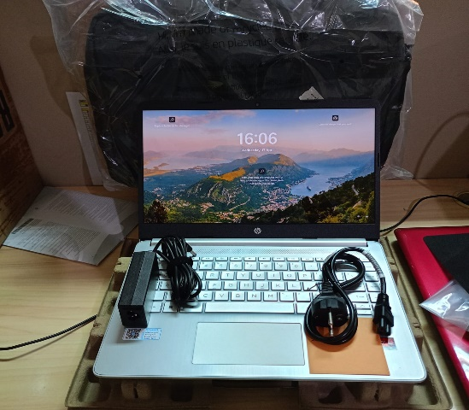
Telah diserahkan inventaris sebagai berikut :
- HP Laptop 14s-fq1135AU (8G1D0PA) (1 Unit)
  - Processor : AMD Ryzen™ 5 5500U (up to 4.0 GHz max boost clock, 8 MB L3 cache, 6 cores, 12 threads)
  - Display : 14" WUXGA Intel® Iris® Xe Graphics
  - RAM 8 GB DDR4-3200 MHz RAM (1 x 8 GB))
  - Storage : 1x 512 GB SSD PCIe
  - SN : 5CD324QSCT
  - Warna : SILVER
- Charger Laptop (1 Unit)
- Tas Laptop HP (1 Unit)

Kondisi : 100% (Baru)
Kepada :

Nama : Moch Fauzan
Divisi : JPC SBY
NIK :

Notes :
Laptop Baru untuk user, PWR: 2024/SBY-0013 R2 PO: 2024/SBY-L- 0020;
Include Office Pro Plus 2021 PWR: 2024/SBY-0027 PO: 2024/SBY-L-0020

Mengetahui,

Ali Rakhman

Menerima,

Moch Fauzan
Menyetujui,

Bramantya Zain

Menyerahkan,

M N Mahmudi
BERITA ACARA SERAH TERIMA INVENTARIS
PT. JAKARTA PRIMA CRANES
Wisma JPC, Jl. Mampang Prapatan Raya No.20

No. Dokumen : IT/BAST/2024/04/05
No. Inventaris : MHZ-2024-001
DEPARTEMEN GA-IT
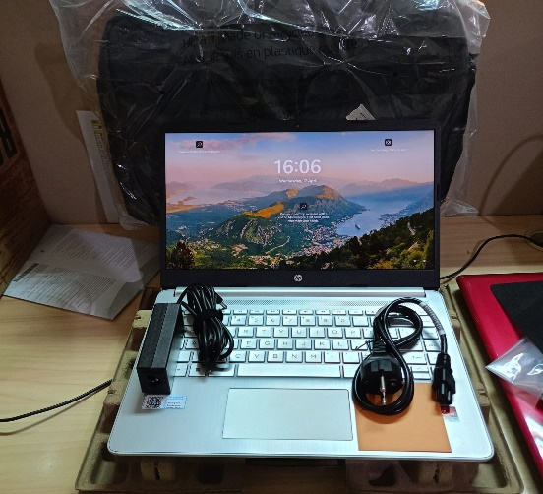
Hari ………………, ……. ………… 2024
Telah diserahkan inventaris sebagai berikut
- Laptop HP Laptop 14s-fq1135AU (8G1D0PA) (1 Unit) Processor : AMD Ryzen™ 5 5500U (up to 4.0 GHz max boost clock, 8 MB L3 cache, 6 cores, 12 threads)
  - Display : 14" WUXGA Intel® Iris® Xe Graphics
  - RAM : 8 GB DDR4-3200 MHz RAM (1 x 8 GB)
  - Storage : 1x 512 GB PCIe® NVMe™ M.2 SSD
  - SN : 5CD324QSCT
  - Warna : SILVER.
- Charger Laptop (1 Unit)
- Tas Laptop HP (1 Unit)

Kondisi : 100% (Baru)
Kepada :

Nama : Moch Fauzan
Divisi : JPC SBY
NIK :

Notes :
Laptop Baru untuk user, PWR: 2024/SBY-0013 R2 PO: 2024/SBY-L- 0020;
Include Office Pro Plus 2021 PWR: 2024/SBY-0027 PO: 2024/SBY-L-0020

Menerima,

Moch Fauzan
Menyetujui,

Bramantya Zain

Mengetahui,

Ali Rakhman

Menyerahkan,

M N Mahmudi
------------------
System Information
------------------
Time of this report: 4/17/2024, 16:26:56
Machine name: MHZ-2024-001
Machine Id: {085F56DA-C90C-4D97-B5AF-19D406893F22}
Operating System: Windows 11 Home Single Language 64-bit (10.0, Build 22621) (22621.ni_release.220506-1250)
Language: English (Regional Setting: English)
System Manufacturer:sor: AMD Ryzen 5 5500U with Radeon Graphics (12 CPUs), ~2.1GHz
Memory: 8192MB RAM
Available OS Memory: 7502MB RAM
Page File: 4225MB used, 5133MB available
Windows Dir: C:\windows
DirectX Version: DirectX 12 HP
---------------
Display Devices
---------------
Card name: AMD Radeon(TM) Graphics
Manufacturer: Advanced Micro Devices, Inc.
Chip type: AMD Radeon Graphics Processor (0x164C)
DAC type: Internal DAC(400MHz)
Device Type: Full Device (POST)
Device Key: Enum\PCI\VEN_1002&DEV_164C&SUBSYS_887C103C&REV_C2
Device Status: 0180200A [DN_DRIVER_LOADED|DN_STARTED|DN_DISABLEABLE|DN_NT_ENUMERATOR|DN_NT_DRIVER]
Device Problem Code: No Problem
Driver Problem Code: Unknown
Display Memory: 4246 MB
Dedicated Memory: 495 MB
Shared Memory: 3751 MB
Current Mode: 1920 x 1080 (32 bit) (60Hz)
------------------------
Disk & DVD/CD-ROM Drives
------------------------
Drive: C:
Free Space: 223.8 GB
Total Space: 287.5 GB
File System: NTFS
Model: SK hynix BC711 HFM512GD3JX013N

Drive: D:
Free Space: 199.9 GB
Total Space: 200.0 GB
File System: NTFS
Model: SK hynix BC711 HFM512GD3JX013N

LABEL DI BELAKANG LAPTOP

NO INVENTARIS
MHZ | - | 2024 | - | 001
NO INVENTARIS
MHZ | - | 2024 | - | 001

EMAIL MS | cd324qsct@outlook.com
PASS | JpcOffice2024
DATE | 17 / 04 / 2024
BAST | IT/BAST/2024/04/005
USER | MOCH FAUZAN
EMAIL MS | cd324qsct@outlook.com
PASS | JpcOffice2024
DATE | 17 / 04 / 2024
BAST | IT/BAST/2024/04/005
USER | MOCH FAUZAN

PWR | 2024/SBY-0013 R2
PO | 2024/SBY-L-0019
PWR | 2024/SBY-0013 R2
PO | 2024/SBY-L-0019

LABEL DI CHARGER
NO INVENTARIS
MHZ | - | 2024 | - | 001

LABEL DI BOX LAPTOP
NO INVENTARIS
MHZ | - | 2024 | - | 001

EMAIL MS | cd324qsct@outlook.com
PASS | JpcOffice2024
DATE | 17 / 04 / 2024
BAST | IT/BAST/2024/04/005
USER | MOCH FAUZAN

PWR | 2024/SBY-0013 R2
PO | 2024/SBY-L-0019

LABEL DI KARTU GARANSI
NO INVENTARIS
MHZ | - | 2024 | - | 001

EMAIL MS | cd324qsct@outlook.com
PASS | JpcOffice2024
DATE | 17 / 04 / 2024
BAST | IT/BAST/2024/04/005
USER | MOCH FAUZAN

PWR | 2024/SBY-0013 R2
PO | 2024/SBY-L-0019

LABEL DI LISENSI OFFICE

