BERITA ACARA SERAH TERIMA INVENTARIS
PT. JAKARTA PRIMA CRANES
Wisma JPC, Jl. Mampang Prapatan Raya No.20

No. Dokumen : IT/BAST/2025/02/04
No. Inventaris : 6.2025/LT54.3/WS1LT2
DEPARTEMEN GA-IT

Hari ………………, ……. ………… 2025
Telah diserahkan inventaris sebagai berikut :
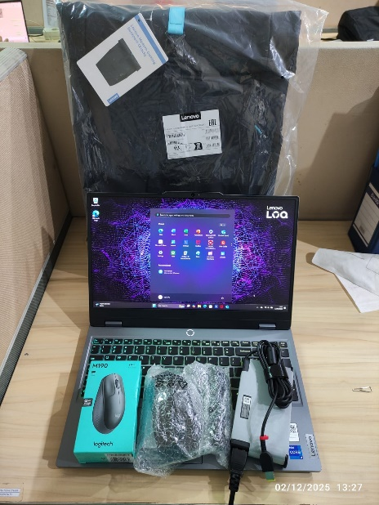
- Laptop LENOVO LOQ 15IRX9 - Type 83DV (1 UNIT)
  - Processor : 13th Generation Intel® Core™ i7-13650HX Processor(Core™ i7-13650HX)
  - Display : NVIDIA® GeForce RTX™ 4050 6GB 15.6'' FHD
  - RAM : 1x 12 GB DDR5-4800 (EXTEND TO 16GB)
  - Storage : 1x 512 GB SSD PCIe (EXTEND TO 1TB)
  - SN : MP2QQJDB
  - Warna : Luna Grey
- Charger Laptop (1 Unit)
- Tas Laptop Lenovo (1 Unit)
- Mouse LOQ (1 Unit)
- Mouse Logitech M190 (1 Unit)

Kepada :
Nama : Marena Agust
Divisi : FA
NIK :

Notes :
Laptop Baru Untuk FA Marena Agust
REFF PWR : 2025/JKT-0060; REFF PO : 2025/JKT-L-0037

BERITA ACARA SERAH TERIMA INVENTARIS
Menerima,

Marena Agust
Menyerahkan,

M N Mahmudi
Mengetahui,

Ali Rakhman

Menyetujui,

Bramantya Zain

PT. JAKARTA PRIMA CRANES
Wisma JPC, Jl. Mampang Prapatan Raya No.20

No. Dokumen : IT/BAST/2025/02/04
No. Inventaris : 6.2025/LT54.3/WS1LT2
DEPARTEMEN GA-IT

Hari ………………, ……. ………… 2025
Telah diserahkan inventaris sebagai berikut :
- Laptop LENOVO LOQ 15IRX9 - Type 83DV (1 UNIT)
  - Processor : 13th Generation Intel® Core™ i7-13650HX Processor(Core™ i7-13650HX)
  - Display : NVIDIA® GeForce RTX™ 4050 6GB 15.6'' FHD
  - RAM : 1x 12 GB DDR5-4800 (EXTEND TO 16GB)
  - Storage : 1x 512 GB SSD PCIe (EXTEND TO 1TB)
  - SN : MP2QQJDB
  - Warna : Luna Grey
- Charger Laptop (1 Unit)
- Tas Laptop Lenovo (1 Unit)
- Mouse LOQ (1 Unit)
- Mouse Logitech M190 (1 Unit)

Kepada :
Nama : Marena Agust
Divisi : FA
NIK :

Notes :
Laptop Baru Untuk FA Marena Agust
REFF PWR : 2025/JKT-0060; REFF PO : 2025/JKT-L-0037

Menerima,

Marena Agust
Menyerahkan,

M N Mahmudi
Mengetahui,

Ali Rakhman

Menyetujui,

Bramantya Zain

------------------
System Information
------------------
Time of this report: 2/12/2025, 13:22:27
Machine name: LAPTOP-BFGT7SPF
Machine Id: {B9CE06A4-0AA2-4B8D-BCDC-975FC6961595}
Operating System: Windows 11 Home Single Language 64-bit (10.0, Build 26100) (26100.ge_release.240331-1435)
Language: English (Regional Setting: English)
System Manufacturer: LENOVO
System Model: 83DV
BIOS: NECN40WW (type: UEFI)
Processor: 13th Gen Intel(R) Core(TM) i7-13650HX (20 CPUs), ~2.6GHz
Memory: 16384MB RAM
Available OS Memory: 16092MB RAM
Page File: 6266MB used, 12769MB available
Windows Dir: C:\Windows
DirectX Version: DirectX 12
---------------
Display Devices
---------------
Card name: NVIDIA GeForce RTX 4050 Laptop GPU
Manufacturer: NVIDIA
Chip type: NVIDIA GeForce RTX 4050 Laptop GPU
DAC type: Integrated RAMDAC
Device Type: Full Device
Device Key: Enum\PCI\VEN_10DE&DEV_28E1&SUBSYS_3D0617AA&REV_A1
Device Status: 0180600A [DN_DRIVER_LOADED|DN_STARTED|DN_DISABLEABLE|DN_REMOVABLE|DN_NT_ENUMERATOR|DN_NT_DRIVER]
Device Problem Code: No Problem
Driver Problem Code: Unknown
Display Memory: 13966 MB
Dedicated Memory: 5921 MB
Shared Memory: 8045 MB
------------------------
Disk & DVD/CD-ROM Drives
------------------------
Drive: C:
Free Space: 880.8 GB
Total Space: 951.6 GB
File System: NTFS
Model: KINGSTON SNV3S1000G

LABEL DI BELAKANG LAPTOP

NO INVENTARIS
6.2025/LT54.3/WS1LT2
NO INVENTARIS
6.2025/LT54.3/WS1LT2

EMAIL MS | MP2QQJDB@outlook.com
PASS | JpcOffice2025
DATE | 12 / 2 / 2025
BAST | IT/BAST/2025/02/04
USER | MARENA AGUST
EMAIL MS | MP2QQJDB@outlook.com
PASS | JpcOffice2025
DATE | 12 / 2 / 2025
BAST | IT/BAST/2025/02/04
USER | MARENA AGUST

PWR | 2025/JKT-0060
PO | 2025/JKT-L-0037
PWR | 2025/JKT-0060
PO | 2025/JKT-L-0037

LABEL DI CHARGER
NO INVENTARIS
6.2025/LT54.3/WS1LT2

LABEL DI BOX LAPTOP
NO INVENTARIS
6.2025/LT54.3/WS1LT2

EMAIL MS | MP2QQJDB@outlook.com
PASS | JpcOffice2025
DATE | 12 / 2 / 2025
BAST | IT/BAST/2025/02/04
USER | MARENA AGUST

PWR | 2025/JKT-0060
PO | 2025/JKT-L-0037

LABEL DI KARTU GARANSI
NO INVENTARIS
6.2025/LT54.3/WS1LT2

EMAIL MS | MP2QQJDB@outlook.com
PASS | JpcOffice2025
DATE | 12 / 2 / 2025
BAST | IT/BAST/2025/02/04
USER | MARENA AGUST

PWR | 2025/JKT-0060
PO | 2025/JKT-L-0037

