BERITA ACARA SERAH TERIMA INVENTARIS
PT. JAKARTA PRIMA CRANES
Wisma JPC, Jl. Mampang Prapatan Raya No.20

No. Dokumen : IT/BAST/2024/05/01
No. Inventaris : QC-2024-001
DEPARTEMEN GA-IT

Hari ………………, ……. ………… 2024
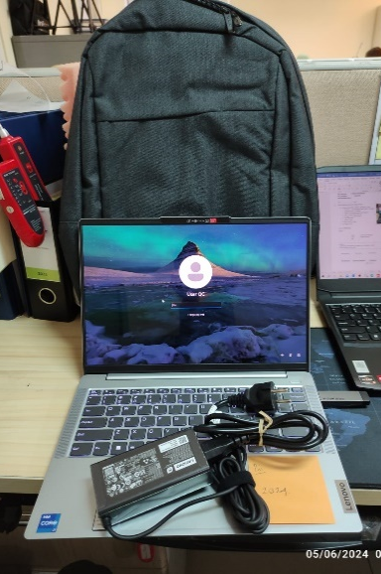
Telah diserahkan inventaris sebagai berikut :
- Laptop IdeaPad Slim 5 14IRL8 - Type 82XD (1 Unit)
  - Processor : 13th Generation Intel® Core™ i7-13620H Processor(Core™ i7-13620H)
  - Display : 14" WUXGA Intel® UHD Graphics
  - RAM : 16GBLPDDR5-5200 (1x)
  - Storage : 1x 512 GB SSD PCIe
  - SN : MP2KT245
  - Warna : Silver
- Charger Laptop (1 Unit)
- Tas Laptop (1 Unit)
Kondisi : 100% (Baru)
Kepada :

Nama : Sendi Dwi Oktaviandi
Divisi : Quality Control
NIK :

Notes :
Laptop Baru untuk New QC Inspector, PO: 2024/JKT-L- 0150;
Include Office Pro Plus 2021 PO: 2024/JKT-L- 0153;

Menerima,

Sendi Dwi Oktaviandi
Mengetahui,

Ali Rakhman

Menyetujui,

Bramantya Zain

Menyerahkan,

M N Mahmudi
BERITA ACARA SERAH TERIMA INVENTARIS
PT. JAKARTA PRIMA CRANES
Wisma JPC, Jl. Mampang Prapatan Raya No.20

No. Dokumen : IT/BAST/2024/05/01
No. Inventaris : QC-2024-001
DEPARTEMEN GA-IT

Hari ………………, ……. ………… 2024
Telah diserahkan inventaris sebagai berikut :
- Laptop IdeaPad Slim 5 14IRL8 - Type 82XD (1 Unit)
  - Processor : 13th Generation Intel® Core™ i7-13620H Processor(Core™ i7-13620H)
  - Display : 14" WUXGA Intel® UHD Graphics
  - RAM : 16GBLPDDR5-5200 (1x)
  - Storage : 1x 512 GB SSD PCIe
  - SN : MP2KT245
  - Warna : Silver
- Charger Laptop (1 Unit)
- Tas Laptop (1 Unit)
Kondisi : 100% (Baru)
Kepada :

Nama : Sendi Dwi Oktaviandi
Divisi : Quality Control
NIK :

Notes :
Laptop Baru untuk New QC Inspector, PO: 2024/JKT-L- 0150;
Include Office Pro Plus 2021 PO: 2024/JKT-L- 0153;

Menerima,

Sendi Dwi Oktaviandi
Mengetahui,

Ali Rakhman

Menyetujui,

Bramantya Zain

Menyerahkan,

M N Mahmudi
------------------
System Information
------------------
Time of this report: 5/6/2024, 08:48:08
Machine name: LAPTOP-I0V1217H
Machine Id: {D86997FF-F792-47BD-9D01-56218A61F66B}
Operating System: Windows 11 Home Single Language 64-bit (10.0, Build 22631) (22621.ni_release.220506-1250)
Language: English (Regional Setting: English)
System Manufacturer: LENOVO
System Model: 82XD
BIOS: LACN29WW (type: UEFI)
Processor: 13th Gen Intel(R) Core(TM) i7-13620H (16 CPUs), ~2.4GHz
Memory: 16384MB RAM
Available OS Memory: 16108MB RAM
Page File: 7839MB used, 11212MB available
Windows Dir: C:\Windows
DirectX Version: DirectX 12
---------------
Display Devices
---------------
Card name: Intel(R) UHD Graphics
Manufacturer: Intel Corporation
Chip type: Intel(R) UHD Graphics Family
DAC type: Internal
Device Type: Full Device (POST)
Device Key: Enum\PCI\VEN_8086&DEV_A7A8&SUBSYS_3C4417AA&REV_04
Device Status: 0180200A [DN_DRIVER_LOADED|DN_STARTED|DN_DISABLEABLE|DN_NT_ENUMERATOR|DN_NT_DRIVER]
Device Problem Code: No Problem
Driver Problem Code: Unknown
Display Memory: 8181 MB
Dedicated Memory: 128 MB
Shared Memory: 8053 MB
------------------------
Disk & DVD/CD-ROM Drives
------------------------
Drive: C:
Free Space: 124.6 GB
Total Space: 206.1 GB
File System: NTFS
Model: SKHynix_HFS512GEJ4X112N

Drive: D:
Free Space: 279.9 GB
Total Space: 280.0 GB
File System: NTFS
Model: SKHynix_HFS512GEJ4X112N

LABEL DI BELAKANG LAPTOP

NO INVENTARIS
QC | - | 2024 | - | 001
NO INVENTARIS
QC | - | 2024 | - | 001

EMAIL MS | cd2097fty@outlook.com
PASS | JpcOffice2024
DATE | 17 / 04 / 2024
BAST | IT/BAST/2024/05/001
USER | INSPECTOR QC
EMAIL MS | cd2097fty@outlook.com
PASS | JpcOffice2024
DATE | 17 / 04 / 2024
BAST | IT/BAST/2024/04/008
USER | JOKO TRIWASONO PUTRO

PWR | 2024/SBY-0013 R2
PO | 2024/SBY-L-0019
PWR | 2024/SBY-0027
PO | 2024/SBY-L-0020

LABEL DI CHARGER
NO INVENTARIS
JKT | - | 2024 | - | 001

LABEL DI BOX LAPTOP
NO INVENTARIS
JKT | - | 2024 | - | 001

EMAIL MS | cd2097fty@outlook.com
PASS | JpcOffice2024
DATE | 17 / 04 / 2024
BAST | IT/BAST/2024/04/008
USER | JOKO TRIWASONO PUTRO

PWR | 2024/SBY-0013 R2
PO | 2024/SBY-L-0019

LABEL DI KARTU GARANSI
NO INVENTARIS
JKT | - | 2024 | - | 001

EMAIL MS | cd2097fty@outlook.com
PASS | JpcOffice2024
DATE | 17 / 04 / 2024
BAST | IT/BAST/2024/04/008
USER | JOKO TRIWASONO PUTRO

PWR | 2024/SBY-0013 R2
PO | 2024/SBY-L-0019

LABEL DI LISENSI OFFICE

