BERITA ACARA SERAH TERIMA INVENTARIS
PT. JAKARTA PRIMA CRANES
Wisma JPC, Jl. Mampang Prapatan Raya No.20

No. Dokumen : IT/BAST/2024/04/07
No. Inventaris : HNW-2024-001
DEPARTEMEN GA-IT

Hari ………………, ……. ………… 2024
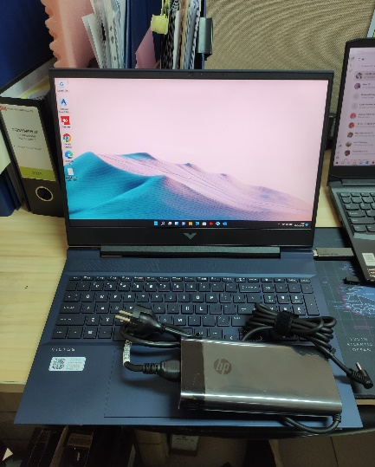
Telah diserahkan inventaris sebagai berikut :
- Laptop HP Victus 16-e0085AX (492K3PA) (8G1D0PA) (1 Unit)
  - Processor : AMD Ryzen™ 7 5800H (up to 4.4 GHz max boost clock, 16 MB L3 cache, 8 cores, 16 threads)
  - Display : NVIDIA® GeForce RTX™ 3060 Laptop GPU (6 GB GDDR6 dedicated)
  - RAM : 16 GB DDR4-3200 MHz RAM (2 x 8 GB)
  - Storage : 1x 512 GB PCIe® NVMe™ TLC M.2 SSD
  - SN : 5CD2097FS2
  - Warna : Performance blue
- Charger Laptop (1 Unit)

Kondisi : 100% (Baru)
Kepada :

Nama : Henneko Purwanto
Divisi : JPC SBY
NIK :

Notes :
Laptop Baru untuk user, PWR: 2024/SBY-0013 R2 PO: 2024/SBY-L- 0020;
Include Office Pro Plus 2021 PWR: 2024/SBY-0027 PO: 2024/SBY-L-0020

Mengetahui,

Ali Rakhman

Menerima,

Henneko Purwanto
Menyetujui,

Bramantya Zain

Menyerahkan,

M N Mahmudi
BERITA ACARA SERAH TERIMA INVENTARIS
PT. JAKARTA PRIMA CRANES
Wisma JPC, Jl. Mampang Prapatan Raya No.20

No. Dokumen : IT/BAST/2024/04/07
No. Inventaris : HNW-2024-001
DEPARTEMEN GA-IT

Hari ………………, ……. ………… 2024
Telah diserahkan inventaris sebagai berikut :
- Laptop HP Victus 16-e0085AX (492K3PA) (8G1D0PA) (1 Unit)
  - Processor : AMD Ryzen™ 7 5800H (up to 4.4 GHz max boost clock, 16 MB L3 cache, 8 cores, 16 threads)
  - Display : NVIDIA® GeForce RTX™ 3060 Laptop GPU (6 GB GDDR6 dedicated)
  - RAM : 16 GB DDR4-3200 MHz RAM (2 x 8 GB)
  - Storage : 1x 512 GB PCIe® NVMe™ TLC M.2 SSD
  - SN : 5CD2097FS2
  - Warna : Performance blue
- Charger Laptop (1 Unit)

Kondisi : 100% (Baru)
Kepada :

Nama : Henneko Purwanto
Divisi : JPC SBY
NIK :

Notes :
Laptop Baru untuk user, PWR: 2024/SBY-0013 R2 PO: 2024/SBY-L- 0020;
Include Office Pro Plus 2021 PWR: 2024/SBY-0027 PO: 2024/SBY-L-0020

Mengetahui,

Ali Rakhman

Menerima,

Henneko Purwanto
Menyetujui,

Bramantya Zain

Menyerahkan,

M N Mahmudi
------------------
System Information
------------------
Time of this report: 4/18/2024, 11:27:58
Machine name: HNW-2024-001
Machine Id: {78DB06AA-212A-498D-8621-BBEC70B495C6}
Operating System: Windows 11 Home Single Language 64-bit (10.0, Build 22000) (22000.co_release.210604-1628)
Language: English (Regional Setting: English)
System Manufacturer: HP
System Model: Victus by HP Laptop 16-e0xxx
BIOS: F.12 (type: UEFI)
Processor: AMD Ryzen 7 5800H with Radeon Graphics (16 CPUs), ~3.2GHz
Memory: 16384MB RAM
Available OS Memory: 15716MB RAM
Page File: 8471MB used, 10188MB available
Windows Dir: C:\windows
DirectX Version: DirectX 12
---------------
Display Devices
---------------
Card name: NVIDIA GeForce RTX 3060 Laptop GPU
Manufacturer: NVIDIA
Chip type: NVIDIA GeForce RTX 3060 Laptop GPU
DAC type: Integrated RAMDAC
Device Type: Full Device
Device Key: Enum\PCI\VEN_10DE&DEV_2520&SUBSYS_88EE103C&REV_A1
Device Status: 0180200A [DN_DRIVER_LOADED|DN_STARTED|DN_DISABLEABLE|DN_NT_ENUMERATOR|DN_NT_DRIVER]
Device Problem Code: No Problem
Driver Problem Code: Unknown
Display Memory: 13881 MB
Dedicated Memory: 6023 MB
Shared Memory: 7858 MB
------------------------
Disk & DVD/CD-ROM Drives
------------------------
Drive: C:
Free Space: 203.2 GB
Total Space: 287.5 GB
File System: NTFS
Model: SK hynix PC711 HFS512GDE9X073N

Drive: E:
Free Space: 171.4 GB
Total Space: 200.0 GB
File System: NTFS
Model: SK hynix PC711 HFS512GDE9X073N

LABEL DI BELAKANG LAPTOP

NO INVENTARIS
HNW | - | 2024 | - | 001
NO INVENTARIS
HNW | - | 2024 | - | 001

EMAIL MS | cd2097fs2@outlook.com
PASS | JpcOffice2024
DATE | 17 / 04 / 2024
BAST | IT/BAST/2024/04/007
USER | HENNEKO PURWANTO
EMAIL MS | cd2097fs2@outlook.com
PASS | JpcOffice2024
DATE | 17 / 04 / 2024
BAST | IT/BAST/2024/04/007
USER | HENNEKO PURWANTO

PWR | 2024/SBY-0013 R2
PO | 2024/SBY-L-0019
PWR | 2024/SBY-0027
PO | 2024/SBY-L-0020

LABEL DI CHARGER
NO INVENTARIS
HNW | - | 2024 | - | 001

LABEL DI BOX LAPTOP
NO INVENTARIS
HNW | - | 2024 | - | 001

EMAIL MS | cd2097fs2@outlook.com
PASS | JpcOffice2024
DATE | 17 / 04 / 2024
BAST | IT/BAST/2024/04/007
USER | HENNEKO PURWANTO

PWR | 2024/SBY-0013 R2
PO | 2024/SBY-L-0019

LABEL DI KARTU GARANSI
NO INVENTARIS
HNW | - | 2024 | - | 001

EMAIL MS | cd2097fs2@outlook.com
PASS | JpcOffice2024
DATE | 17 / 04 / 2024
BAST | IT/BAST/2024/04/007
USER | HENNEKO PURWANTO

PWR | 2024/SBY-0013 R2
PO | 2024/SBY-L-0019

LABEL DI LISENSI OFFICE

