BERITA ACARA SERAH TERIMA INVENTARIS
PT. JAKARTA PRIMA CRANES
Wisma JPC, Jl. Mampang Prapatan Raya No.20

No. Dokumen : IT/BAST/2024/03/01
No. Inventaris : PNA-2024-001
DEPARTEMEN GA-IT

Hari ………………, ……. ………… 2024
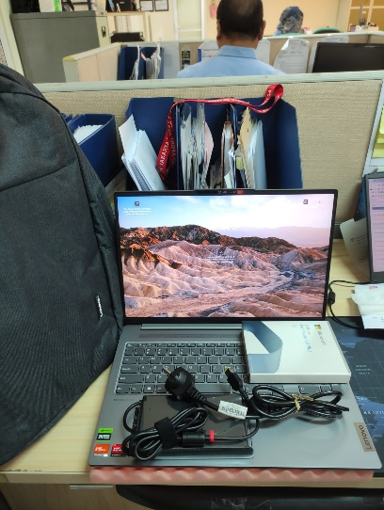
Telah diserahkan inventaris sebagai berikut :
- Laptop LENOVO IdeaPad Pro 5 16APH8 - Type 83AR (1 Unit)
  - Processor : AMD Ryzen™ 7 7840HS Processor(Ryzen™ 7 7840HS)
  - Display : 16" WQXGA NVIDIA® GeForce RTX™ 3050 6GB
  - RAM : 1x 16GB LPD5X-6400
  - Storage : 1x 1 TB SSD PCIe
  - SN : PF4NVKNL
  - Warna : Arctic Grey
- Charger Laptop (1 Unit)
- Tas Laptop LENOVO (1 Unit)
- Mouse Logitech M170 (1 Unit)

Kondisi : 100% (Baru)
Kepada :

Nama : Pinawaty
Divisi : Project Control
NIK :

Notes :
Laptop baru untuk user,
Reff PO: 2024/JKT-L-0047, Inc Office Pro Plus 2021

Menerima,

Pinawaty
Menyetujui,

Bramantya Zain

Mengetahui,

Ali Rakhman

Menyerahkan,

M N Mahmudi
BERITA ACARA SERAH TERIMA INVENTARIS
PT. JAKARTA PRIMA CRANES
Wisma JPC, Jl. Mampang Prapatan Raya No.20

No. Dokumen : IT/BAST/2024/03/01
No. Inventaris : PNA-2024-001
DEPARTEMEN GA-IT

Hari ………………, ……. ………… 2024
Telah diserahkan inventaris sebagai berikut :
- Laptop LENOVO IdeaPad Pro 5 16APH8 - Type 83AR (1 Unit)
  - Processor : AMD Ryzen™ 7 7840HS Processor(Ryzen™ 7 7840HS)
  - Display : 16" WQXGA NVIDIA® GeForce RTX™ 3050 6GB
  - RAM : 1x 16GB LPD5X-6400
  - Storage : 1x 1 TB SSD PCIe
  - SN : PF4NVKNL
  - Warna : Arctic Grey
- Charger Laptop (1 Unit)
- Tas Laptop LENOVO (1 Unit)
- Mouse Logitech M170 (1 Unit)

Kondisi : 100% (Baru)
Kepada :

Nama : Pinawaty
Divisi : Project Control
NIK :

Notes :
Laptop baru untuk user,
Reff PO: 2024/JKT-L-0047, Inc Office Pro Plus 2021

Menerima,

Pinawaty
Menyetujui,

Bramantya Zain

Mengetahui,

Ali Rakhman

Menyerahkan,

M N Mahmudi
------------------
System Information
------------------
Time of this report: 3/6/2024, 13:30:12
Machine name: PNA-2024-001
Machine Id: {8923609D-CC64-436D-97D8-F11BD52AA9EB}
Operating System: Windows 11 Home Single Language 64-bit (10.0, Build 22631) (22621.ni_release.220506-1250)
Language: English (Regional Setting: English)
System Manufacturer: LENOVO
System Model: 83AR
BIOS: MDCN27WW (type: UEFI)
Processor: AMD Ryzen 7 7840HS with Radeon 780M Graphics (16 CPUs), ~3.8GHz
Memory: 16384MB RAM
Available OS Memory: 14148MB RAM
Page File: 10808MB used, 6027MB available
Windows Dir: C:\Windows
DirectX Version: DirectX 12
---------------
Display Devices
---------------
Card name: NVIDIA GeForce RTX 3050 6GB Laptop GPU
Manufacturer: NVIDIA
Chip type: NVIDIA GeForce RTX 3050 6GB Laptop GPU
DAC type: Integrated RAMDAC
Device Type: Full Device
Device Key: Enum\PCI\VEN_10DE&DEV_25EC&SUBSYS_3CCB17AA&REV_A1
Device Status: 0180600A [DN_DRIVER_LOADED|DN_STARTED|DN_DISABLEABLE|DN_REMOVABLE|DN_NT_ENUMERATOR|DN_NT_DRIVER]
Device Problem Code: No Problem
Driver Problem Code: Unknown
Display Memory: 13089 MB
Dedicated Memory: 6016 MB
Shared Memory: 7073 MB
------------------------
Disk & DVD/CD-ROM Drives
------------------------
Drive: C:
Free Space: 395.8 GB
Total Space: 474.5 GB
File System: NTFS
Model: SKHynix_HFS001TEJ4X112N

Drive: D:
Free Space: 287.3 GB
Total Space: 500.0 GB
File System: NTFS
Model: SKHynix_HFS001TEJ4X112N

LABEL DI BELAKANG LAPTOP

NO INVENTARIS
PNA | - | 2024 | - | 001

EMAIL MS | mp2488lx@outlook.com
PASS | sarah / SARAH
DATE | 06 / 03 / 2024
BAST | IT/BAST/2024/03/001
USER | PINAWATY

PWR | 2024/JKT-0114
PO | 2024/JKT-L-0047

LABEL DI CHARGER
NO INVENTARIS
PNA | - | 2024 | - | 001

LABEL DI BOX LAPTOP
NO INVENTARIS
PNA | - | 2024 | - | 001

EMAIL MS | mp2488lx@outlook.com
PASS | sarah / SARAH
TGL | 06 / 03 / 2024
BA | IT/BAST/2024/03/001
USER | PINAWATY

PWR | 2024/JKT-0114
PO | 2024/JKT-L-0047

LABEL DI KARTU GARANSI
NO INVENTARIS
PNA | - | 2024 | - | 001

EMAIL MS | mp2488lx@outlook.com
PASS | sarah / SARAH
TGL | 06 / 03 / 2024
BA | IT/BAST/2024/03/001
USER | PINAWATY

PWR | 2024/JKT-0114
PO | 2024/JKT-L-0047

