BERITA ACARA SERAH TERIMA INVENTARIS
PT. JAKARTA PRIMA CRANES
Wisma JPC, Jl. Mampang Prapatan Raya No.20

No. Dokumen : GA/2023/05/005
No. Inventaris : SRS-2023-001
DEPARTEMEN GA-IT

Hari ………………, ……. ………… 2023
Telah diserahkan inventaris sebagai berikut :
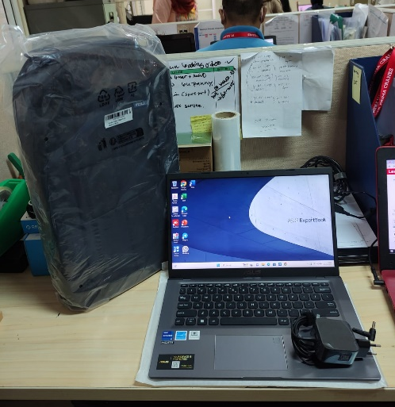
- Laptop ASUS P1412CEA-EK7851WS (1 Unit)
  - Processor : Intel® Core™ i7-1165G7 Processor 2.8 GHz (12M Cache, up to 4.7 GHz, 4 cores)
  - Display : 14.0-inch, FHD (1920 x 1080) 16:9, TN, Anti-glare display, LED Backlit, NTSC: 45%, Screen-to-body ratio:82 %
  - RAM : 1x 8G DDR4 on board
  - Storage : 1TB M.2 NVMe™ PCIe® 3.0 SSD
  - SN : N8NXCV11J79735D
  - Warna : GREY
- Charger Laptop (1 Unit)
- Tas Gendong Laptop ASUS (1 Unit)
- Mouse Logitech M170 (1 Unit)
  - SN : 2237LZX02TD9

Kondisi : 100% (Baru)
Kepada :
Nama : Sri Suparyanti
Divisi : FA
NIK :
Notes :
User menggunakan laptop inventaris baru.

Menyetujui,

( Bramantya Zain )
Menyerahkan,

( M Nurhasan Mahmudi )
Menerima,

( Sri Suparyanti )
BERITA ACARA SERAH TERIMA INVENTARIS
PT. JAKARTA PRIMA CRANES
Wisma JPC, Jl. Mampang Prapatan Raya No.20

No. Dokumen : GA/2023/05/005
No. Inventaris : SRS-2023-001
DEPARTEMEN GA-IT

Hari ………………, ……. ………… 2023
Telah diserahkan inventaris sebagai berikut :
- Laptop ASUS P1412CEA-EK7851WS (1 Unit)
  - Processor : Intel® Core™ i7-1165G7 Processor 2.8 GHz (12M Cache, up to 4.7 GHz, 4 cores)
  - Display : 14.0-inch, FHD (1920 x 1080) 16:9, TN, Anti-glare display, LED Backlit, NTSC: 45%, Screen-to-body ratio:82 %
  - RAM : 1x 8G DDR4 on board
  - Storage : 1TB M.2 NVMe™ PCIe® 3.0 SSD
  - SN : N8NXCV11J79735D
  - Warna : GREY
- Charger Laptop (1 Unit)
- Tas Gendong Laptop ASUS (1 Unit)
- Mouse Logitech M170 (1 Unit)
  - SN : 2237LZX02TD9

Kondisi : 100% (Baru)
Kepada :
Nama : Sri Suparyanti
Divisi : FA
NIK :
Notes :
User menggunakan laptop inventaris baru.

Menyetujui,

( Bramantya Zain )
Menyerahkan,

( M Nurhasan Mahmudi )
Menerima,

( Sri Suparyanti )
------------------
System Information
------------------
Time of this report: 5/12/2023, 16:21:17
Machine name: SRS-2023-001
Machine Id: {E23F870B-2B92-4605-B6C9-3936124A19D2}
Operating System: Windows 11 Home Single Language 64-bit (10.0, Build 22000) (22000.co_release.210604-1628)
Language: English (Regional Setting: English)
System Manufacturer: ASUSTeK COMPUTER INC.
System Model: ASUS P1412CEA_P1412CEA
BIOS: P1412CEA.208 (type: UEFI)
Processor: 11th Gen Intel(R) Core(TM) i7-1165G7 @ 2.80GHz (8 CPUs), ~2.8GHz
Memory: 8192MB RAM
Available OS Memory: 7886MB RAM
Page File: 4907MB used, 4899MB available
Windows Dir: C:\Windows
DirectX Version: DirectX 12
DX Setup Parameters: Not found
User DPI Setting: 144 DPI (150 percent)
System DPI Setting: 144 DPI (150 percent)
DWM DPI Scaling: UnKnown
Miracast: Available, with HDCP
Microsoft Graphics Hybrid: Not Supported
DirectX Database Version: 1.2.2
DxDiag Version: 10.00.22000.0001 64bit Unicode

LABEL DI BELAKANG LAPTOP
NO INVENTARIS
SRS | - | 2023 | - | 001

EMAIL MS | jpc_fa_sri_2023@outlook
PASS | #JpcOffice2023*
TGL | 12 / 05 / 2023
BA | GA/2023/ 05 / 005
USER | SRI SUPARYANTI

PWR | 2023/JKT-0238
PO | 2023/JKT-L-0150

LABEL DI CHARGER
NO INVENTARIS
SRS | - | 2023 | - | 001

LABEL DI BOX LAPTOP
NO INVENTARIS
SRS | - | 2023 | - | 001

EMAIL MS | jpc_fa_sri_2023@outlook
PASS | #JpcOffice2023*
TGL | 12 / 05 / 2023
BA | GA/2023/ 05 / 005
USER | SRI SUPARYANTI

PWR | 2023/JKT-0238
PO | 2023/JKT-L-0150

LABEL DI KARTU GARANSI

NO INVENTARIS
SRS | - | 2023 | - | 001

EMAIL MS | jpc_fa_sri_2023@outlook
PASS | #JpcOffice2023*
TGL | 12 / 05 / 2023
BA | GA/2023/ 05 / 005
USER | SRI SUPARYANTI

PWR | 2023/JKT-0238
PO | 2023/JKT-L-0150

