BERITA ACARA SERAH TERIMA INVENTARIS
PT. JAKARTA PRIMA CRANES
Wisma JPC, Jl. Mampang Prapatan Raya No.20

No. Dokumen : GA/2023/03/006
No. Inventaris : ZNO-2023-001
DEPARTEMEN GA-IT

Hari ………………, ……. ………… 2023
Telah diserahkan inventaris sebagai berikut :
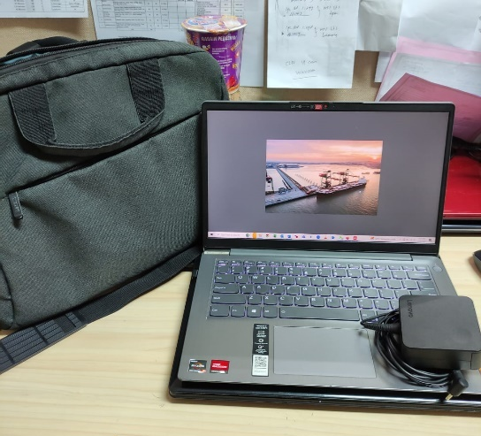
- Laptop LENOVO IdeaPad 3-14ALC6 Laptop - Type 82KT (1 Unit)
  - Processor : AMD Ryzen 5 5500U Lucienne (2.1 GHz, 6 cores, TDP 15W
  - Display : 14″ Full HD LED IPS 300cd/m² 45% NTSC (1920×1080, anti-glare)
  - RAM : 8 GB (4 GB soldered 4 GB) DDR4 3200 MHz
  - Storage : 512GB M.2 SSD (NVMe PCIe 3.0 x4, 2280).
  - SN : PF38TL1G
  - Warna : SLATE GREY
- Charger Laptop (1 Unit)
- Tas Laptop Lenovo (1 Unit)
- Mouse Logitech M190 (1 Unit)

Kondisi : 95% (Bekas Pakai)
Kepada :
Nama : Rivka Noerghisty
Divisi : PS
NIK :
Notes :
Menggunakan Laptop ex Zano, Laptop ex Rivka diserahkan ke IT

Menyetujui,

( Bramantya Zain )
Menyerahkan,

( M Nurhasan Mahmudi )
Menerima,

( Rivka Noerghisty)
BERITA ACARA SERAH TERIMA INVENTARIS
PT. JAKARTA PRIMA CRANES
Wisma JPC, Jl. Mampang Prapatan Raya No.20

No. Dokumen : GA/2023/03/006
No. Inventaris : ZNO-2023-001
DEPARTEMEN GA-IT

Hari ………………, ……. ………… 2023
Telah diserahkan inventaris sebagai berikut :
- Laptop LENOVO IdeaPad 3-14ALC6 Laptop - Type 82KT (1 Unit)
  - Processor : AMD Ryzen 5 5500U Lucienne (2.1 GHz, 6 cores, TDP 15W
  - Display : 14″ Full HD LED IPS 300cd/m² 45% NTSC (1920×1080, anti-glare)
  - RAM : 8 GB (4 GB soldered 4 GB) DDR4 3200 MHz
  - Storage : 512GB M.2 SSD (NVMe PCIe 3.0 x4, 2280).
  - SN : PF38TL1G
  - Warna : SLATE GREY
- Charger Laptop (1 Unit)
- Tas Laptop Lenovo (1 Unit)
- Mouse Logitech M190 (1 Unit)

Kondisi : 95% (Bekas Pakai)
Kepada :
Nama : Rivka Noerghisty
Divisi : PS
NIK :
Notes :
Menggunakan Laptop ex Zano, Laptop ex Rivka diserahkan ke IT

Menyetujui,

( Bramantya Zain )
Menyerahkan,

( M Nurhasan Mahmudi )
Menerima,

( Rivka Noerghisty)
------------------
System Information
------------------
Time of this report: 3/20/2023, 15:25:23
Machine name: ZANO-JPC
Machine Id: {EC2A872C-96A2-4048-9AB7-17EE26D0E0D8}
Operating System: Windows 10 Pro 64-bit (10.0, Build 19045) (19041.vb_release.191206-1406)
Language: English (Regional Setting: English)
System Manufacturer: LENOVO
System Model: 82KT
BIOS: GLCN52WW (type: UEFI)
Processor: AMD Ryzen 5 5500U with Radeon Graphics (12 CPUs), ~2.1GHz
Memory: 8192MB RAM
Available OS Memory: 5990MB RAM
Page File: 8523MB used, 1941MB available
Windows Dir: C:\Windows
DirectX Version: DirectX 12
DX Setup Parameters: Not found
User DPI Setting: 120 DPI (125 percent)
System DPI Setting: 144 DPI (150 percent)
DWM DPI Scaling: UnKnown
Miracast: Available, with HDCP
Microsoft Graphics Hybrid: Not Supported
DirectX Database Version: 1.0.8
DxDiag Version: 10.00.19041.2075 64bit Unicode

