BERITA ACARA SERAH TERIMA INVENTARIS
PT. JAKARTA PRIMA CRANES
Wisma JPC, Jl. Mampang Prapatan Raya No.20

No. Dokumen : GA/2023/03/004
No. Inventaris : RDH-2022-001
DEPARTEMEN GA-IT

Hari ………………, ……. ………… 2023
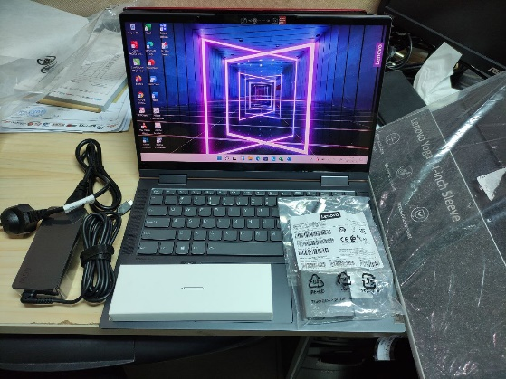
Telah diserahkan inventaris sebagai berikut :
- Laptop LENOVO YOGA 714ACN6 (1 Unit)
  - Processor : AMD Ryzen 7 5800U Processor 1.9GHz (4MB Chace; Up to 4.4GHz)
  - Display : 14″ FHD (1920×1080) IPS 300nits Glossy, 72% NTSC, 10-point Multi-touch.
  - RAM : 16GB Soldered LPDDR4x-4266, not upgradable.
  - Storage : 512GB SSD M.2 2280 PCIe 3.0×4 NVMe.
  - SN : PF3DYJZ6
  - Warna : SLATE GREY
- Charger Laptop (1 Unit)
- Lenovo YOGA 14-inch Sleeve (1 Unit)
- Adaptor type C to VGA & HDMI (1 Unit)
- Stylus Pen (1 Unit)
Kondisi : 95% (Bekas Pakai)
Kepada :
Nama : Zano Tabramian
Divisi : MK PS
NIK :
Notes :
Laptop Lama Zano diberikan ke Rivka & Zano Pakai Laptop ex RDH

Menyetujui,

( Bramantya Zain )
Menyerahkan,

( M Nurhasan Mahmudi )
Menerima,

( Zano Tabramian )
BERITA ACARA SERAH TERIMA INVENTARIS
PT. JAKARTA PRIMA CRANES
Wisma JPC, Jl. Mampang Prapatan Raya No.20

No. Dokumen : GA/2023/03/004
No. Inventaris : RDH-2022-001
DEPARTEMEN GA-IT

Hari ………………, ……. ………… 2023
Telah diserahkan inventaris sebagai berikut :
- Laptop LENOVO YOGA 714ACN6 (1 Unit)
  - Processor : AMD Ryzen 7 5800U Processor 1.9GHz (4MB Chace; Up to 4.4GHz)
  - Display : 14″ FHD (1920×1080) IPS 300nits Glossy, 72% NTSC, 10-point Multi-touch.
  - RAM : 16GB Soldered LPDDR4x-4266, not upgradable.
  - Storage : 512GB SSD M.2 2280 PCIe 3.0×4 NVMe.
  - SN : PF3DYJZ6
  - Warna : SLATE GREY
- Charger Laptop (1 Unit)
- Lenovo YOGA 14-inch Sleeve (1 Unit)
- Adaptor type C to VGA & HDMI (1 Unit)
- Stylus Pen (1 Unit)
Kondisi : 95% (Bekas Pakai)
Kepada :
Nama : Zano Tabramian
Divisi : MK PS
NIK :
Notes :
Laptop Lama Zano diberikan ke Rivka & Zano Pakai Laptop ex RDH
Menyetujui,

( Bramantya Zain )
Menyerahkan,

( M Nurhasan Mahmudi )
Menerima,

( Zano Tabramian )

------------------
System Information
------------------
Time of this report: 3/14/2023, 13:26:31
Machine name: RDH-2022-001
Machine Id: {66A415E3-D799-4C8B-9FD0-A1C17CC40086}
Operating System: Windows 10 Home Single Language 64-bit (10.0, Build 19044) (19041.vb_release.191206-1406)
Language: English (Regional Setting: English)
System Manufacturer: LENOVO
System Model: 82N7
BIOS: H9CN28WW (type: UEFI)
Processor: AMD Ryzen 5 5600U with Radeon Graphics (12 CPUs), ~2.3GHz
Memory: 16384MB RAM
Available OS Memory: 14188MB RAM
Page File: 5027MB used, 11848MB available
Windows Dir: C:\Windows
DirectX Version: DirectX 12
DX Setup Parameters: Not found
User DPI Setting: 144 DPI (150 percent)
System DPI Setting: 144 DPI (150 percent)
DWM DPI Scaling: UnKnown
Miracast: Available, with HDCP
Microsoft Graphics Hybrid: Not Supported
DirectX Database Version: 1.0.8
DxDiag Version: 10.00.19041.2075 64bit Unicode

