BERITA ACARA SERAH TERIMA INVENTARIS
PT. JAKARTA PRIMA CRANES
Wisma JPC, Jl. Mampang Prapatan Raya No.20

No. Dokumen : GA/2023/05/006
No. Inventaris : SRS-2021-001
DEPARTEMEN GA-IT

Hari ………………, ……. ………… 2023
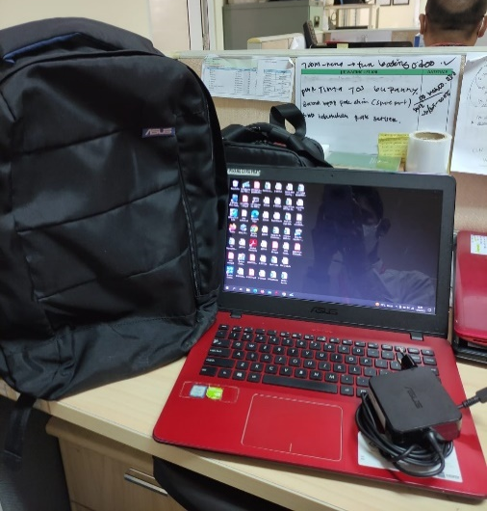
Telah diserahkan inventaris sebagai berikut :
- Laptop ASUS Vivobook A442UR-GA043T
  - Processor : Intel(R) Core(TM) i5-8250U CPU @ 1.60GHz (8 CPUs), ~1.8GHz
  - Display : 14” Intel(R) UHD Graphics 620 1366 x 768 (32 bit) (60Hz)
  - RAM : 4 GB Unremovable + 4 GB Extend
  - Storage : 512 SSD
  - SN : J1N0CV175826058
  - Warna : Merah
- Charger Laptop
- Tas Laptop ASUS
Kondisi : 85% (Bekas Pakai)
Kepada :

Nama : M Nurhasan Mahmudi
Divisi : HR & GA / IT
NIK : JPC-JKT-825
Notes :
Tarikan laptop karena user sudah mendapatkan alokasi inventaris laptop baru

Menyetujui,

( Bramantya Zain )
Menyerahkan,

( Sri Suparyanti )
Menerima,

( M Nurhasan Mahmudi )
BERITA ACARA SERAH TERIMA INVENTARIS
PT. JAKARTA PRIMA CRANES
Wisma JPC, Jl. Mampang Prapatan Raya No.20

No. Dokumen : GA/2023/05/006
No. Inventaris : SRS-2021-001
DEPARTEMEN GA-IT

Hari ………………, ……. ………… 2023
Telah diserahkan inventaris sebagai berikut :
- Laptop ASUS Vivobook A442UR-GA043T
  - Processor : Intel(R) Core(TM) i5-8250U CPU @ 1.60GHz (8 CPUs), ~1.8GHz
  - Display : 14” Intel(R) UHD Graphics 620 1366 x 768 (32 bit) (60Hz)
  - RAM : 4 GB Unremovable + 4 GB Extend
  - Storage : 512 SSD
  - SN : J1N0CV175826058
  - Warna : Merah
- Charger Laptop
- Tas Laptop ASUS
Kondisi : 85% (Bekas Pakai)
Kepada :

Nama : M Nurhasan Mahmudi
Divisi : HR & GA / IT
NIK : JPC-JKT-825
Notes :
Tarikan laptop karena user sudah mendapatkan alokasi inventaris laptop baru

Menyetujui,

( Bramantya Zain )
Menyerahkan,

( Sri Suparyanti )
Menerima,

( M Nurhasan Mahmudi )
------------------
System Information
------------------
Time of this report: 5/16/2023, 09:18:09
Machine name: PC-SRI-FA
Machine Id: {103B367C-F95B-4B3C-AFE5-FAD5F3863031}
Operating System: Windows 10 Home Single Language 64-bit (10.0, Build 19044) (19041.vb_release.191206-1406)
Language: Indonesian (Regional Setting: Indonesian)
System Manufacturer: ASUSTeK COMPUTER INC.
System Model: X442URR
BIOS: X442URR.308 (type: UEFI)
Processor: Intel(R) Core(TM) i5-8250U CPU @ 1.60GHz (8 CPUs), ~1.8GHz
Memory: 8192MB RAM
Available OS Memory: 8078MB RAM
Page File: 3158MB used, 16183MB available
Windows Dir: C:\WINDOWS
DirectX Version: DirectX 12
DX Setup Parameters: Not found
User DPI Setting: 96 DPI (100 percent)
System DPI Setting: 96 DPI (100 percent)
DWM DPI Scaling: Disabled
Miracast: Available, with HDCP
Microsoft Graphics Hybrid: Supported
DirectX Database Version: 1.4.6
DxDiag Version: 10.00.19041.1741 64bit Unicode

LABEL DI BELAKANG LAPTOP
NO INVENTARIS
SRS | - | 2021 | - | 001

EMAIL MS
PASS
TGL | 16 / 05 / 2023
BA | GA/2023/ 05 / 007
USER | SRI SUPARYANTI

LABEL DI CHARGER
NO INVENTARIS
SRS | - | 2021 | - | 001

