BERITA ACARA SERAH TERIMA INVENTARIS
PT. JAKARTA PRIMA CRANES
Wisma JPC, Jl. Mampang Prapatan Raya No.20

No. Dokumen : GA/2023/04/002
No. Inventaris : PRP-2022-001
DEPARTEMEN GA-IT

Hari ………….., …………………… 2023,
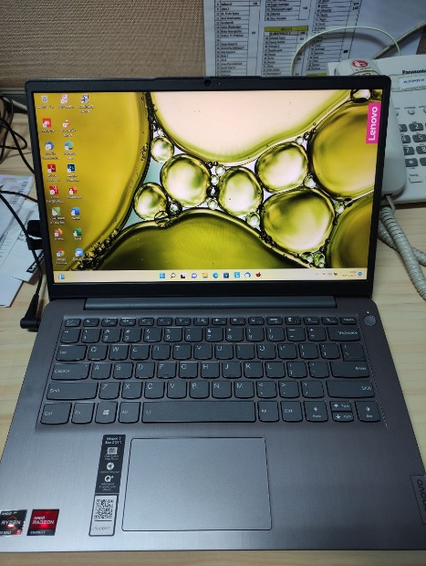
Telah diserahkan inventaris sebagai berikut :
- Laptop Lenovo IdeaPad 3 14ALC6 (1 Unit)
  - CPU : AMD Ryzen™ 5 5500U Processor(Ryzen™ 5 5500U)
  - Display : Integrated AMD Monitor 14.0 FHD 45% NTSC
  - Storage : 512 GB SSD PCIe
  - RAM : 2x 4 GB DDR4-3200
  - SN : PF3NLP28
  - Warna ARCTIC GREY
- Charger Laptop (1 Unit)
- Tas Laptop Lenovo (1 Unit)
Kondisi : 90% (Bekas Pakai)
Kepada :

Nama : Adnan Ramadhitya Maulana Rifqi Adipramana
Divisi : Procurement
NIK :
Notes :
Karyawan Baru

Menyetujui,

( Bramantya Zain )
Menyerahkan,

( M Nurhasan Mahmudi )
Menerima,

( Adnan Ramadhitya )
BERITA ACARA SERAH TERIMA INVENTARIS
PT. JAKARTA PRIMA CRANES
Wisma JPC, Jl. Mampang Prapatan Raya No.20

No. Dokumen : GA/2023/04/002
No. Inventaris : PRP-2022-001
DEPARTEMEN GA-IT

Hari ………….., …………………… 2023,
Telah diserahkan inventaris sebagai berikut :
- Laptop Lenovo IdeaPad 3 14ALC6 (1 Unit)
  - CPU : AMD Ryzen™ 5 5500U Processor(Ryzen™ 5 5500U)
  - Display : Integrated AMD Monitor 14.0 FHD 45% NTSC
  - Storage : 512 GB SSD PCIe
  - RAM : 2x 4 GB DDR4-3200
  - SN : PF3NLP28
  - Warna ARCTIC GREY
- Charger Laptop (1 Unit)
- Tas Laptop Lenovo (1 Unit)
Kondisi : 90% (Bekas Pakai)
Kepada :

Nama : Adnan Ramadhitya Maulana Rifqi Adipramana
Divisi : Procurement
NIK :
Notes :
Karyawan Baru

Menyetujui,

( Bramantya Zain )
Menyerahkan,

( M Nurhasan Mahmudi )
Menerima,

( Adnan Ramadhitya )
------------------
System Information
------------------
Time of this report: 4/3/2023, 13:08:51
Machine name: PRP-2022-001
Machine Id: {CA480E60-5F0A-4B8A-BE90-BC8A3910A2C6}
Operating System: Windows 11 Home Single Language 64-bit (10.0, Build 22000) (22000.co_release.210604-1628)
Language: English (Regional Setting: English)
System Manufacturer: LENOVO
System Model: 82KT
BIOS: GLCN46WW (type: UEFI)
Processor: AMD Ryzen 5 5500U with Radeon Graphics (12 CPUs), ~2.1GHz
Memory: 8192MB RAM
Available OS Memory: 6006MB RAM
Page File: 4823MB used, 16030MB available
Windows Dir: C:\Windows
DirectX Version: DirectX 12
DX Setup Parameters: Not found
User DPI Setting: 144 DPI (150 percent)
System DPI Setting: 144 DPI (150 percent)
DWM DPI Scaling: UnKnown
Miracast: Available, with HDCP
Microsoft Graphics Hybrid: Not Supported
DirectX Database Version: 1.2.2
DxDiag Version: 10.00.22000.0653 64bit Unicode

