BERITA ACARA SERAH TERIMA INVENTARIS
PT. JAKARTA PRIMA CRANES
Wisma JPC, Jl. Mampang Prapatan Raya No.20

No. Dokumen : GA/2023/05/007
No. Inventaris : WPI-2015-001
DEPARTEMEN GA-IT

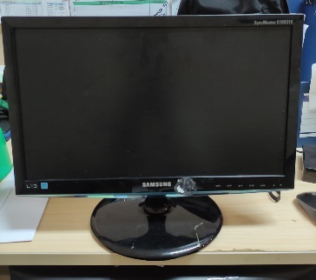
Hari ………………, ……. ………… 2023
Telah diserahkan inventaris sebagai berikut :
- SET PC
  - Processor : Intel(R) Core(TM) i5-3330 CPU @ 3.00GHz (4 CPUs), ~3.0GHz Display : AMD Radeon HD 5700 Series 1GB
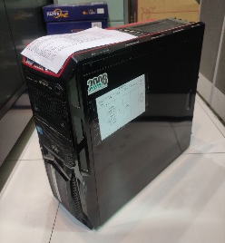
  - RAM : 4 GB DDR3
  - Storage : 512 HDD
- Monitor Samsung SyncMaster S19B310 19”
  - SN : ZV7AH4LC700354D
- Keyboard Logitech K120

Kondisi : 70% (Bekas Pakai)
Kepada :

Nama : M Nurhasan Mahmudi
Divisi : HR & GA / IT
NIK : JPC-JKT-825
Notes :
Tarikan PC karena user sudah mendapatkan alokasi inventaris laptop baru

Menyetujui,

( Bramantya Zain )
Menyerahkan,

( Wahyu Puji Lestari )
Menerima,

( M Nurhasan Mahmudi )
BERITA ACARA SERAH TERIMA INVENTARIS
PT. JAKARTA PRIMA CRANES
Wisma JPC, Jl. Mampang Prapatan Raya No.20

No. Dokumen : GA/2023/05/007
No. Inventaris : WPI-2015-001
DEPARTEMEN GA-IT

Hari ………………, ……. ………… 2023
Telah diserahkan inventaris sebagai berikut :
- SET PC
  - Processor : Intel(R) Core(TM) i5-3330 CPU @ 3.00GHz (4 CPUs), ~3.0GHz Display : AMD Radeon HD 5700 Series 1GB
  - RAM : 4 GB DDR3
  - Storage : 512 HDD
- Monitor Samsung SyncMaster S19B310 19”
  - SN : ZV7AH4LC700354D
- Keyboard Logitech K120

Kondisi : 70% (Bekas Pakai)
Kepada :

Nama : M Nurhasan Mahmudi
Divisi : HR & GA / IT
NIK : JPC-JKT-825
Notes :
Tarikan PC karena user sudah mendapatkan alokasi inventaris laptop baru

Menyetujui,

( Bramantya Zain )
Menyerahkan,

( Wahyu Puji Lestari )
Menerima,

( M Nurhasan Mahmudi )
------------------
System Information
------------------
Time of this report: 5/16/2023, 13:47:06
Machine name: FA-TARI
Operating System: Windows 7 Ultimate 32-bit (6.1, Build 7601) Service Pack 1 (7601.win7sp1_rtm.101119-1850)
Language: Indonesian (Regional Setting: Indonesian)
System Manufacturer: System manufacturer
System Model: System Product Name
BIOS: BIOS Date: 03/19/14 17:34:07 Ver: 12.04
Processor: Intel(R) Core(TM) i5-3330 CPU @ 3.00GHz (4 CPUs), ~3.0GHz
Memory: 4096MB RAM
Available OS Memory: 3550MB RAM
Page File: 1432MB used, 5664MB available
Windows Dir: C:\Windows
DirectX Version: DirectX 11
DX Setup Parameters: Not found
User DPI Setting: Using System DPI
System DPI Setting: 96 DPI (100 percent)
DWM DPI Scaling: Disabled
DxDiag Version: 6.01.7601.17514 32bit Unicode
LABEL DI BELAKANG LAPTOP
NO INVENTARIS
WPI | - | 2015 | - | 001

EMAIL MS
PASS
TGL | 16 / 05 / 2023
BA | GA/2023/ 05 / 008
USER | WAHYU PUJI LESTARI

SPESIFIKASI
- Processor : Intel(R) Core(TM) i5-3330 CPU @ 3.00GHz (4 CPUs), ~3.0GHz Display : AMD Radeon HD 5700 Series 1GB
- RAM : 4 GB DDR3
- Storage : 512 HDD

