BERITA ACARA SERAH TERIMA INVENTARIS
PT. JAKARTA PRIMA CRANES
Wisma JPC, Jl. Mampang Prapatan Raya No.20

No. Dokumen : IT/BAST/2025/11/01
No. Inventaris : 6.2021/LT21.1/WS1LT2
DEPARTEMEN GA-IT

Hari ………………, ……. ………… 2025
Telah diserahkan inventaris sebagai berikut :
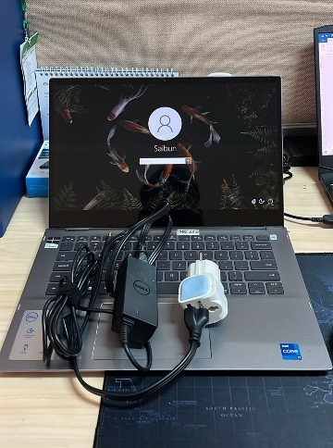
- LAPTOP DELL INSPIRON 5406 2-IN-1 (1 UNIT)
  - Processor : 11th Generation Intel® Core™ i7-1165G7
  - Display : 14.0'' FHD NVIDIA
  - RAM : 1x 8GB
  - Storage : 1x 512 GB SSD PCIe
  - SN : F9S1C63
  - Warna : Gray
- Charger Laptop (1 Unit)
- Tas Laptop Dell (1 Unit)

Dari :
Nama : Saibun K Sirait
Dept. : MKT EPC
NIP :
Kepada :
Nama : M N Mahmudi
Dept. : HR&GA/IT
NIP :

Notes :
Pengembalian laptop lama; karena user sudah menerima laptop inventaris baru.

BERITA ACARA SERAH TERIMA INVENTARIS
Menerima,

M N Mahmudi
Menyerahkan,

Saibun K Sirait
Mengetahui,

Ali Rakhman

Menyetujui,

Bramantya Zain

PT. JAKARTA PRIMA CRANES
Wisma JPC, Jl. Mampang Prapatan Raya No.20

No. Dokumen : IT/BAST/2025/11/01
No. Inventaris : 6.2021/LT21.1/WS1LT2
DEPARTEMEN GA-IT

Hari ………………, ……. ………… 2025
Telah diserahkan inventaris sebagai berikut :
- LAPTOP DELL INSPIRON 5406 2-IN-1 (1 UNIT)
  - Processor : 11th Generation Intel® Core™ i7-1165G7
  - Display : 14.0'' FHD NVIDIA
  - RAM : 1x 8GB
  - Storage : 1x 512 GB SSD PCIe
  - SN : F9S1C63
  - Warna : Gray
- Charger Laptop (1 Unit)
- Tas Laptop Dell (1 Unit)

Dari :
Nama : Saibun K Sirait
Dept. : MKT EPC
NIP :
Kepada :
Nama : M N Mahmudi
Dept. : HR&GA/IT
NIP :

Notes :
Pengembalian laptop lama; karena user sudah menerima laptop inventaris baru.

Menerima,

M N Mahmudi
Menyerahkan,

Saibun K Sirait
Mengetahui,

Ali Rakhman

Menyetujui,

Bramantya Zain

LABEL DI BELAKANG LAPTOP

NO INVENTARIS
6.2025/LT89.1/WS1LT2
NO INVENTARIS
6.2025/LT89.1/WS1LT2

EMAIL MS | MP2SAHQF@outlook.com
PASS | JpcOffice2025
DATE | 28 / 10 / 2025
BAST | IT/BAST/2025/10/03
USER | SAIBUN K SIRAIT
EMAIL MS | MP2SAHQF@outlook.com
PASS | JpcOffice2025
DATE | 28 / 10 / 2025
BAST | IT/BAST/2025/10/03
USER | SAIBUN K SIRAIT

PWR | EPC/2025/1692
PO | EPC-JK/L/2025-0502
PWR | EPC/2025/1692
PO | EPC-JK/L/2025-0502

LABEL DI CHARGER
NO INVENTARIS
6.2025/LT89.1/WS1LT2

LABEL DI BOX LAPTOP
NO INVENTARIS
6.2025/LT89.1/WS1LT2

EMAIL MS | MP2SAHQF@outlook.com
PASS | JpcOffice2025
DATE | 28 / 10 / 2025
BAST | IT/BAST/2025/10/03
USER | SAIBUN K SIRAIT

PWR | EPC/2025/1692
PO | EPC-JK/L/2025-0502

LABEL DI KARTU GARANSI
NO INVENTARIS
6.2025/LT89.1/WS1LT2

EMAIL MS | MP2SAHQF@outlook.com
PASS | JpcOffice2025
DATE | 28 / 10 / 2025
BAST | IT/BAST/2025/10/03
USER | SAIBUN K SIRAIT

PWR | EPC/2025/1692
PO | EPC-JK/L/2025-0502

