BERITA ACARA SERAH TERIMA INVENTARIS
PT. JAKARTA PRIMA CRANES
Wisma JPC, Jl. Mampang Prapatan Raya No.20

No. Dokumen : IT/BAST/2025/10/002
No. Inventaris : 6.2016/LT04.13/WS2LT1
DEPARTEMEN GA-IT

Hari ………………, ……. ………… 2025
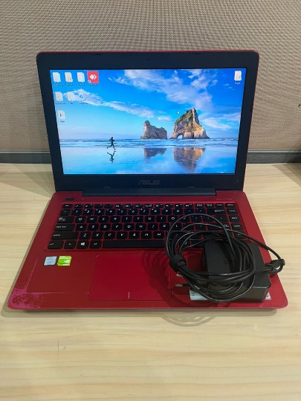
Telah diserahkan inventaris sebagai berikut :
- Laptop ASUS A456UR-GA093D (1 Unit)
  - Processor : Intel(R) Core(TM) i5-7200U CPU @ 2.50GHz 2.71 GHz
  - Display : 14” Inch HD (1366 x 768) Nvidia GeForce GT930MX 2GB, Intel(R) HD Graphics 620 (128 MB)
  - RAM : 4 GB + 8 GB, DDR4
  - Storage : 932 GB SSD WD Blue SA510 2.5 1000GB
  - SN : H8N0CX09142332H
  - Warna : Glamour Red
- Charger Laptop (1 Unit)

Dari :
Nama : Denny Arief
Divisi : Project Control
NIP :
Kepada :
Nama : M N Mahmudi
Divisi : HR&GA/IT
NIP :

Notes :
Tarikan laptop karena user sudah mendapatkan alokasi laptop baru.

Menyerahkan,

Denny Arief
Menerima,

M N Mahmudi
Mengetahui,

Ali Rakhman

Menyetujui,

Bramantya Zain

BERITA ACARA SERAH TERIMA INVENTARIS
PT. JAKARTA PRIMA CRANES
Wisma JPC, Jl. Mampang Prapatan Raya No.20

No. Dokumen : IT/BAST/2025/10/002
No. Inventaris : 6.2016/LT04.13/WS2LT1
DEPARTEMEN GA-IT

Hari ………………, ……. ………… 2025
Telah diserahkan inventaris sebagai berikut :
- Laptop ASUS A456UR-GA093D (1 Unit)
  - Processor : Intel(R) Core(TM) i5-7200U CPU @ 2.50GHz 2.71 GHz
  - Display : 14” Inch HD (1366 x 768) Nvidia GeForce GT930MX (2GB), Intel(R) HD Graphics 620 (128 MB)
  - RAM : 4 GB + 8 GB, DDR4
  - Storage : 932 GB SSD WD Blue SA510 2.5 1000GB
  - SN : H8N0CX09142332H
  - Warna : Glamour Red
- Charger Laptop (1 Unit)

Dari :
Nama : Denny Arief
Divisi : Project Control
NIP :
Kepada :
Nama : M N Mahmudi
Divisi : HR&GA/IT
NIP :

Notes :
Tarikan laptop karena user sudah mendapatkan alokasi laptop baru.

Menyerahkan,

Denny Arief
Menerima,

M N Mahmudi
Mengetahui,

Ali Rakhman

Menyetujui,

Bramantya Zain

System Information
------------------
Time of this report: 10/24/2025, 10:35:52
Machine name: DENNY
Machine Id: {22E160AC-874B-4895-8590-AF0E6FF06EAB}
Operating System: Windows 10 Pro 64-bit (10.0, Build 19045) (19041.vb_release.191206-1406)
Language: Indonesian (Regional Setting: Indonesian)
System Manufacturer: ASUSTeK COMPUTER INC.
System Model: X456URK
BIOS: X456URK.307 (type: UEFI)
Processor: Intel(R) Core(TM) i5-7200U CPU @ 2.50GHz (4 CPUs), ~2.7GHz
Memory: 12288MB RAM
Available OS Memory: 12170MB RAM
Page File: 4916MB used, 13909MB available
Windows Dir: C:\Windows
DirectX Version: DirectX 12
---------------
Display Devices
Card name: Intel(R) HD Graphics 620
Manufacturer: Intel Corporation
Chip type: Intel(R) HD Graphics Family
DAC type: Internal
Device Type: Full Device (POST)
Device Key: Enum\PCI\VEN_8086&DEV_5916&SUBSYS_13201043&REV_02
Device Status: 0180200A [DN_DRIVER_LOADED|DN_STARTED|DN_DISABLEABLE|DN_NT_ENUMERATOR|DN_NT_DRIVER]
Device Problem Code: No Problem
Driver Problem Code: Unknown
Display Memory: 6212 MB
Dedicated Memory: 128 MB
Shared Memory: 6084 MB
------------------------
Disk & DVD/CD-ROM Drives
Drive: C:
Free Space: 149.7 GB
Total Space: 409.1 GB
File System: NTFS
Model: WD Blue SA510 2.5 1000GB

Drive: D:
Free Space: 308.7 GB
Total Space: 344.1 GB
File System: NTFS
Model: WD Blue SA510 2.5 1000GB

Drive: E:
Free Space: 77.1 GB
Total Space: 100.0 GB
File System: NTFS
Model: WD Blue SA510 2.5 1000GB

Drive: U:
Free Space: 45.0 GB
Total Space: 100.0 GB
File System: NTFS
Model: WD Blue SA510 2.5 1000GB

Drive: G:
Model: Slimtype DVD A DA8AESH
Driver: C:\WINDOWS\SYSTEM32\DRIVERS\CDROM.SYS, 10.00.19041.4355 (Indonesian), 5/15/2024 09:19:18, 175616 bytes

