BERITA ACARA SERAH TERIMA INVENTARIS
PT. JAKARTA PRIMA CRANES
Wisma JPC, Jl. Mampang Prapatan Raya No.20

No. Dokumen : IT/BAST/2025/05/05
No. Inventaris : 6.2025/LT80.2/WS1LT1
DEPARTEMEN GA-IT

Hari ………………, ……. ………… 2025
Telah diserahkan inventaris sebagai berikut :
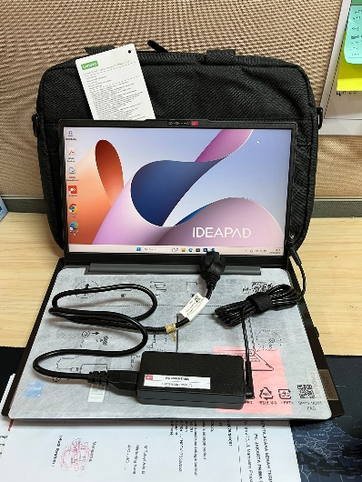
- LAPTOP LENOVO IdeaPad Slim 3 14IAH8 - Type 83EQ (1 UNIT)
  - Processor : 12th Generation Intel® Core™ i5-12450H Processor(Core™ i5-12450H)
  - Display : Intel® UHD Graphics 14" FHD
  - RAM : 1x 16GBLPDDR5-4800
  - Storage : 1x 512 GB SSD PCIe
  - SN : PF5F23DX
  - Warna : Luna Grey
- Charger Laptop (1 Unit)
- Tas Laptop Lenovo (1 Unit)

Kepada :
Nama : Agus Tirta
Divisi : PE Cranes
NIK :

Notes :
Laptop Inventaris Baru Untuk User Agus Tirta,
Reff PWR JPC/2025/0169; Reff PO JPC-JK/L/2025-0171

BERITA ACARA SERAH TERIMA INVENTARIS
Menerima,

Agus Tirta
Menyerahkan,

M N Mahmudi
Mengetahui,

Ali Rakhman

Menyetujui,

Bramantya Zain

PT. JAKARTA PRIMA CRANES
Wisma JPC, Jl. Mampang Prapatan Raya No.20

No. Dokumen : IT/BAST/2025/05/05
No. Inventaris : 6.2025/LT80.2/WS1LT1
DEPARTEMEN GA-IT

Hari ………………, ……. ………… 2025
Telah diserahkan inventaris sebagai berikut :
- LAPTOP LENOVO IdeaPad Slim 3 14IAH8 - Type 83EQ (1 UNIT)
  - Processor : 12th Generation Intel® Core™ i5-12450H Processor(Core™ i5-12450H)
  - Display : Intel® UHD Graphics 14" FHD
  - RAM : 1x 16GBLPDDR5-4800
  - Storage : 1x 512 GB SSD PCIe
  - SN : PF5F23DX
  - Warna : Luna Grey
- Charger Laptop (1 Unit)
- Tas Laptop Lenovo (1 Unit)

Kepada :
Nama : Agus Tirta
Divisi : PE Cranes
NIK :

Notes :
Laptop Inventaris Baru Untuk User Agus Tirta,
Reff PWR JPC/2025/0169; Reff PO JPC-JK/L/2025-0171

------------------
Menerima,

Agus Tirta
Menyerahkan,

M N Mahmudi
Mengetahui,

Ali Rakhman

Menyetujui,

Bramantya Zain

System Information
------------------
Time of this report: 5/20/2025, 09:27:52
Machine name: LAPTOP-LUHKHE9O
Machine Id: {82103D9C-7035-4D48-9C85-CDA9D25046DC}
Operating System: Windows 11 Home Single Language 64-bit (10.0, Build 26100) (26100.ge_release.240331-1435)
Language: English (Regional Setting: English)
System Manufacturer: LENOVO
System Model: 83EQ
BIOS: LTCN34WW (type: UEFI)
Processor: 12th Gen Intel(R) Core(TM) i5-12450H (12 CPUs), ~2.0GHz
Memory: 16384MB RAM
Available OS Memory: 16076MB RAM
Page File: 6394MB used, 12626MB available
Windows Dir: C:\Windows
DirectX Version: DirectX 12
---------------
Display Devices
---------------
Card name: Intel(R) UHD Graphics
Manufacturer: Intel Corporation
Chip type: Intel(R) UHD Graphics Family
DAC type: Internal
Device Type: Full Device (POST)
Device Key: Enum\PCI\VEN_8086&DEV_46A3&SUBSYS_384A17AA&REV_0C
Device Status: 0180200A [DN_DRIVER_LOADED|DN_STARTED|DN_DISABLEABLE|DN_NT_ENUMERATOR|DN_NT_DRIVER]
Device Problem Code: No Problem
Driver Problem Code: Unknown
Display Memory: 8166 MB
Dedicated Memory: 128 MB
Shared Memory: 8038 MB
------------------------
Disk & DVD/CD-ROM Drivess
------------------------
Drive: C:
Free Space: 117.4 GB
Total Space: 206.1 GB
File System: NTFS
Model: Micron MTFDKCD512QGN-1BN1AABLA

Drive: D:
Free Space: 279.9 GB
Total Space: 280.0 GB
File System: NTFS
Model: Micron MTFDKCD512QGN-1BN1AABLA

LABEL DI BELAKANG LAPTOP

NO INVENTARIS
6.2025/LT80.2/WS1LT1
NO INVENTARIS
6.2025/LT80.2/WS1LT1

EMAIL MS | PF5F23DX@outlook.com
PASS | JpcOffice2025
DATE | 20 / 5 / 2025
BAST | IT/BAST/2025/05/05
USER | AGUS TIRTA
EMAIL MS | PF5F23DX@outlook.com
PASS | JpcOffice2025
DATE | 20 / 5 / 2025
BAST | IT/BAST/2025/05/05
USER | AGUS TIRTA

PWR | JPC/2025/0169
PO | JPC-JK/L/2025-0171
PWR | JPC/2025/0169
PO | JPC-JK/L/2025-0171

LABEL DI CHARGER
NO INVENTARIS
6.2025/LT80.2/WS1LT1

LABEL DI BOX LAPTOP
NO INVENTARIS
6.2025/LT80.2/WS1LT1

EMAIL MS | PF5F23DX@outlook.com
PASS | JpcOffice2025
DATE | 20 / 5 / 2025
BAST | IT/BAST/2025/05/05
USER | AGUS TIRTA

PWR | JPC/2025/0169
PO | JPC-JK/L/2025-0171

LABEL DI KARTU GARANSI
NO INVENTARIS
6.2025/LT80.2/WS1LT1

EMAIL MS | PF5F23DX@outlook.com
PASS | JpcOffice2025
DATE | 20 / 5 / 2025
BAST | IT/BAST/2025/05/05
USER | AGUS TIRTA

PWR | JPC/2025/0169
PO | JPC-JK/L/2025-0171

