BERITA ACARA SERAH TERIMA INVENTARIS
PT. JAKARTA PRIMA CRANES
Wisma JPC, Jl. Mampang Prapatan Raya No.20

No. Dokumen : IT/BAST/2025/03/07
No. Inventaris : 6.2025/LT75.1/WS2LT2
DEPARTEMEN GA-IT

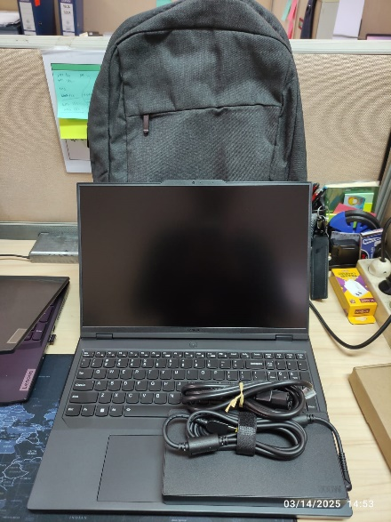
Hari ………………, ……. ………… 2025
Telah diserahkan inventaris sebagai berikut :
- LAPTOP LENOVO LEGION PRO 5 16IRX9 - TYPE 83DF (1 UNIT)
  - Processor : 14th Generation Intel® Core™ i7-14650HX Processor(Core™ i7-14650HX)
  - Display : NVIDIA® GeForce RTX™ 4060 8GB
  - RAM : 1x 16 GB DDR5-5600
  - Storage : 1x 1 TB SSD PCIe
  - SN : PF5CL246
  - Warna : Luna Grey
- Charger Laptop (1 Unit)
- Tas Laptop Lenovo (1 Unit)
- Mouse Legion Wired (1 Unit)

Kepada :
Nama : Gavin Alif
Divisi : Engineering
NIK :

Notes :
Laptop Inventaris Baru Untuk User Gavin Alif,
Reff PWR : JPC/2025/0147 R1 Reff PO : JPC-JK/L/2025/0077

BERITA ACARA SERAH TERIMA INVENTARIS
Menerima,

Gavin Alif
Menyerahkan,

M N Mahmudi
Mengetahui,

Ali Rakhman

Menyetujui,

Bramantya Zain

PT. JAKARTA PRIMA CRANES
Wisma JPC, Jl. Mampang Prapatan Raya No.20

No. Dokumen : IT/BAST/2025/03/07
No. Inventaris : 6.2025/LT75.1/WS2LT2
DEPARTEMEN GA-IT

Hari ………………, ……. ………… 2025
Telah diserahkan inventaris sebagai berikut :
- LAPTOP LENOVO LEGION PRO 5 16IRX9 - TYPE 83DF (1 UNIT)
  - Processor : 14th Generation Intel® Core™ i7-14650HX Processor(Core™ i7-14650HX)
  - Display : NVIDIA® GeForce RTX™ 4060 8GB
  - RAM : 1x 16 GB DDR5-5600
  - Storage : 1x 1 TB SSD PCIe
  - SN : PF5CL246
  - Warna : Luna Grey
- Charger Laptop (1 Unit)
- Tas Laptop Lenovo (1 Unit)
- Mouse Legion Wired (1 Unit)

Kepada :
Nama : Gavin Alif
Divisi : Engineering
NIK :

Notes :
Laptop Inventaris Baru Untuk User Gavin Alif,
Reff PWR : JPC/2025/0147 R1 Reff PO : JPC-JK/L/2025/0077

Menerima,

Gavin Alif
Menyerahkan,

M N Mahmudi
Mengetahui,

Ali Rakhman

Menyetujui,

Bramantya Zain

------------------
System Information
------------------
Time of this report: 3/17/2025, 12:49:04
Machine name: LAPTOP-C8U0QGT0
Machine Id: {6F8AC4EB-568E-476F-9D7E-4504E45AAFF3}
Operating System: Windows 11 Home Single Language 64-bit (10.0, Build 26100) (26100.ge_release.240331-1435)
Language: English (Regional Setting: English)
System Manufacturer: LENOVO
System Model: 83DF
BIOS: N0CN29WW (type: UEFI)
Processor: Intel(R) Core(TM) i7-14650HX (24 CPUs), ~2.2GHz
Memory: 16384MB RAM
Available OS Memory: 16108MB RAM
Page File: 7419MB used, 11632MB available
Windows Dir: C:\Windows
---------------
Display Devices
---------------
Card name: NVIDIA GeForce RTX 4060 Laptop GPU
Manufacturer: NVIDIA
Chip type: NVIDIA GeForce RTX 4060 Laptop GPU
DAC type: Integrated RAMDAC
Device Type: Full Device
Device Key: Enum\PCI\VEN_10DE&DEV_28E0&SUBSYS_3CF217AA&REV_A1
Device Status: 0180600A [DN_DRIVER_LOADED|DN_STARTED|DN_DISABLEABLE|DN_REMOVABLE|DN_NT_ENUMERATOR|DN_NT_DRIVER]
Device Problem Code: No Problem
Driver Problem Code: Unknown
Display Memory: 16010 MB
Dedicated Memory: 7957 MB
Shared Memory: 8053 MB
------------------------
Disk & DVD/CD-ROM Drives
------------------------
Drive: C:
Free Space: 220.1 GB
Total Space: 314.5 GB
File System: NTFS
Model: KXG80ZNV1T02 LS KIOXIA

Drive: D:
Free Space: 659.9 GB
Total Space: 660.0 GB
File System: NTFS
Model: KXG80ZNV1T02 LS KIOXIA

LABEL DI BELAKANG LAPTOP

NO INVENTARIS
6.2025/LT75.1/WS2LT2
NO INVENTARIS
6.2025/LT75.1/WS2LT2

EMAIL MS | PF5CL246@outlook.com
PASS | JpcOffice2025
DATE | 17 / 3 / 2025
BAST | IT/BAST/2025/03/07
USER | GAVIN ALIF
EMAIL MS | PF5CL246@outlook.com
PASS | JpcOffice2025
DATE | 17 / 3 / 2025
BAST | IT/BAST/2025/03/07
USER | GAVIN ALIF

PWR | JPC/2025/0147 R1
PO | JPC-JK/L/2025/0077
PWR | JPC/2025/0147 R1
PO | JPC-JK/L/2025/0077

LABEL DI CHARGER
NO INVENTARIS
6.2025/LT75.1/WS2LT2

LABEL DI BOX LAPTOP
NO INVENTARIS
6.2025/LT75.1/WS2LT2

EMAIL MS | PF5CL246@outlook.com
PASS | JpcOffice2025
DATE | 17 / 3 / 2025
BAST | IT/BAST/2025/03/07
USER | GAVIN ALIF

PWR | JPC/2025/0147 R1
PO | JPC-JK/L/2025/0077

LABEL DI KARTU GARANSI
NO INVENTARIS
6.2025/LT75.1/WS2LT2

EMAIL MS | PF5CL246@outlook.com
PASS | JpcOffice2025
DATE | 17 / 3 / 2025
BAST | IT/BAST/2025/03/07
USER | GAVIN ALIF

PWR | JPC/2025/0147 R1
PO | JPC-JK/L/2025/0077
RUSAK
PWR | -
PO | JPC-M/2025-0038

21/
14/03/2025 ~ MHN

Battery Asus A456UR SN: GBN0CX227238466 - (Bekas/Rusak)

Pergantian Battery Karena tidak tahan lama. Pak Pri

Penyelesaian Service
14/03/2025.

