BERITA ACARA SERAH TERIMA INVENTARIS
PT. JAKARTA PRIMA CRANES
Wisma JPC, Jl. Mampang Prapatan Raya No.20

No. Dokumen : IT/BAST/2025/04/07
No. Inventaris : 6.2025/PC11.1/PKU
DEPARTEMEN GA-IT

Hari ………………, ……. ………… 2025
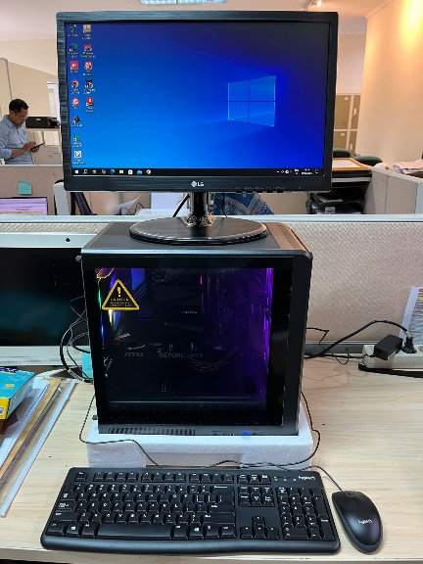
Telah diserahkan inventaris sebagai berikut :
- PC RAKITAN (1 UNIT)
  - Processor : AMD Ryzen 7 8700F 8-Core Processor (16 CPUs), ~4.1GHz
  - Display : NVIDIA GeForce RTX 4060
  - RAM : Memory: 16384MB RAM
  - Storage : 1 TB PCIe NVME
- MONITOR LG 19" MODEL 19M38L-B (1 Unit)
- Mouse Logitech K120 (1 Unit)
- Keyboard Logitech K120 (1 Unit)

Kepada :
Nama : Ramadhanil
Divisi : JPC Pekanbaru
NIK :

Notes :
PC Untuk Teksini Pekanbaru,
Reff PWR : PKU/2025/0525 Reff PO : JPC-JK/L/2025-0134

BERITA ACARA SERAH TERIMA INVENTARIS
Menerima,

Ramadhanil
Menyerahkan,

M N Mahmudi
Mengetahui,

Ali Rakhman

Menyetujui,

Bramantya Zain

PT. JAKARTA PRIMA CRANES
Wisma JPC, Jl. Mampang Prapatan Raya No.20

No. Dokumen : IT/BAST/2025/04/07
No. Inventaris : 6.2025/PC11.1/PKU
DEPARTEMEN GA-IT

Hari ………………, ……. ………… 2025
Telah diserahkan inventaris sebagai berikut :
- PC RAKITAN (1 UNIT)
  - Processor : AMD Ryzen 7 8700F 8-Core Processor (16 CPUs), ~4.1GHz
  - Display : NVIDIA GeForce RTX 4060
  - RAM : Memory: 16384MB RAM
  - Storage : 1 TB PCIe NVME
- MONITOR LG 19" MODEL 19M38L-B (1 Unit)
- Mouse Logitech K120 (1 Unit)
- Keyboard Logitech K120 (1 Unit)

Kepada :
Nama : Ramadhanil
Divisi : JPC Pekanbaru
NIK :

Notes :
PC Untuk Teksini Pekanbaru,
Reff PWR : PKU/2025/0525 Reff PO : JPC-JK/L/2025-0134

------------------
Menerima,

Ramadhanil
Menyerahkan,

M N Mahmudi
Mengetahui,

Ali Rakhman

Menyetujui,

Bramantya Zain

System Information
------------------
Time of this report: 4/29/2025, 20:32:42
Machine name: DESKTOP-I0F7FK9
Machine Id: {4701BA68-26F4-4754-9630-1412A33BE3DB}
Operating System: Windows 10 Pro 64-bit (10.0, Build 19044) (19041.vb_release.191206-1406)
Language: English (Regional Setting: English)
System Manufacturer: Gigabyte Technology Co., Ltd.
System Model: B650M K
BIOS: FB2 (type: UEFI)
Processor: AMD Ryzen 7 8700F 8-Core Processor (16 CPUs), ~4.1GHz
Memory: 16384MB RAM
Available OS Memory: 15990MB RAM
Page File: 6129MB used, 12804MB available
Windows Dir: C:\Windows
DirectX Version: DirectX 12
---------------
Display Devices
---------------
Card name: NVIDIA GeForce RTX 4060
Manufacturer: NVIDIA
Chip type: NVIDIA GeForce RTX 4060
DAC type: Integrated RAMDAC
Device Type: Full Device (POST)
Device Key: Enum\PCI\VEN_10DE&DEV_2882&SUBSYS_51611462&REV_A1
Device Status: 0180200A [DN_DRIVER_LOADED|DN_STARTED|DN_DISABLEABLE|DN_NT_ENUMERATOR|DN_NT_DRIVER]
Device Problem Code: No Problem
Driver Problem Code: Unknown
Display Memory: 15951 MB
Dedicated Memory: 7957 MB
Shared Memory: 7994 MB
Current Mode: 1366 x 768 (32 bit) (60Hz)
------------------------
Disk & DVD/CD-ROM Drives
------------------------
Drive: C:
Total Space: 1TB SSD
File System: NTFS
Model: ADATA LEGEND 860

LABEL DI BELAKANG LAPTOP

NO INVENTARIS
6.2025/PC11.1/PKU
NO INVENTARIS
6.2025/PC11.1/PKU

EMAIL MS | pc.pku042025@outlook.com
PASS | JpcOffice2025
DATE | 30 / 4 / 2025
BAST | IT/BAST/2025/04/07
USER | TEKNISI PEKANBARU
EMAIL MS | pc.pku042025@outlook.com
PASS | JpcOffice2025
DATE | 30 / 4 / 2025
BAST | IT/BAST/2025/04/07
USER | TEKNISI PEKANBARU

PWR | PKU/2025/0525
PO | JPC-JK/L/2025-0134
PWR | PKU/2025/0525
PO | JPC-JK/L/2025-0134

LABEL DI CHARGER
NO INVENTARIS
6.2025/PC11.1/PKU

LABEL DI BOX LAPTOP
NO INVENTARIS
6.2025/PC11.1/PKU

EMAIL MS | pc.pku042025@outlook.com
PASS | JpcOffice2025
DATE | 30 / 4 / 2025
BAST | IT/BAST/2025/04/07
USER | TEKNISI PEKANBARU

PWR | PKU/2025/0525
PO | JPC-JK/L/2025-0134

LABEL DI KARTU GARANSI
NO INVENTARIS
6.2025/PC11.1/PKU

EMAIL MS | pc.pku042025@outlook.com
PASS | JpcOffice2025
DATE | 30 / 4 / 2025
BAST | IT/BAST/2025/04/07
USER | TEKNISI PEKANBARU

PWR | PKU/2025/0525
PO | JPC-JK/L/2025-0134

