BERITA ACARA SERAH TERIMA INVENTARIS
PT. JAKARTA PRIMA CRANES
Wisma JPC, Jl. Mampang Prapatan Raya No.20

No. Dokumen : IT/BAST/2025/03/01
No. Inventaris : 6.2025/LT74.1/WS1LT1
DEPARTEMEN GA-IT

Hari ………………, ……. ………… 2025
Telah diserahkan inventaris sebagai berikut :
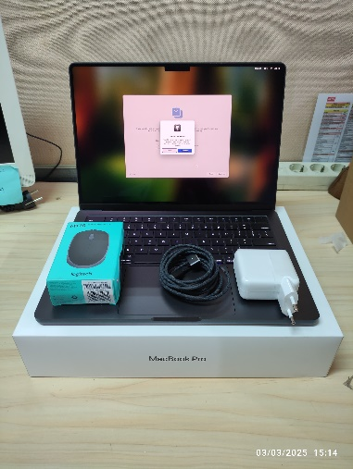
- Macbook Pro (14-INCH, M4 PRO OR M4 MAX, 2024)
  - Processor : Chip Apple M4 Pro CPU 12 core dengan 8 core performa dan core efisiensi GPU 16 core
  - Display : Layar Liquid Retina XDR 14,2 inci (diagonal) Refresh Rate Up To 120 Hz
  - RAM : 24 GB Integrated
  - Storage : 512 GB SSD
  - SN : DLC7JT7LRY
  - Warna : Cosmic Black
- Adaptor Daya USB-C 70 W (1 Unit)
- Kabel USB-C ke MagSafe 3 (2 m) (1 Unit)
- Mouse Logitech M170 (1 Unit)

Kepada :
Nama : Ali Rakhman
Divisi : HR&GA/IT
NIK :

Notes :
Laptop inventaris baru untuk user.
REFF PWR : JPC/2025/0145 REFF PO : JPC-JK/L/2025-0056

BERITA ACARA SERAH TERIMA INVENTARIS
Menerima,

Ali Rakhman
Menyerahkan,

M N Mahmudi
Mengetahui,

Ali Rakhman

Menyetujui,

Bramantya Zain

PT. JAKARTA PRIMA CRANES
Wisma JPC, Jl. Mampang Prapatan Raya No.20

No. Dokumen : IT/BAST/2025/03/01
No. Inventaris : 6.2025/LT74.1/WS1LT1
DEPARTEMEN GA-IT

Hari ………………, ……. ………… 2025
Telah diserahkan inventaris sebagai berikut :
- Macbook Pro (14-INCH, M4 PRO OR M4 MAX, 2024)
  - Processor : Chip Apple M4 Pro CPU 12 core dengan 8 core performa dan core efisiensi GPU 16 core
  - Display : Layar Liquid Retina XDR 14,2 inci (diagonal) Refresh Rate Up To 120 Hz
  - RAM : 24 GB Integrated
  - Storage : 512 GB SSD
  - SN : DLC7JT7LRY
  - Warna : Cosmic Black
- Adaptor Daya USB-C 70 W (1 Unit)
- Kabel USB-C ke MagSafe 3 (2 m) (1 Unit)
- Mouse Logitech M170 (1 Unit)

Kepada :
Nama : Ali Rakhman
Divisi : HR&GA/IT
NIK :

Notes :
Laptop inventaris baru untuk user.
REFF PWR : JPC/2025/0145 REFF PO : JPC-JK/L/2025-0056

Menerima,

Ali Rakhman
Menyerahkan,

M N Mahmudi
Mengetahui,

Ali Rakhman

Menyetujui,

Bramantya Zain

LABEL DI BELAKANG LAPTOP

NO INVENTARIS
6.2025/LT74.1/WS1LT1

DATE | 3 / 3 / 2025
BAST | IT/BAST/2025/03/01
USER | ALI RAKHMAN

PWR | JPC/2025/0020
PO | JPC-JK/L/2025/0040

LABEL DI CHARGER
NO INVENTARIS
6.2025/LT74.1/WS1LT1

LABEL DI BOX LAPTOP
NO INVENTARIS
6.2025/LT74.1/WS1LT1

DATE | 3 / 3 / 2025
BAST | IT/BAST/2025/03/01
USER | ALI RAKHMAN

PWR | JPC/2025/0020
PO | JPC-JK/L/2025/0040

LABEL DI KARTU GARANSI
NO INVENTARIS
6.2025/LT74.1/WS1LT1

DATE | 3 / 3 / 2025
BAST | IT/BAST/2025/03/01
USER | ALI RAKHMAN

PWR | JPC/2025/0020
PO | JPC-JK/L/2025/0040

NO INVENTARIS
6.2025/LT74.1/WS1LT1

DATE | 3 / 3 / 2025
BAST | IT/BAST/2025/03/01
USER | ALI RAKHMAN

PWR | JPC/2025/0020
PO | JPC-JK/L/2025/0040

