BERITA ACARA SERAH TERIMA INVENTARIS
PT. JAKARTA PRIMA CRANES
Wisma JPC, Jl. Mampang Prapatan Raya No.20

No. Dokumen : IT/BAST/2025/04/01
No. Inventaris : 6.2025/LT76.1/SBY
DEPARTEMEN GA-IT

Hari ………………, ……. ………… 2025
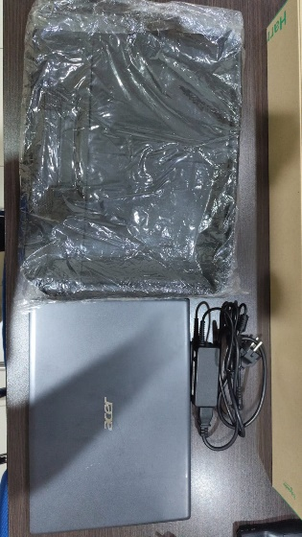
Telah diserahkan inventaris sebagai berikut :
- LAPTOP ACER ASPIRE 3 SLIM A314-22-R3RG (1 UNIT)
  - Processor : AMD Ryzen 3 3250U Processor 2.6 GHz (4M Cache; up to 3.5 GHz; 2 cores)
  - Display : 14″ HD 1366 x 768 resolution Acer ComfyView™
  - RAM : 8GB (2×4 GB DDR4)
  - Storage : 1x 512 GB SSD
  - SN : NXHVVSB0151452728A7600
  - Warna : Grey
- Charger Laptop (1 Unit)
- Tas Laptop (1 Unit)

Kepada :
Nama : Budi Sulistiono
Divisi : JPC Surabaya
NIK :

Notes :
Laptop Inventaris Untuk Karyawan Baru.

BERITA ACARA SERAH TERIMA INVENTARIS
Menerima,

Budi Sulistiono
Menyerahkan,

Petralina
Mengetahui,

Ali Rakhman

Menyetujui,

Bramantya Zain

PT. JAKARTA PRIMA CRANES
Wisma JPC, Jl. Mampang Prapatan Raya No.20

No. Dokumen : IT/BAST/2025/04/01
No. Inventaris : 6.2025/LT76.1/SBY
DEPARTEMEN GA-IT

Hari ………………, ……. ………… 2025
Telah diserahkan inventaris sebagai berikut :
- LAPTOP ACER ASPIRE 3 SLIM A314-22-R3RG (1 UNIT)
  - Processor : AMD Ryzen 3 3250U Processor 2.6 GHz (4M Cache; up to 3.5 GHz; 2 cores)
  - Display : 14″ HD 1366 x 768 resolution Acer ComfyView™
  - RAM : 8GB (2×4 GB DDR4)
  - Storage : 1x 512 GB SSD
  - SN : NXHVVSB0151452728A7600
  - Warna : Grey
- Charger Laptop (1 Unit)
- Tas Laptop (1 Unit)

Kepada :
Nama : Budi Sulistiono
Divisi : JPC Surabaya
NIK :

Notes :
Laptop Inventaris Untuk Karyawan Baru.

Menerima,

Budi Sulistiono
Menyerahkan,

Petralina
Mengetahui,

Ali Rakhman

Menyetujui,

Bramantya Zain

LABEL DI BELAKANG LAPTOP

NO INVENTARIS
6.2025/LT76.1/SBY
NO INVENTARIS
6.2025/LT76.1/SBY

EMAIL MS | NXHVVSB0151452728A7600@
PASS | JpcOffice2025
DATE | 14 / 4 / 2025
BAST | IT/BAST/2025/04/01
USER | JPC SURABAYA
EMAIL MS | NXHVVSB0151452728A7600@
PASS | JpcOffice2025
DATE | 14 / 4 / 2025
BAST | IT/BAST/2025/04/01
USER | JPC SURABAYA

PWR
PO
PWR
PO

LABEL DI CHARGER
NO INVENTARIS
6.2025/LT76.1/SBY

LABEL DI BOX LAPTOP
NO INVENTARIS
6.2025/LT76.1/SBY

EMAIL MS | NXHVVSB0151452728A7600@
PASS | JpcOffice2025
DATE | 14 / 4 / 2025
BAST | IT/BAST/2025/04/01
USER | JPC SURABAYA

PWR
PO

LABEL DI KARTU GARANSI
NO INVENTARIS
6.2025/LT76.1/SBY

EMAIL MS | NXHVVSB0151452728A7600@
PASS | JpcOffice2025
DATE | 14 / 4 / 2025
BAST | IT/BAST/2025/04/01
USER | JPC SURABAYA

PWR
PO

