BERITA ACARA SERAH TERIMA INVENTARIS
PT. JAKARTA PRIMA CRANES
Wisma JPC, Jl. Mampang Prapatan Raya No.20

No. Dokumen : IT/BAST/2025/07/03
No. Inventaris : 6.2025/LT54.5/WS1LT1
DEPARTEMEN GA-IT

Hari ………………, ……. ………… 2025
Telah diserahkan inventaris sebagai berikut :
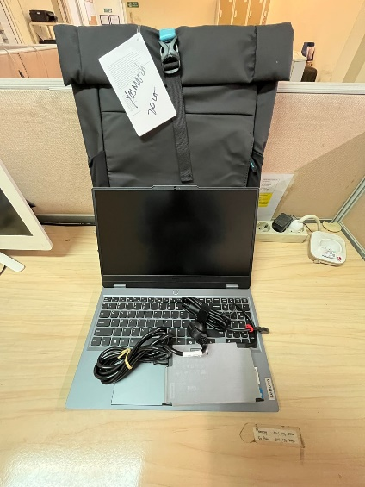
- LAPTOP LENOVO LOQ 15IRX9 - TYPE 83DV (1 UNIT)
  - Processor : 13th Generation Intel® Core™ i7-13650HX Processor(Core™ i7-13650HX)
  - Display : 15.6'' FHD NVIDIA® GeForce RTX™ 4060 8GB
  - RAM : 1x 12 GB DDR5-4800
  - Storage : 1x 512 GB SSD PCIe
  - SN : MP2RQ2XD
  - Warna : Luna Grey
- Charger Laptop (1 Unit)
- Tas Laptop Lenovo (1 Unit)

Kondisi : Baru
Kepada :

Nama : Yosmardi
Divisi : PE
NIK :
Notes :
Laptop Inventaris Baru Untuk User Yosmardi,
Reff PWR JPC/JKT/1372;PO JPC-JK/L/2025-0275; Include Lisensi AutoCAD 2026 LT; Ms. Project 2024

BERITA ACARA SERAH TERIMA INVENTARIS
Menerima,

Yosmardi
Menyerahkan,

M N Mahmudi
Mengetahui,

Ali Rakhman

Menyetujui,

Bramantya Zain

PT. JAKARTA PRIMA CRANES
Wisma JPC, Jl. Mampang Prapatan Raya No.20

No. Dokumen : IT/BAST/2025/07/03
No. Inventaris : 6.2025/LT54.5/WS1LT1
DEPARTEMEN GA-IT

Hari ………………, ……. ………… 2025
Telah diserahkan inventaris sebagai berikut :
- LAPTOP LENOVO LOQ 15IRX9 - TYPE 83DV (1 UNIT)
  - Processor : 13th Generation Intel® Core™ i7-13650HX Processor(Core™ i7-13650HX)
  - Display : 15.6'' FHD NVIDIA® GeForce RTX™ 4060 8GB
  - RAM : 1x 12 GB DDR5-4800
  - Storage : 1x 512 GB SSD PCIe
  - SN : MP2RQ2XD
  - Warna : Luna Grey
- Charger Laptop (1 Unit)
- Tas Laptop Lenovo (1 Unit)

Kondisi : Baru
Kepada :

Nama : Yosmardi
Divisi : PE
NIK :
Notes :
Laptop Inventaris Baru Untuk User Yosmardi,
Reff PWR JPC/JKT/1372;PO JPC-JK/L/2025-0275; Include Lisensi AutoCAD 2026 LT; Ms. Project 2024

------------------
Menerima,

Yosmardi
Menyerahkan,

M N Mahmudi
Mengetahui,

Ali Rakhman

Menyetujui,

Bramantya Zain

System Information
------------------
Time of this report: 7/10/2025, 14:22:23
Machine name: LAPTOP-YOSMARDI
Machine Id: {F2C6FC34-D172-4FF7-8FA9-799EC26C0584}
Operating System: Windows 11 Home Single Language 64-bit (10.0, Build 26100) (26100.ge_release.240331-1435)
Language: English (Regional Setting: English)
System Manufacturer: LENOVO
System Model: 83DV
BIOS: NECN44WW (type: UEFI)
Processor: 13th Gen Intel(R) Core(TM) i7-13650HX (20 CPUs), ~2.6GHz
Memory: 12288MB RAM
Available OS Memory: 11996MB RAM
Page File: 8435MB used, 5992MB available
Windows Dir: C:\Windows
DirectX Version: DirectX 12
---------------
Display Devices
---------------
Card name: NVIDIA GeForce RTX 4060 Laptop GPU
Manufacturer: NVIDIA
Chip type: NVIDIA GeForce RTX 4060 Laptop GPU
DAC type: Integrated RAMDAC
Device Type: Full Device
Device Key: Enum\PCI\VEN_10DE&DEV_28E0&SUBSYS_3D0617AA&REV_A1
Device Status: 0180600A [DN_DRIVER_LOADED|DN_STARTED|DN_DISABLEABLE|DN_REMOVABLE|DN_NT_ENUMERATOR|DN_NT_DRIVER]
Device Problem Code: No Problem
Driver Problem Code: Unknown
Display Memory: 13954 MB
Dedicated Memory: 7957 MB
Shared Memory: 5997 MB
------------------------
Disk & DVD/CD-ROM Drives
------------------------
Drive: C:
Free Space: 386.4 GB
Total Space: 486.1 GB
File System: NTFS
Model: Micron MTFDKCD512TGE-1BK1AABLA

LABEL DI BELAKANG LAPTOP

NO INVENTARIS
6.2025/LT54.5/WS1LT1
NO INVENTARIS
6.2025/LT54.5/WS1LT1

EMAIL MS | MP2RQ2XD@outlook.com
PASS | JpcOffice2025
DATE | 10 / 7 / 2025
BAST | IT/BAST/2025/07/03
USER | YOSMARDI
EMAIL MS | MP2RQ2XD@outlook.com
PASS | JpcOffice2025
DATE | 10 / 7 / 2025
BAST | IT/BAST/2025/07/03
USER | YOSMARDI

PWR | JPC/JKT/1372
PO | JPC-JK/L/2025-0275
PWR | JPC/JKT/1372
PO | JPC-JK/L/2025-0275

LABEL DI CHARGER
NO INVENTARIS
6.2025/LT54.5/WS1LT1

LABEL DI BOX LAPTOP
NO INVENTARIS
6.2025/LT54.5/WS1LT1

EMAIL MS | MP2RQ2XD@outlook.com
PASS | JpcOffice2025
DATE | 10 / 7 / 2025
BAST | IT/BAST/2025/07/03
USER | YOSMARDI

PWR | JPC/JKT/1372
PO | JPC-JK/L/2025-0275

LABEL DI KARTU GARANSI
NO INVENTARIS
6.2025/LT54.5/WS1LT1

EMAIL MS | MP2RQ2XD@outlook.com
PASS | JpcOffice2025
DATE | 10 / 7 / 2025
BAST | IT/BAST/2025/07/03
USER | YOSMARDI

PWR | JPC/JKT/1372
PO | JPC-JK/L/2025-0275

