BERITA ACARA SERAH TERIMA INVENTARIS
PT. JAKARTA PRIMA CRANES
Wisma JPC, Jl. Mampang Prapatan Raya No.20

No. Dokumen : IT/BAST/2025/09/01
No. Inventaris : 6.2025/LT82.1/WS1LT1
DEPARTEMEN GA-IT

Hari ………………, ……. ………… 2025
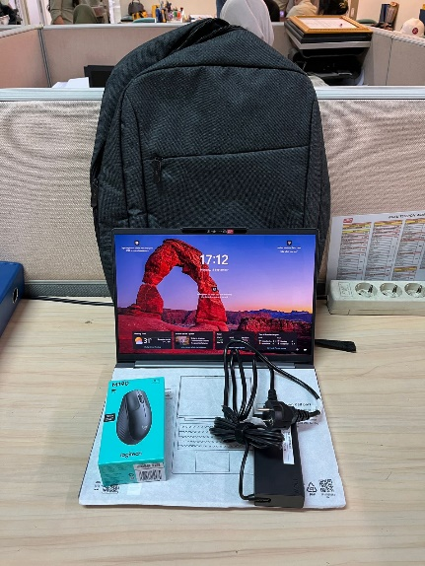
Telah diserahkan inventaris sebagai berikut :
- LAPTOP LENOVO IDEAPAD PRO 5 14IAH10 - Type 83LK (1 UNIT)
  - Processor : 1x Intel® Core™ Ultra 7 255H Processor(Core™ Ultra 7 255H)
  - Display : 1x Intel® Arc™ 140T GPU 14”
  - RAM : 1x 24 GBLPD5X-8533
  - Storage : 1x 1 TB SSD PCIe
  - SN : MP2RVN4X
  - Warna : Luna Grey
- Charger Laptop (1 Unit)
- Tas Laptop Lenovo (1 Unit)
- Mouse Logitech M190; SN: 2512LV2265G9 (1 Unit)

Kepada :
Nama : Nabila Maesya
Dept. : QHSE
NIP :

Notes :
Laptop Inventaris Baru Untuk User Nabila Maesya,

BERITA ACARA SERAH TERIMA INVENTARIS
Menerima,

Nabila Maesya
Menyerahkan,

M N Mahmudi
Mengetahui,

Ali Rakhman

Menyetujui,

Bramantya Zain

PT. JAKARTA PRIMA CRANES
Wisma JPC, Jl. Mampang Prapatan Raya No.20

No. Dokumen : IT/BAST/2025/09/01
No. Inventaris : 6.2025/LT82.1/WS1LT1
DEPARTEMEN GA-IT

Hari ………………, ……. ………… 2025
Telah diserahkan inventaris sebagai berikut :
- LAPTOP LENOVO IDEAPAD PRO 5 14IAH10 - Type 83LK (1 UNIT)
  - Processor : 1x Intel® Core™ Ultra 7 255H Processor(Core™ Ultra 7 255H)
  - Display : 1x Intel® Arc™ 140T GPU 14”
  - RAM : 1x 24 GBLPD5X-8533
  - Storage : 1x 1 TB SSD PCIe
  - SN : MP2RVN4X
  - Warna : Luna Grey
- Charger Laptop (1 Unit)
- Tas Laptop Lenovo (1 Unit)
- Mouse Logitech M190; SN: 2512LV2265G9 (1 Unit)

Kepada :
Nama : Nabila Maesya
Dept. : QHSE
NIP :

Notes :
Laptop Inventaris Baru Untuk User Nabila Maesya,

------------------
Menerima,

Nabila Maesya
Menyerahkan,

M N Mahmudi
Mengetahui,

Ali Rakhman

Menyetujui,

Bramantya Zain

System Information
------------------
Time of this report: 9/15/2025, 17:12:24
Machine name: LAPTOP-2E2VF80R
Machine Id: {18FC5FFD-8A34-405A-B56A-EBD1153D0A1D}
Operating System: Windows 11 Home Single Language 64-bit (10.0, Build 26100) (26100.ge_release.240331-1435)
Language: English (Regional Setting: English)
System Manufacturer: LENOVO
System Model: 83JK
BIOS: QLCN28WW (type: UEFI)
Processor: Intel(R) Core(TM) Ultra 7 255H (16 CPUs), ~2.0GHz
Memory: 24576MB RAM
Available OS Memory: 24062MB RAM
Page File: 8320MB used, 19708MB available
Windows Dir: C:\Windows
DirectX Version: DirectX 12
---------------
Display Devices
Card name: Intel(R) Arc(TM) 140T GPU (12GB)
Manufacturer: Intel Corporation
Chip type: Intel(R) Arc(TM) Graphics Family
DAC type: Internal
Device Type: Full Device (POST)
Device Key: Enum\PCI\VEN_8086&DEV_7D51&SUBSYS_380317AA&REV_03
Device Status: 0180200A [DN_DRIVER_LOADED|DN_STARTED|DN_DISABLEABLE|DN_NT_ENUMERATOR|DN_NT_DRIVER]
Device Problem Code: No Problem
Driver Problem Code: Unknown
Display Memory: 13842 MB
Dedicated Memory: 128 MB
Shared Memory: 13714 MB
------------------------
Disk & DVD/CD-ROM Drives
------------------------
Drive: C:
Free Space: 275.5 GB
Total Space: 374.5 GB
File System: NTFS
Model: WD PC SN7100S SDFPMSL-1T00-1101
Drive: E:
Free Space: 599.9 GB
Total Space: 600.0 GB
File System: NTFS
Model: WD PC SN7100S SDFPMSL-1T00-1101

LABEL DI BELAKANG LAPTOP

NO INVENTARIS
6.2025/LT82.1/WS1LT1
NO INVENTARIS
6.2025/LT82.1/WS1LT1

EMAIL MS | MP2RVN4X@outlook.com
PASS | JpcOffice2025
DATE | 15 / 9 / 2025
BAST | IT/BAST/2025/09/01
USER | NABILA MAESYA
EMAIL MS | MP2RVN4X@outlook.com
PASS | JpcOffice2025
DATE | 15 / 9 / 2025
BAST | IT/BAST/2025/09/01
USER | NABILA MAESYA

PWR
PO
PWR
PO

LABEL DI CHARGER
NO INVENTARIS
6.2025/LT82.1/WS1LT1

LABEL DI BOX LAPTOP
NO INVENTARIS
6.2025/LT82.1/WS1LT1

EMAIL MS | MP2RVN4X@outlook.com
PASS | JpcOffice2025
DATE | 15 / 9 / 2025
BAST | IT/BAST/2025/09/01
USER | NABILA MAESYA

PWR
PO

LABEL DI KARTU GARANSI
NO INVENTARIS
6.2025/LT82.1/WS1LT1

EMAIL MS | MP2RVN4X@outlook.com
PASS | JpcOffice2025
DATE | 15 / 9 / 2025
BAST | IT/BAST/2025/09/01
USER | NABILA MAESYA

PWR
PO

