BERITA ACARA SERAH TERIMA INVENTARIS
PT. JAKARTA PRIMA CRANES
Wisma JPC, Jl. Mampang Prapatan Raya No.20

No. Dokumen : IT/BAST/2025/08/05
No. Inventaris : 6.2025/LT79.3/WS1LT1
DEPARTEMEN GA-IT

Hari ………………, ……. ………… 2025
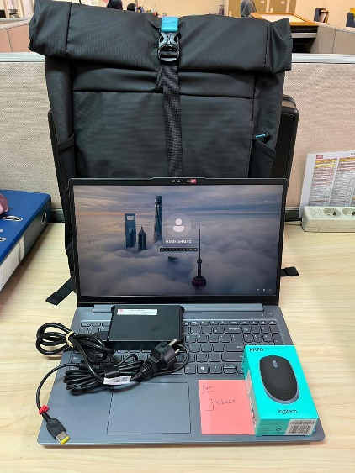
Telah diserahkan inventaris sebagai berikut :
- LAPTOP LENOVO LOQ 15IAX9E - Type 83LK (1 UNIT)
  - Processor : 12th Generation Intel® Core™ i5-12450HX Processor(Core™ i5-12450HX)
  - Display : NVIDIA® GeForce RTX™ 2050 4GB
  - RAM : 1x 12 GB DDR5-4800
  - Storage : 1x 512 GB SSD PCIe
  - SN : PF5CFY53
  - Warna : Luna Grey
- Charger Laptop (1 Unit)
- Tas Laptop Lenovo (1 Unit)
- Mouse Logitech M170 (1 Unit)

Kepada :
Nama : Haris Ahmad
Divisi : JPC Surabaya
NIK :

Notes :
Laptop Inventaris Baru Untuk User Haris Ahmad,

BERITA ACARA SERAH TERIMA INVENTARIS
Menerima,

Haris Ahmad
Menyerahkan,

M N Mahmudi
Mengetahui,

Ali Rakhman

Menyetujui,

Bramantya Zain

PT. JAKARTA PRIMA CRANES
Wisma JPC, Jl. Mampang Prapatan Raya No.20

No. Dokumen : IT/BAST/2025/08/05
No. Inventaris : 6.2025/LT79.3/WS1LT1
DEPARTEMEN GA-IT

Hari ………………, ……. ………… 2025
Telah diserahkan inventaris sebagai berikut :
- LAPTOP LENOVO LOQ 15IAX9E - Type 83LK (1 UNIT)
  - Processor : 12th Generation Intel® Core™ i5-12450HX Processor(Core™ i5-12450HX)
  - Display : NVIDIA® GeForce RTX™ 2050 4GB
  - RAM : 1x 12 GB DDR5-4800
  - Storage : 1x 512 GB SSD PCIe
  - SN : PF5CFY53
  - Warna : Luna Grey
- Charger Laptop (1 Unit)
- Tas Laptop Lenovo (1 Unit)
- Mouse Logitech M170 (1 Unit)

Kepada :
Nama : Haris Ahmad
Divisi : JPC Surabaya
NIK :

Notes :
Laptop Inventaris Baru Untuk User Haris Ahmad,

Menerima,

Haris Ahmad
Menyerahkan,

M N Mahmudi
Mengetahui,

Ali Rakhman

Menyetujui,

Bramantya Zain

------------------
System Information
------------------
Time of this report: 9/10/2025, 14:44:38
Machine name: HARIS-AHMAD
Machine Id: {453F8D7F-6F96-4B76-A782-76E50913EA38}
Operating System: Windows 11 Home Single Language 64-bit (10.0, Build 26100) (26100.ge_release.240331-1435)
Language: English (Regional Setting: English)
System Manufacturer: LENOVO
System Model: 83LK
BIOS: Q8CN19WW (type: UEFI)
Processor: 12th Gen Intel(R) Core(TM) i5-12450HX (12 CPUs), ~2.4GHz
Memory: 12288MB RAM
Available OS Memory: 12012MB RAM
Page File: 6948MB used, 7495MB available
Windows Dir: C:\Windows
DirectX Version: DirectX 12
Card name: NVIDIA GeForce RTX 3050 6GB Laptop GPU
Manufacturer: NVIDIA
Chip type: NVIDIA GeForce RTX 3050 6GB Laptop GPU
DAC type: Integrated RAMDAC
Device Type: Full Device
Device Key: Enum\PCI\VEN_10DE&DEV_25AC&SUBSYS_3DA017AA&REV_A1
Device Status: 0180600A [DN_DRIVER_LOADED|DN_STARTED|DN_DISABLEABLE|DN_REMOVABLE|DN_NT_ENUMERATOR|DN_NT_DRIVER]
Device Problem Code: No Problem
Driver Problem Code: Unknown
Display Memory: 12007 MB
Dedicated Memory: 6002 MB
Shared Memory: 6005 MB
------------------------
Disk & DVD/CD-ROM Drives
------------------------
Drive: C:
Free Space: 114.2 GB
Total Space: 216.1 GB
File System: NTFS
Model: Micron MTFDKCD512QFM-1BD1AABLA

Drive: D:
Free Space: 269.9 GB
Total Space: 270.0 GB
File System: NTFS
Model: Micron MTFDKCD512QFM-1BD1AABLA

LABEL DI BELAKANG LAPTOP

NO INVENTARIS
6.2025/LT79.3/WS1LT1
NO INVENTARIS
6.2025/LT79.3/WS1LT1

EMAIL MS | PF5CFY53@outlook.com
PASS | JpcOffice2025
DATE | 15 / 5 / 2025
BAST | IT/BAST/2025/08/05
USER | HARIS AHMAD
EMAIL MS | PF5CFY53@outlook.com
PASS | JpcOffice2025
DATE | 15 / 5 / 2025
BAST | IT/BAST/2025/08/05
USER | HARIS AHMAD

PWR | JPC/2025/1275
PO | JPC-JK/L/2025-0244
PWR | JPC/2025/1275
PO | JPC-JK/L/2025-0244

LABEL DI CHARGER
NO INVENTARIS
6.2025/LT79.3/WS1LT1

LABEL DI BOX LAPTOP
NO INVENTARIS
6.2025/LT79.3/WS1LT1

EMAIL MS | PF5CFY53@outlook.com
PASS | JpcOffice2025
DATE | 15 / 5 / 2025
BAST | IT/BAST/2025/08/05
USER | HARIS AHMAD

PWR | JPC/2025/1275
PO | JPC-JK/L/2025-0244

LABEL DI KARTU GARANSI
NO INVENTARIS
6.2025/LT79.3/WS1LT1

EMAIL MS | PF5CFY53@outlook.com
PASS | JpcOffice2025
DATE | 15 / 5 / 2025
BAST | IT/BAST/2025/08/05
USER | HARIS AHMAD

PWR | JPC/2025/1275
PO | JPC-JK/L/2025-0244

