BERITA ACARA SERAH TERIMA INVENTARIS
PT. JAKARTA PRIMA CRANES
Wisma JPC, Jl. Mampang Prapatan Raya No.20

No. Dokumen : IT/BAST/2025/05/03
No. Inventaris : 6.2025/LT79.1/SBY
DEPARTEMEN GA-IT

Hari ………………, ……. ………… 2025
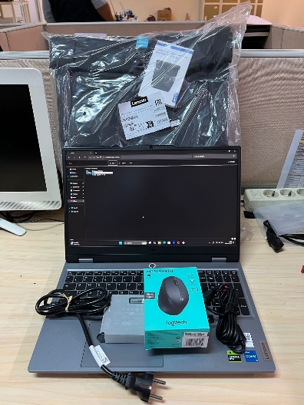
Telah diserahkan inventaris sebagai berikut :
- LAPTOP LENOVO LOQ 15IAX9E - Type 83LK (1 UNIT)
  - Processor : 12th Generation Intel® Core™ i5-12450HX Processor(Core™ i5-12450HX)
  - Display : NVIDIA® GeForce RTX™ 2050 4GB
  - RAM : 1x 12 GB DDR5-4800
  - Storage : 1x 512 GB SSD PCIe
  - SN : PF57LJNL
  - Warna : Luna Grey
- Charger Laptop (1 Unit)
- Tas Laptop Lenovo (1 Unit)
- Mouse Logitech M330 (1 Unit)

Kepada :
Nama :
Divisi : JPC Surabaya
NIK :

Notes :
Laptop Inventaris Baru Untuk User Karyawan Baru Surabaya,

BERITA ACARA SERAH TERIMA INVENTARIS
Menerima,

_______________
Menyerahkan,

Petralina
Mengetahui,

Ali Rakhman

Menyetujui,

Bramantya Zain

PT. JAKARTA PRIMA CRANES
Wisma JPC, Jl. Mampang Prapatan Raya No.20

No. Dokumen : IT/BAST/2025/05/03
No. Inventaris : 6.2025/LT79.1/SBY
DEPARTEMEN GA-IT

Hari ………………, ……. ………… 2025
Telah diserahkan inventaris sebagai berikut :
- LAPTOP LENOVO LOQ 15IAX9E - Type 83LK (1 UNIT)
  - Processor : 12th Generation Intel® Core™ i5-12450HX Processor(Core™ i5-12450HX)
  - Display : NVIDIA® GeForce RTX™ 2050 4GB
  - RAM : 1x 12 GB DDR5-4800
  - Storage : 1x 512 GB SSD PCIe
  - SN : PF57LJNL
  - Warna : Luna Grey
- Charger Laptop (1 Unit)
- Tas Laptop Lenovo (1 Unit)
- Mouse Logitech M330 (1 Unit)

Kepada :
Nama :
Divisi : JPC Surabaya
NIK :

Notes :
Laptop Inventaris Baru Untuk User Karyawan Baru Surabaya,

------------------
Menerima,

_______________
Menyerahkan,

Petralina
Mengetahui,

Ali Rakhman

Menyetujui,

Bramantya Zain

System Information
------------------
Time of this report: 5/5/2025, 09:26:39
Machine name: LAPTOP-8FNQU4RV
Machine Id: {0AA0CCC7-7261-44BC-8F42-5E5EB2DC4F6F}
Operating System: Windows 11 Home Single Language 64-bit (10.0, Build 26100) (26100.ge_release.240331-1435)
Language: English (Regional Setting: English)
System Manufacturer: LENOVO
System Model: 83GS
BIOS: NECN40WW (type: UEFI)
Processor: 12th Generation Intel® Core™ i5-12450HX Processor(Core™ i5-12450HX)
Memory: 12288MB RAM
Available OS Memory: 11996MB RAM
Page File: 8284MB used, 6143MB available
Windows Dir: C:\Windows
DirectX Version: DirectX 12
---------------
Display Devices
---------------
Card name: NVIDIA GeForce RTX 3050 6GB Laptop GPU
Manufacturer: NVIDIA
Chip type: NVIDIA GeForce RTX 3050 6GB Laptop GPU
DAC type: Integrated RAMDAC
Device Type: Full Device
Device Key: Enum\PCI\VEN_10DE&DEV_25EC&SUBSYS_3D0617AA&REV_A1
Device Status: 0180600A [DN_DRIVER_LOADED|DN_STARTED|DN_DISABLEABLE|DN_REMOVABLE|DN_NT_ENUMERATOR|DN_NT_DRIVER]
Device Problem Code: No Problem
Driver Problem Code: Unknown
Display Memory: 11999 MB
Dedicated Memory: 6002 MB
Shared Memory: 5997 MB

------------------------
Disk & DVD/CD-ROM Drives
------------------------
Drive: C:
Free Space: 124.5 GB
Total Space: 206.1 GB
File System: NTFS
Model: Micron MTFDKCD512QGN-1BN1AABLA

Drive: D:
Free Space: 278.8 GB
Total Space: 280.0 GB
File System: NTFS
Model: Micron MTFDKCD512QGN-1BN1AABLA

LABEL DI BELAKANG LAPTOP

NO INVENTARIS
6.2025/LT79.1/SBY
NO INVENTARIS
6.2025/LT79.1/SBY

EMAIL MS | PF57LJNL@outlook.com
PASS | JpcOffice2025
DATE | 15 / 5 / 2025
BAST | IT/BAST/2025/05/03
USER | USER SURABAYA
EMAIL MS | PF57LJNL@outlook.com
PASS | JpcOffice2025
DATE | 15 / 5 / 2025
BAST | IT/BAST/2025/05/03
USER | USER SURABAYA

PWR | SBY/2025/0576
PO | SBY-SB/L/2025-0129
PWR | SBY/2025/0576
PO | SBY-SB/L/2025-0129

LABEL DI CHARGER
NO INVENTARIS
6.2025/LT79.1/SBY

LABEL DI BOX LAPTOP
NO INVENTARIS
6.2025/LT79.1/SBY

EMAIL MS | PF57LJNL@outlook.com
PASS | JpcOffice2025
DATE | 15 / 5 / 2025
BAST | IT/BAST/2025/05/03
USER | USER SURABAYA

PWR | SBY/2025/0576
PO | SBY-SB/L/2025-0129

LABEL DI KARTU GARANSI
NO INVENTARIS
6.2025/LT79.1/SBY

EMAIL MS | PF57LJNL@outlook.com
PASS | JpcOffice2025
DATE | 15 / 5 / 2025
BAST | IT/BAST/2025/05/03
USER | USER SURABAYA

PWR | SBY/2025/0576
PO | SBY-SB/L/2025-0129

