BERITA ACARA SERAH TERIMA INVENTARIS
PT. JAKARTA PRIMA CRANES
Wisma JPC, Jl. Mampang Prapatan Raya No.20

No. Dokumen : IT/BAST/2025/09/02
No. Inventaris : 6.2025/LT82.1/PKU
DEPARTEMEN GA-IT

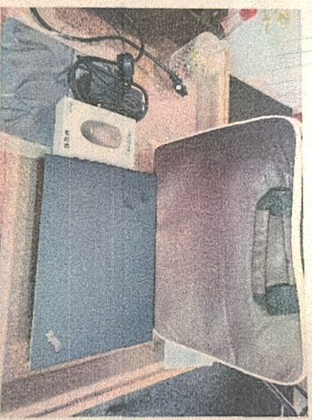
Hari ………………, ……. ………… 2025
Telah diserahkan inventaris sebagai berikut :
- LAPTOP LENOVO T14 GEN 2 (TYPE 20W0, 20W1) THINKPAD- TYPE 20W0 (1 UNIT)
  - Processor : 11th Generation Intel® Core™ i5-1135G7 Processor(Core™ i5-1135G7)
  - Display : 14.0 FHD Intel UHD Graphics
  - RAM : 1x 16GB DDR4 3200
  - Storage : 1x 512GBPCIeOPAL2
  - SN : PF2WW2BV
  - Warna : Luna Grey
- Charger Laptop (1 Unit)
- Tas Laptop Lenovo (1 Unit)
- Mouse (1 Unit)

Kepada :
Nama : Niko Andrian
Dept. : JPC Pekanbaru
NIP :

Notes :
Laptop second untuk user Niko Andrian,
Pembelian langsung dengan Reff Kwitansi Rp. 5.850.000

Menerima,

Niko Andrian
Menyerahkan,

Ramadhanil
Mengetahui,

Ali Rakhman

Menyetujui,

Bramantya Zain

LABEL DI BELAKANG LAPTOP

NO INVENTARIS
6.2025/LT82.1/PKU

EMAIL MS | PF2WW2BV@outlook.com
PASS | JpcOffice2025
DATE | 25 / 9 / 2025
BAST | IT/BAST/2025/09/02
USER | NIKO ANDRIAN

LABEL DI CHARGER
NO INVENTARIS
6.2025/LT82.1/PKU

LABEL DI BOX LAPTOP
NO INVENTARIS
6.2025/LT82.1/PKU

EMAIL MS | PF2WW2BV@outlook.com
PASS | JpcOffice2025
DATE | 25 / 9 / 2025
BAST | IT/BAST/2025/09/02
USER | NIKO ANDRIAN

