BERITA ACARA SERAH TERIMA INVENTARIS
PT. JAKARTA PRIMA CRANES
Wisma JPC, Jl. Mampang Prapatan Raya No.20

No. Dokumen : IT/BAST/2025/07/01
No. Inventaris : 6.2025/LT81.1/WS1LT2
DEPARTEMEN GA-IT

Hari ………………, ……. ………… 2025
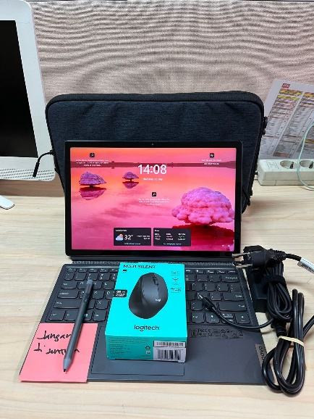
Telah diserahkan inventaris sebagai berikut :
- LAPTOP LENOVO IdeaPad Duet 5 12IRU8 - Type 83B3 (1 UNIT)
  - Processor : 13th Generation Intel® Core™ i7-1355U Processor(Core™ i7-1355U)
  - Display : 12.4" WQXGA Intel® Iris® Xe Graphics
  - RAM : 1x 16GB LPD4X-4266
  - Storage : 1x 512 GB SSD PCIe
  - SN : PF55NSVE
  - Warna : Luna Grey
- Charger Laptop (1 Unit)
- Stylus Pen (1 Unit)
- Mouse Logitech M331 (1 Unit)
- Tas Laptop Lenovo (1 Unit)
Kondisi : Baru
Kepada :
Nama : Gialdy Permana
Divisi : FA
NIK :
Notes :
Laptop Inventaris Baru Untuk User Gialdy Permana,
Reff PWR JPC/2025/0413; REFF PO JPC-JK/L/2025-0264

BERITA ACARA SERAH TERIMA INVENTARIS
Menerima,

Gialdy Permana
Menyerahkan,

M N Mahmudi
Mengetahui,

Ali Rakhman

Menyetujui,

Bramantya Zain

PT. JAKARTA PRIMA CRANES
Wisma JPC, Jl. Mampang Prapatan Raya No.20

No. Dokumen : IT/BAST/2025/07/01
No. Inventaris : 6.2025/LT81.1/WS1LT2
DEPARTEMEN GA-IT

Hari ………………, ……. ………… 2025
Telah diserahkan inventaris sebagai berikut :
- LAPTOP LENOVO IdeaPad Duet 5 12IRU8 - Type 83B3 (1 UNIT)
  - Processor : 13th Generation Intel® Core™ i7-1355U Processor(Core™ i7-1355U)
  - Display : 12.4" WQXGA Intel® Iris® Xe Graphics
  - RAM : 1x 16GB LPD4X-4266
  - Storage : 1x 512 GB SSD PCIe
  - SN : PF55NSVE
  - Warna : Luna Grey
- Charger Laptop (1 Unit)
- Stylus Pen (1 Unit)
- Mouse Logitech M331 (1 Unit)
- Tas Laptop Lenovo (1 Unit)
Kondisi : Baru
Kepada :
Nama : Gialdy Permana
Divisi : FA
NIK :
Notes :
Laptop Inventaris Baru Untuk User Gialdy Permana,
Reff PWR JPC/2025/0413; REFF PO JPC-JK/L/2025-0264

------------------
Menerima,

Gialdy Permana
Menyerahkan,

M N Mahmudi
Mengetahui,

Ali Rakhman

Menyetujui,

Bramantya Zain

System Information
------------------
Time of this report: 7/3/2025, 14:09:53
Machine name: LAPTOP-GIALDY-2
Machine Id: {357F474B-C6F4-43BA-A202-45F84370C204}
Operating System: Windows 11 Home Single Language 64-bit (10.0, Build 26100) (26100.ge_release.240331-1435)
Language: English (Regional Setting: English)
System Manufacturer: LENOVO
System Model: 83B3
BIOS: M7CN26WW(V1.13) (type: UEFI)
Processor: 13th Gen Intel(R) Core(TM) i7-1355U (12 CPUs), ~1.7GHz
Memory: 16384MB RAM
Available OS Memory: 16108MB RAM
Page File: 6999MB used, 12052MB available
Windows Dir: C:\Windows
DirectX Version: DirectX 12
---------------
Display Devices
---------------
Card name: Intel(R) Iris(R) Xe Graphics
Manufacturer: Intel Corporation
Chip type: Intel(R) Iris(R) Xe Graphics Family
DAC type: Internal
Device Type: Full Device (POST)
Device Key: Enum\PCI\VEN_8086&DEV_A7A1&SUBSYS_3CD817AA&REV_04
Device Status: 0180200A [DN_DRIVER_LOADED|DN_STARTED|DN_DISABLEABLE|DN_NT_ENUMERATOR|DN_NT_DRIVER]
Device Problem Code: No Problem
Driver Problem Code: Unknown
Display Memory: 8181 MB
Dedicated Memory: 128 MB
Shared Memory: 8053 MB
------------------------
Disk & DVD/CD-ROM Drives
------------------------
Drive: C:
Free Space: 113.8 GB
Total Space: 186.1 GB
File System: NTFS
Model: WD PC SN740 SDDPMQD-512G-1101

Drive: E:
Free Space: 299.9 GB
Total Space: 300.0 GB
File System: NTFS
Model: WD PC SN740 SDDPMQD-512G-1101

LABEL DI BELAKANG LAPTOP

NO INVENTARIS
6.2025/LT81.1/WS1LT2
NO INVENTARIS
6.2025/LT81.1/WS1LT2

EMAIL MS | PF55NSVE@outlook.com
PASS | JpcOffice2025
DATE | 03 / 7 / 2025
BAST | IT/BAST/2025/07/01
USER | GIALDY PERMANA
EMAIL MS | PF55NSVE@outlook.com
PASS | JpcOffice2025
DATE | 03 / 7 / 2025
BAST | IT/BAST/2025/07/01
USER | GIALDY PERMANA

PWR | JPC/2025/0413
PO | JPC-JK/L/2025-0264
PWR | JPC/2025/0413
PO | JPC-JK/L/2025-0264

LABEL DI CHARGER
NO INVENTARIS
6.2025/LT81.1/WS1LT2

LABEL DI BOX LAPTOP
NO INVENTARIS
6.2025/LT81.1/WS1LT2

EMAIL MS | PF55NSVE@outlook.com
PASS | JpcOffice2025
DATE | 03 / 7 / 2025
BAST | IT/BAST/2025/07/01
USER | GIALDY PERMANA

PWR | JPC/2025/0413
PO | JPC-JK/L/2025-0264

LABEL DI KARTU GARANSI
NO INVENTARIS
6.2025/LT81.1/WS1LT2

EMAIL MS | PF55NSVE@outlook.com
PASS | JpcOffice2025
DATE | 03 / 7 / 2025
BAST | IT/BAST/2025/07/01
USER | GIALDY PERMANA

PWR | JPC/2025/0413
PO | JPC-JK/L/2025-0264

