BERITA ACARA SERAH TERIMA INVENTARIS
PT. JAKARTA PRIMA CRANES
Wisma JPC, Jl. Mampang Prapatan Raya No.20

No. Dokumen : IT/BAST/2023/12/001
No. Inventaris : HDP-2023-001
DEPARTEMEN GA-IT

Hari ………………, ……. ………… 2023
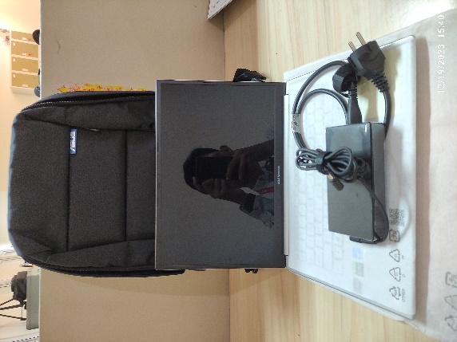
Telah diserahkan inventaris sebagai berikut :
- Laptop ASUS Vivobook Pro 14 OLED Type M3401Q (1 Unit)
  - Processor : AMD Ryzen™ 7 5800H/HS Mobile Processor 3.2 GHz (8-core/16-thread, 16MB cache, up to 4.4 GHz max boost)
  - Display : 14.0-inch, 3K (2880 x 1800) OLED NVIDIA® GeForce® RTX™ 3050 Laptop GPU 4GB GDDR6
  - RAM : 1x 8GB DDR4 on board
  - Storage : 1x 512GB M.2 NVMe™ PCIe® 3.0 SSD
  - SN : N3N0CX13452310B
  - Warna : Arctic Grey
- Charger Laptop (1 Unit)
- Tas Laptop ASUS (1 Unit)

Kondisi : 100% (Baru)
Kepada :

Nama : Hendra Permana
Divisi : PE
NIK :
Notes :
Laptop baru untuk Hendra Permana., Reff PO. 2023/JKT-L-0442
Inc Lisensi Office Pro Plus 2021

Menyetujui,

Bramantya Zain

Mengetahui,

Ali Rakhman

Menerima,

Hendra Permana
Menyerahkan,

M N Mahmudi
BERITA ACARA SERAH TERIMA INVENTARIS
PT. JAKARTA PRIMA CRANES
Wisma JPC, Jl. Mampang Prapatan Raya No.20

No. Dokumen : IT/BAST/2023/12/001
No. Inventaris : HDP-2023-001
DEPARTEMEN GA-IT

Hari ………………, ……. ………… 2023
Telah diserahkan inventaris sebagai berikut :
- Laptop ASUS Vivobook Pro 14 OLED Type M3401Q (1 Unit)
  - Processor : AMD Ryzen™ 7 5800H/HS Mobile Processor 3.2 GHz (8-core/16-thread, 16MB cache, up to 4.4 GHz max boost)
  - Display : 14.0-inch, 3K (2880 x 1800) OLED NVIDIA® GeForce® RTX™ 3050 Laptop GPU 4GB GDDR6
  - RAM : 1x 8GB DDR4 on board
  - Storage : 1x 512GB M.2 NVMe™ PCIe® 3.0 SSD
  - SN : N3N0CX13452310B
  - Warna : Arctic Grey
- Charger Laptop (1 Unit)
- Tas Laptop ASUS (1 Unit)

Kondisi : 100% (Baru)
Kepada :

Nama : Hendra Permana
Divisi : PE
NIK :
Notes :
Laptop baru untuk Hendra Permana., Reff PO. 2023/JKT-L-0442
Inc Lisensi Office Pro Plus 2021

Menyetujui,

Bramantya Zain

Mengetahui,

Ali Rakhman

Menerima,

Hendra Permana
Menyerahkan,

M N Mahmudi
------------------
System Information
------------------
Time of this report: 12/19/2023, 14:05:08
Machine name: HDP-2023-001
Machine Id: {3BE8256F-8DFD-45BB-B261-6243AC55D630}
Operating System: Windows 11 Home Single Language 64-bit (10.0, Build 22000) (22000.co_release.210604-1628)
Language: English (Regional Setting: English)
System Manufacturer: ASUSTeK COMPUTER INC.
System Model: Vivobook_ASUSLaptop M3401QC_M3401QC
BIOS: M3401QC.304 (type: UEFI)
Processor: AMD Ryzen 7 5800H with Radeon Graphics (16 CPUs), ~3.2GHz
Memory: 8192MB RAM
Available OS Memory: 7584MB RAM
Page File: 4778MB used, 4661MB available
Windows Dir: C:\WINDOWS
DirectX Version: DirectX 12
---------------
Display Devices
---------------
Card name: AMD Radeon(TM) Graphics
Manufacturer: Advanced Micro Devices, Inc.
Chip type: AMD Radeon Graphics Processor (0x1638)
DAC type: Internal DAC(400MHz)
Device Type: Full Device (POST)
Device Key: Enum\PCI\VEN_1002&DEV_1638&SUBSYS_1B321043&REV_C5
Device Status: 0180200A [DN_DRIVER_LOADED|DN_STARTED|DN_DISABLEABLE|DN_NT_ENUMERATOR|DN_NT_DRIVER]
Device Problem Code: No Problem
Driver Problem Code: Unknown
Display Memory: 4288 MB
Dedicated Memory: 496 MB
Shared Memory: 3791 MB
Current Mode: 2880 x 1800 (32 bit) (90Hz)
------------------------
Disk & DVD/CD-ROM Drives
------------------------
Drive: C:
Free Space: 186.2 GB
Total Space: 236.8 GB
File System: NTFS
Model: INTEL SSDPEKNU512GZ

Drive: D:
Free Space: 245.3 GB
Total Space: 250.0 GB
File System: NTFS
Model: INTEL SSDPEKNU512GZ

LABEL DI BELAKANG LAPTOP

NO INVENTARIS
HDP | - | 2023 | - | 001

EMAIL MS | jpc2023_023@outlook.com
PASS | JpcOffice2023
TGL | 19 / 12 / 2023
BA | IT/BAST/2023/12/001
USER | HENDRA PERMANA

PWR | 2023/JKT-0752
PO | 2023/JKT-L-0442

LABEL DI CHARGER
NO INVENTARIS
HDP | - | 2023 | - | 001

LABEL DI BOX LAPTOP
NO INVENTARIS
HDP | - | 2023 | - | 001

EMAIL MS | jpc2023_023@outlook.com
PASS | JpcOffice2023
TGL | 19 / 12 / 2023
BA | IT/BAST/2023/12/001
USER | HENDRA PERMANA

PWR | 2023/JKT-0752
PO | 2023/JKT-L-0442

LABEL DI KARTU GARANSI
NO INVENTARIS
HDP | - | 2023 | - | 001

EMAIL MS | jpc2023_023@outlook.com
PASS | JpcOffice2023
TGL | 19 / 12 / 2023
BA | IT/BAST/2023/12/001
USER | HENDRA PERMANA

PWR | 2023/JKT-0752
PO | 2023/JKT-L-0442

