BERITA ACARA SERAH TERIMA INVENTARIS
PT. JAKARTA PRIMA CRANES
Wisma JPC, Jl. Mampang Prapatan Raya No.20

No. Dokumen : GA/2023/06/010
No. Inventaris : ERH-2023-001
DEPARTEMEN GA-IT

Hari ………………, ……. ………… 2023
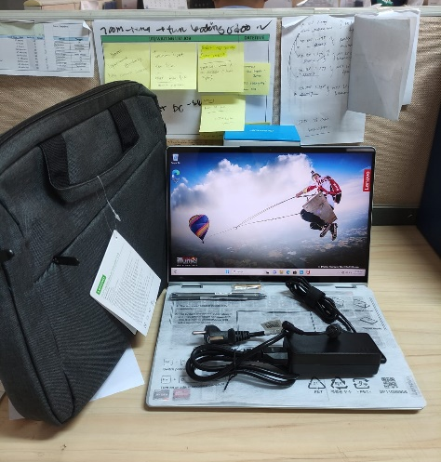
Telah diserahkan inventaris sebagai berikut :
- Laptop LENOVO IdeaPad Flex 5 14ALC7 Laptop - Type 82R9 (1 Unit)
  - Processor : AMD Ryzen™ 7 5700U Processor(Ryzen™ 7 5700U)
  - Display : 14” WUXGA IPS AMD Radeon™ Graphics
  - RAM : 1x 16GB LPD4X-4266
  - Storage : 1x 512 GB SSD PCIe
  - SN : PW029J7H
  - Warna : Cloud Grey
- Charger Laptop (1 Unit)
- Tas Laptop LENOVO (1 Unit)

Kondisi : 100% (Baru)
Kepada :

Nama : Eryc Hermanu
Divisi : PE
NIK :
Notes :
Laptop baru, Laptop lama telah terjadi tindak pencurian oleh orang tidak dikenal.

Menyetujui,

( Bramantya Zain )
Menyerahkan,

( M Nurhasan Mahmudi )
Menerima,

( Eryc Hermanu )
BERITA ACARA SERAH TERIMA INVENTARIS
PT. JAKARTA PRIMA CRANES
Wisma JPC, Jl. Mampang Prapatan Raya No.20

No. Dokumen : GA/2023/06/010
No. Inventaris : ERH-2023-001
DEPARTEMEN GA-IT

Hari ………………, ……. ………… 2023
Telah diserahkan inventaris sebagai berikut :
- Laptop LENOVO IdeaPad Flex 5 14ALC7 Laptop - Type 82R9 (1 Unit)
  - Processor : AMD Ryzen™ 7 5700U Processor(Ryzen™ 7 5700U)
  - Display : 14” WUXGA IPS AMD Radeon™ Graphics
  - RAM : 1x 16GB LPD4X-4266
  - Storage : 1x 512 GB SSD PCIe
  - SN : PW029J7H
  - Warna : Cloud Grey
- Charger Laptop (1 Unit)
- Tas Laptop LENOVO (1 Unit)

Kondisi : 100% (Baru)
Kepada :

Nama : Eryc Hermanu
Divisi : PE
NIK :
Notes :
Laptop baru, Laptop lama telah terjadi tindak pencurian oleh orang tidak dikenal.

Menyetujui,

( Bramantya Zain )
Menyerahkan,

( M Nurhasan Mahmudi )
Menerima,

( Eryc Hermanu )
------------------
System Information
------------------
Time of this report: 6/21/2023, 13:14:46
Machine name: ERH-2023-001
Machine Id: {E7D59A40-F0B2-40D4-A1DC-27648DD52439}
Operating System: Windows 11 Home Single Language 64-bit (10.0, Build 22000) (22000.co_release.210604-1628)
Language: English (Regional Setting: English)
System Manufacturer: LENOVO
System Model: 82R9
BIOS: JCCN34WW (type: UEFI)
Processor: AMD Ryzen 7 5700U with Radeon Graphics (16 CPUs), ~1.8GHz
Memory: 16384MB RAM
Available OS Memory: 15710MB RAM
Page File: 7348MB used, 11305MB available
Windows Dir: C:\Windows
DirectX Version: DirectX 12
---------------
Display Devices
---------------
Card name: AMD Radeon(TM) Graphics
Manufacturer: Advanced Micro Devices, Inc.
Chip type: AMD Radeon Graphics Processor (0x164C)
DAC type: Internal DAC(400MHz)
Device Type: Full Device (POST)
Device Key: Enum\PCI\VEN_1002&DEV_164C&SUBSYS_380617AA&REV_C1
Device Status: 0180200A [DN_DRIVER_LOADED|DN_STARTED|DN_DISABLEABLE|DN_NT_ENUMERATOR|DN_NT_DRIVER]
Device Problem Code: No Problem
Driver Problem Code: Unknown
Display Memory: 8350 MB
Dedicated Memory: 495 MB
Shared Memory: 7854 MB
Current Mode: 1920 x 1200 (32 bit) (60Hz)
------------------------
Disk & DVD/CD-ROM Drives
------------------------
Drive: C:
Free Space: 109.3 GB
Total Space: 186.1 GB
File System: NTFS
Model: INTEL SSDPEKNW512GZL

Drive: D:
Free Space: 299.9 GB
Total Space: 300.0 GB
File System: NTFS
Model: INTEL SSDPEKNW512GZL

LABEL DI BELAKANG LAPTOP
NO INVENTARIS
ERH | - | 2023 | - | 001

EMAIL MS | userlenovo1193@outlook
PASS | JpcOffice2023
TGL | 21 / 06 / 2023
BA | GA/2023/ 06 / 010
USER | ERYC HERMANU

PWR | 2023/JKT-0353
PO | 2023/JKT-L-0231

LABEL DI CHARGER
NO INVENTARIS
ERH | - | 2023 | - | 001

LABEL DI BOX LAPTOP
NO INVENTARIS
ERH | - | 2023 | - | 001

EMAIL MS | userlenovo1193@outlook
PASS | JpcOffice2023
TGL | 21 / 06 / 2023
BA | GA/2023/ 06 / 010
USER | ERYC HERMANU

PWR | 2023/JKT-0353
PO | 2023/JKT-L-0231

LABEL DI KARTU GARANSI
NO INVENTARIS
ERH | - | 2023 | - | 001

EMAIL MS | userlenovo1193@outlook
PASS | JpcOffice2023
TGL | 21 / 06 / 2023
BA | GA/2023/ 06 / 010
USER | ERYC HERMANU

PWR | 2023/JKT-0353
PO | 2023/JKT-L-0231

LABEL DI KARTU LISENSI OFFICE
NO INVENTARIS
ERH | - | 2023 | - | 001

EMAIL MS | userlenovo1193@outlook
PASS | JpcOffice2023
TGL | 21 / 06 / 2023
BA | GA/2023/ 06 / 010
USER | ERYC HERMANU

PWR | 2023/JKT-0353
PO | 2023/JKT-L-0231

