BERITA ACARA SERAH TERIMA INVENTARIS
PT. JAKARTA PRIMA CRANES
Wisma JPC, Jl. Mampang Prapatan Raya No.20

No. Dokumen : GA/2023/06/011
No. Inventaris : MHN-2023-001
DEPARTEMEN GA-IT

Hari ………………, ……. ………… 2023
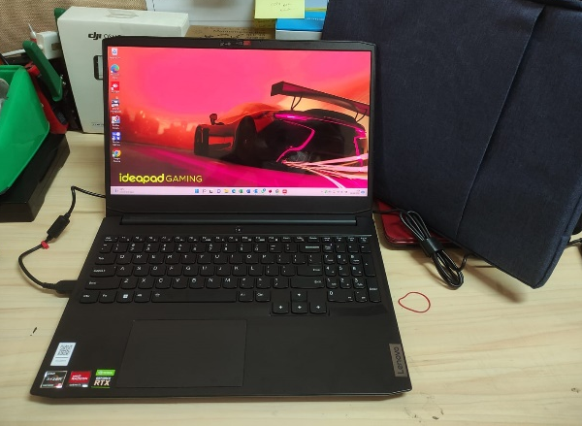
Telah diserahkan inventaris sebagai berikut :
- Laptop LENOVO ideapad Gaming 3-15ACH6 Laptop - Type 82K2 (1 Unit)
  - Processor : AMD Ryzen™ 5 5600H Processor(Ryzen™ 5 5600H)
  - Display : 15.6" FHD NVIDIA® GeForce RTX™ 3050 4GB
  - RAM : 1x 8 GB DDR4-3200
  - Storage : 1x 512 GB SSD PCIe
  - SN : MP2BVX5P
  - Warna : Shadow Black
- Charger Laptop (1 Unit)
- Tas Lapatop Lenovo (1 Unit)
Kondisi : 100% (Baru)
Kepada :
Nama : M Nurhasan Mahmudi
Divisi : HR&GA / IT
NIK :
Notes :
Laptop baru

Menyetujui,

( Bramantya Zain )
Menyerahkan,

( Ali Rakhman )
Menerima,

( M Nurhasan Mahmudi )
BERITA ACARA SERAH TERIMA INVENTARIS
PT. JAKARTA PRIMA CRANES
Wisma JPC, Jl. Mampang Prapatan Raya No.20

No. Dokumen : GA/2023/06/011
No. Inventaris : MHN-2023-001
DEPARTEMEN GA-IT

Hari ………………, ……. ………… 2023
Telah diserahkan inventaris sebagai berikut :
- Laptop LENOVO ideapad Gaming 3-15ACH6 Laptop - Type 82K2 (1 Unit)
  - Processor : AMD Ryzen™ 5 5600H Processor(Ryzen™ 5 5600H)
  - Display : 15.6" FHD NVIDIA® GeForce RTX™ 3050 4GB
  - RAM : 1x 8 GB DDR4-3200
  - Storage : 1x 512 GB SSD PCIe
  - SN : MP2BVX5P
  - Warna : Shadow Black
- Charger Laptop (1 Unit)
- Tas Lapatop Lenovo (1 Unit)
Kondisi : 100% (Baru)
Kepada :
Nama : M Nurhasan Mahmudi
Divisi : HR&GA / IT
NIK :
Notes :
Laptop baru

Menyetujui,

( Bramantya Zain )
Menyerahkan,

( Ali Rakhman )
Menerima,

( M Nurhasan Mahmudi )
------------------
System Information
------------------
Time of this report: 6/23/2023, 16:54:38
Machine name: JPC_IT
Machine Id: {DC6BA44A-FCBD-4EA5-96F5-D6AF7CC1BC44}
Operating System: Windows 11 Home Single Language 64-bit (10.0, Build 22000) (22000.co_release.210604-1628)
Language: English (Regional Setting: English)
System Manufacturer: LENOVO
System Model: 82K2
BIOS: H3CN34WW(V2.04) (type: UEFI)
Processor: AMD Ryzen 5 5600H with Radeon Graphics (12 CPUs), ~3.3GHz
Memory: 8192MB RAM

---------------
Display Devices
---------------

Card name: NVIDIA GeForce RTX 3050 Laptop GPU
Manufacturer: NVIDIA
Chip type: NVIDIA GeForce RTX 3050 Laptop GPU
DAC type: Integrated RAMDAC
Device Type: Render-Only Device
Device Key: Enum\PCI\VEN_10DE&DEV_25A2&SUBSYS_3A5D17AA&REV_A1
Device Status: 0180200A [DN_DRIVER_LOADED|DN_STARTED|DN_DISABLEABLE|DN_NT_ENUMERATOR|DN_NT_DRIVER]
Device Problem Code: No Problem
Driver Problem Code: Unknown
Display Memory: 6991 MB
Dedicated Memory: 3993 MB
------------------------

Disk & DVD/CD-ROM Drives
------------------------
Drive: C:
Free Space: 414.1 GB
Total Space: 486.1 GB
File System: NTFS
Model: INTEL SSDPEKNW512GZL

LABEL DI BELAKANG LAPTOP
NO INVENTARIS
MHN | - | 2023 | - | 001

EMAIL MS | jpc_it@outlook.com
PASS | #JpcOffice2023*
TGL | 23 / 06 / 2023
BA | GA/2023/ 06 / 011
USER | M NURHASAN MAHMUDI

PWR | 2023/JKT-0277
PO | 2023/JKT-L-0179

LABEL DI CHARGER
NO INVENTARIS
MHN | - | 2023 | - | 001

LABEL DI BOX LAPTOP
NO INVENTARIS
MHN | - | 2023 | - | 001

EMAIL MS | jpc_it@outlook.com
PASS | #JpcOffice2023*
TGL | 23 / 06 / 2023
BA | GA/2023/ 06 / 011
USER | M NURHASAN MAHMUDI

PWR | 2023/JKT-0277
PO | 2023/JKT-L-0179

LABEL DI KARTU GARANSI
NO INVENTARIS
MHN | - | 2023 | - | 001

EMAIL MS | jpc_it@outlook.com
PASS | #JpcOffice2023*
TGL | 23 / 06 / 2023
BA | GA/2023/ 06 / 011
USER | M NURHASAN MAHMUDI

PWR | 2023/JKT-0277
PO | 2023/JKT-L-0179

