BERITA ACARA SERAH TERIMA INVENTARIS
PT. JAKARTA PRIMA CRANES
Wisma JPC, Jl. Mampang Prapatan Raya No.20

No. Dokumen : IT/BAST/2023/09/003
No. Inventaris : MEG-2022-001
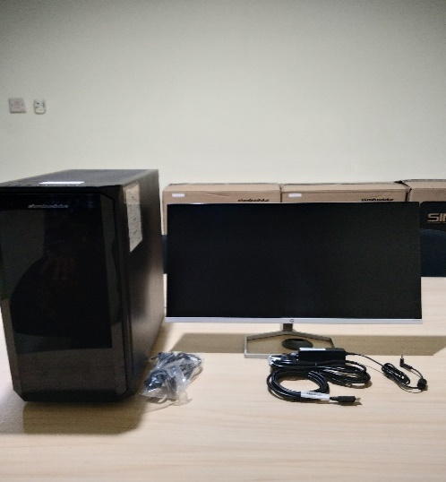
DEPARTEMEN GA-IT

Hari ………………, ……. ………… 2023,
Telah diserahkan inventaris sebagai berikut :

- SET PC (1 Set)
  - CPU : Intel Core i7-1700-LGA1700
  - RAM : 16GB DDR4 on board
  - Storage : 1 TB SSD M2 NVME
  - GPU/VGA : MSI RTX 3050 VENTUS 2X 8G OC 86B GDDR6
  - Warna : Black
  - SN : SMC20SB48019040318

  - Monitor : HP 24fwa 24

- Mouse Wireless Logitech M190 (1 Unit)
Kondisi : 100% (Bekas Pakai)
Kepada :
Nama : M N Mahmudi
Divisi : IT
NIK :
Serah Terima PC Inventaris - Karyawan Resign

Menyerahkan,

Mei Anggita
Mengetahui,

Ali Rakhman
Menyetujui,

Bramantya Zain

Menerima,

M N Mahmudi

BERITA ACARA SERAH TERIMA INVENTARIS
PT. JAKARTA PRIMA CRANES
Wisma JPC, Jl. Mampang Prapatan Raya No.20

No. Dokumen : IT/BAST/2023/09/003
No. Inventaris : MEG-2022-001
DEPARTEMEN GA-IT

Hari ………………, ……. ………… 2023,
Telah diserahkan inventaris sebagai berikut :

- SET PC (1 Set)
  - CPU : Intel Core i7-1700-LGA1700
  - RAM : 16GB DDR4 on board
  - Storage : 1 TB SSD M2 NVME
  - GPU/VGA : MSI RTX 3050 VENTUS 2X 8G OC 86B GDDR6
  - Warna : Black
  - SN : SMC20SB48019040318

  - Monitor : HP 24fwa 24

- Mouse Wireless Logitech M190 (1 Unit)
Kondisi : 100% (Bekas Pakai)
Kepada :
Nama : M N Mahmudi
Divisi : IT
NIK :
Serah Terima PC Inventaris - Karyawan Resign

Menyerahkan,

Mei Anggita
Mengetahui,

Ali Rakhman
Menyetujui,

Bramantya Zain

Menerima,

M N Mahmudi

------------------
System Information
------------------
Time of this report: 9/14/2023, 11:32:50
Machine name: GITA-2022
Machine Id: {8DE479A7-5699-4455-971A-7982DC306E13}
Operating System: Windows 10 Pro 64-bit (10.0, Build 19045) (19041.vb_release.191206-1406)
Language: English (Regional Setting: English)
System Manufacturer: ASUS
System Model: System Product Name
BIOS: 1601 (type: UEFI)
Processor: 11th Gen Intel(R) Core(TM) i7-11700 @ 2.50GHz (16 CPUs), ~2.5GHz
Memory: 16384MB RAM

---------------
Display Devices
---------------
Card name: NVIDIA GeForce RTX 3050
Manufacturer: NVIDIA
Chip type: NVIDIA GeForce RTX 3050
DAC type: Integrated RAMDAC
Device Type: Full Device (POST)
Device Key: Enum\PCI\VEN_10DE&DEV_2507&SUBSYS_C9781462&REV_A1
Device Status: 0180200A [DN_DRIVER_LOADED|DN_STARTED|DN_DISABLEABLE|DN_NT_ENUMERATOR|DN_NT_DRIVER]
Device Problem Code: No Problem
Driver Problem Code: Unknown
Display Memory: 16180 MB
Dedicated Memory: 8070 MB

------------------------
Disk & DVD/CD-ROM Drives
------------------------
Drive: C:
Free Space: 337.1 GB
Total Space: 449.4 GB
File System: NTFS
Model: WD Blue SN570 1TB

Drive: E:
Free Space: 320.4 GB
Total Space: 503.9 GB
File System: NTFS
Model: WD Blue SN570 1TB

