BERITA ACARA SERAH TERIMA INVENTARIS
PT. JAKARTA PRIMA CRANES
Wisma JPC, Jl. Mampang Prapatan Raya No.20

No. Dokumen : IT/BAST/2023/10/05
No. Inventaris : IT/REG/2023/10/03
IT/REG/2023/10/06
DEPARTEMEN GA-IT

Hari ………………, ……. ………… 2023,
Telah diserahkan inventaris sebagai berikut :
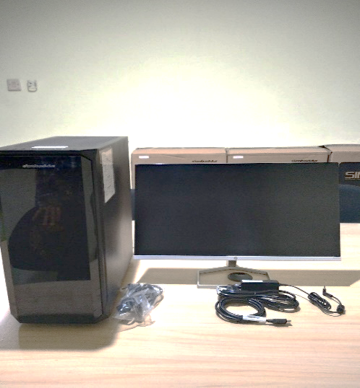
- SET PC (1 Set)
  - No. Inv : IT/REG/2023/10/06
  - CPU : 11th Gen Intel(R) Core(TM) i7 11700 @ 2.50GHz (16 CPUs), ~2.5GHz
  - RAM : 1x 16GB DDR4-3200 on board
  - Storage : 1x 1 TB SSD M2 NVME
  - GPU/VGA : NVIDIA GeForce RTX 3050 8GB GDDR6

  - No. Inv : IT/REG/2023/10/03
  - Monitor : HP 24fwa 24 Diagonal FHD Monitor
  - Display : 24” FHD
Kondisi : 100% (Baru)
Kepada :
Nama : Robi Setianto
Divisi : Engineering
NIK :
Notes :
Serah Terima PC Inventaris Baru

Menerima,

Robi Setianto
Menyetujui,

Bramantya Zain

Mengetahui,

Ali Rakhman
Menyerahkan,

M N Mahmudi

BERITA ACARA SERAH TERIMA INVENTARIS
PT. JAKARTA PRIMA CRANES
Wisma JPC, Jl. Mampang Prapatan Raya No.20

No. Dokumen : IT/BAST/2023/10/05
No. Inventaris : IT/REG/2023/10/03
IT/REG/2023/10/06
DEPARTEMEN GA-IT

Hari ………………, ……. ………… 2023,
Telah diserahkan inventaris sebagai berikut :
- SET PC (1 Set)
  - No. Inv : IT/REG/2023/10/06
  - CPU : 11th Gen Intel(R) Core(TM) i7 11700 @ 2.50GHz (16 CPUs), ~2.5GHz
  - RAM : 1x 16GB DDR4-3200 on board
  - Storage : 1x 1 TB SSD M2 NVME
  - GPU/VGA : NVIDIA GeForce RTX 3050 8GB GDDR6

  - No. Inv : IT/REG/2023/10/03
  - Monitor : HP 24fwa 24 Diagonal FHD Monitor
  - Display : 24” FHD
Kondisi : 100% (Baru)
Kepada :
Nama : Robi Setianto
Divisi : Engineering
NIK :
Notes :
Serah Terima PC Inventaris Baru

Menerima,

Robi Setianto
Menyetujui,

Bramantya Zain

Mengetahui,

Ali Rakhman
Menyerahkan,

M N Mahmudi

------------------
System Information
------------------
Time of this report: 10/30/2023, 13:45:20
Machine name: ADMINISTRATOR
Machine Id: {D20C0DF2-5159-4074-A1CB-8C94FE3D7A7E}
Operating System: Windows 10 Pro 64-bit (10.0, Build 19045) (19041.vb_release.191206-1406)
Language: English (Regional Setting: English)
System Manufacturer: ASUS
System Model: System Product Name
BIOS: 1601 (type: UEFI)
Processor: 11th Gen Intel(R) Core(TM) i7-11700 @ 2.50GHz (16 CPUs), ~2.5GHz
Memory: 16384MB RAM

---------------
Display Devices
---------------
Card name: NVIDIA GeForce RTX 3050
Manufacturer: NVIDIA
Chip type: NVIDIA GeForce RTX 3050
DAC type: Integrated RAMDAC
Device Type: Full Device (POST)
Device Key: Enum\PCI\VEN_10DE&DEV_2582&SUBSYS_8D9D1462&REV_A1
Device Status: 0180200A [DN_DRIVER_LOADED|DN_STARTED|DN_DISABLEABLE|DN_NT_ENUMERATOR|DN_NT_DRIVER]
Device Problem Code: No Problem
Driver Problem Code: Unknown
Display Memory: 16130 MB
Dedicated Memory: 8056 MB

------------------------
Disk & DVD/CD-ROM Drives
------------------------
Drive: C:
Free Space: 284.9 GB
Total Space: 399.4 GB
File System: NTFS
Model: Samsung SSD 970 EVO Plus 1TB

Drive: E:
Free Space: 479.2 GB
Total Space: 553.9 GB
File System: NTFS
Model: Samsung SSD 970 EVO Plus 1TB

