BERITA ACARA SERAH TERIMA INVENTARIS
PT. JAKARTA PRIMA CRANES
Wisma JPC, Jl. Mampang Prapatan Raya No.20

No. Dokumen : GA/2023/06/003
No. Inventaris : YLN-2023-002
DEPARTEMEN GA-IT

Hari ………………, ……. ………… 2023
Telah diserahkan inventaris sebagai berikut :
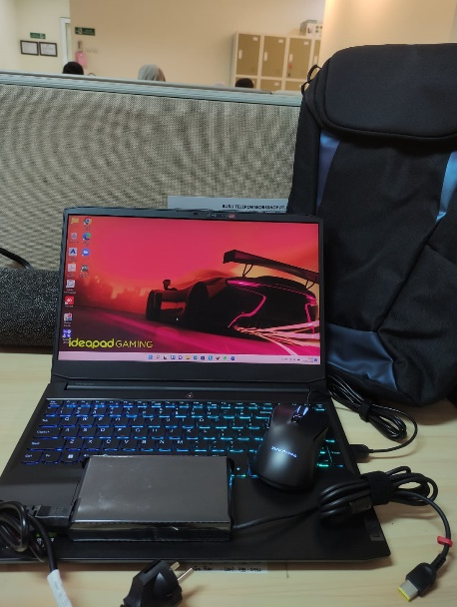
- Laptop LENOVO ideapad Gaming 3-15ACH6 Laptop - Type 82K2 (1 Unit)
  - Processor : AMD Ryzen™ 5 5600H Processor(Ryzen™ 5 5600H)
  - Display : 15.6" FHD NVIDIA® GeForce RTX™ 3050 4GB
  - RAM : 1x 8 GB DDR4-3200
  - Storage : 1x 512 GB SSD PCIe
  - SN : MP2BKFKD
  - Warna : Shadow Black
- Charger Laptop (1 Unit)
- Tas Gendong Lenovo Gaming 15.6 Backpack (1 Unit)
- Mouse IdeaPad Gaming (1 Unit)
  - SN : 1SGY50Z719032Z13X85BS-26
- Mouse Logitech Wireles M185
Kondisi : 100% (Baru)
Kepada :
Nama : Yulian Ahmad
Divisi : PE
NIK :
Notes :
Laptop baru, Laptop lama Sudah Sering Lag dan harddisknya bermasalah

Menyetujui,

( Bramantya Zain )
Menyerahkan,

( M Nurhasan Mahmudi )
Menerima,

( Yulian Ahmad )
BERITA ACARA SERAH TERIMA INVENTARIS
PT. JAKARTA PRIMA CRANES
Wisma JPC, Jl. Mampang Prapatan Raya No.20

No. Dokumen : GA/2023/06/003
No. Inventaris : YLN-2023-002
DEPARTEMEN GA-IT

Hari ………………, ……. ………… 2023
Telah diserahkan inventaris sebagai berikut :
- Laptop LENOVO ideapad Gaming 3-15ACH6 Laptop - Type 82K2 (1 Unit)
  - Processor : AMD Ryzen™ 5 5600H Processor(Ryzen™ 5 5600H)
  - Display : 15.6" FHD NVIDIA® GeForce RTX™ 3050 4GB
  - RAM : 1x 8 GB DDR4-3200
  - Storage : 1x 512 GB SSD PCIe
  - SN : MP2BKFKD
  - Warna : Shadow Black
- Charger Laptop (1 Unit)
- Tas Gendong Lenovo Gaming 15.6 Backpack (1 Unit)
- Mouse IdeaPad Gaming (1 Unit)
  - SN : 1SGY50Z719032Z13X85BS-26
- Mouse Logitech Wireles M185
Kondisi : 100% (Baru)
Kepada :
Nama : Yulian Ahmad
Divisi : PE
NIK :
Notes :
Laptop baru, Laptop lama Sudah Sering Lag dan harddisknya bermasalah

Menyetujui,

( Bramantya Zain )
Menyerahkan,

( M Nurhasan Mahmudi )
Menerima,

( Yulian Ahmad )
------------------
System Information
------------------
Time of this report: 6/9/2023, 11:32:39
Machine name: YLN-2023-001
Machine Id: {B9C52B07-1670-4EC3-8C44-F05B47292558}
Operating System: Windows 11 Home Single Language 64-bit (10.0, Build 22000) (22000.co_release.210604-1628)
Language: English (Regional Setting: English)
System Manufacturer: LENOVO
System Model: 82K2
BIOS: H3CN32WW(V2.02) (type: UEFI)
Processor: AMD Ryzen 5 5600H with Radeon Graphics (12 CPUs), ~3.3GHz
Memory: 8192MB RAM
Available OS Memory: 5996MB RAM
Page File: 6981MB used, 1718MB available
Windows Dir: C:\Windows
DirectX Version: DirectX 12
DX Setup Parameters: Not found
User DPI Setting: 120 DPI (125 percent)
System DPI Setting: 120 DPI (125 percent)
DWM DPI Scaling: UnKnown
Miracast: Available, with HDCP
Microsoft Graphics Hybrid: Supported
DirectX Database Version: 1.4.6
DxDiag Version: 10.00.22000.0653 64bit Unicode

LABEL DI BELAKANG LAPTOP
NO INVENTARIS
YLN | - | 2023 | - | 002

EMAIL MS | mp2bkfkd@outlook.com
PASS | JpcOffice2023
TGL | 09 / 06 / 2023
BA | GA/2023/ 06 / 003
USER | YULIAN AHMAD

PWR | 2023/JKT-0366
PO | 2023/JKT-L-0225

LABEL DI CHARGER
NO INVENTARIS
YLN | - | 2023 | - | 002

LABEL DI BOX LAPTOP
NO INVENTARIS
YLN | - | 2023 | - | 002

EMAIL MS | mp2bkfkd@outlook.com
PASS | JpcOffice2023
TGL | 09 / 06 / 2023
BA | GA/2023/ 06 / 003
USER | YULIAN AHMAD

PWR | 2023/JKT-0366
PO | 2023/JKT-L-0225

LABEL DI KARTU GARANSI
NO INVENTARIS
YLN | - | 2023 | - | 002

EMAIL MS | mp2bkfkd@outlook.com
PASS | JpcOffice2023
TGL | 09 / 06 / 2023
BA | GA/2023/ 06 / 003
USER | YULIAN AHMAD

PWR | 2023/JKT-0366
PO | 2023/JKT-L-0225

