Mini-Shakespearean LLM Assignment
Step 1: Understanding the Blueprint (microGPT)

Overview
This assignment pulls apart the black box of large language models by building a mini GPT-style model from scratch, anchored on Shakespeare. The first step is to reverse-engineer a minimal, real-world GPT-style codebase (microGPT) so the team understands how each matrix operation fits together before moving on to architecting, training, and benchmarking original mini-LLM configurations in PyTorch.
microgpt.py is Andrej Karpathy's ~200-line, dependency-free Python implementation of a GPT-style transformer. It trains and runs inference on a character-level dataset (by default, a list of names) with no external libraries — not even NumPy. This section reverse-engineers the codebase using two sources: the gist itself, and the architecture visualization diagram that maps each code block to its functional role in the transformer pipeline.

Sources Used
- Karpathy's microgpt.py gist — the authoritative source code.
- The architecture visualization diagram (infographic) — used as a visual index into the code, cross-checked against the gist for accuracy.

Step 1.a — Andrej Karpathy's microGPT Gist
The gist (microgpt.py) is a ~200-line, dependency-free Python implementation of a GPT-style transformer, trained and run on character-level text with no external libraries — not even NumPy. Reading it exposes every core component of a real transformer at its most atomic level:
- A custom autograd engine (the Value class), which tracks data, grad, and parent nodes for each scalar, and applies the chain rule via .backward().
- A character-level tokenizer with a special BOS token.
- Token and position embeddings (wte, wpe).
- RMSNorm normalization (no mean subtraction, no learnable gamma/beta).
- A multi-head self-attention block (attn_wq/wk/wv/wo) with causality enforced via a running keys/values cache rather than an explicit mask.
- An MLP feedforward block (mlp_fc1 → ReLU → mlp_fc2) with residual connections.
- A manually implemented Adam optimizer and training loop using cross-entropy loss.
- Autoregressive inference via temperature-scaled sampling.

Step 1.b — Architecture Visualization
Using the architecture visualization guide alongside the code turns the abstract flowchart into something concrete — each diagram box maps directly onto a specific variable or function in microgpt.py (e.g., "Autograd Engine" maps to the Value class; "Transformer Block" maps to attn_wq/wk/wv/wo plus mlp_fc1/fc2). This mapping was confirmed line-by-line below, cross-checking every listed spec (vocab size 27, n_embd=16, block_size=16, n_head=4, ~4,192 parameters, etc.) against the actual source code.

Architecture Diagram
Figure 1 below shows the full microGPT pipeline, from the autograd engine through embeddings, normalization, the transformer block, and the output/training/inference stages.
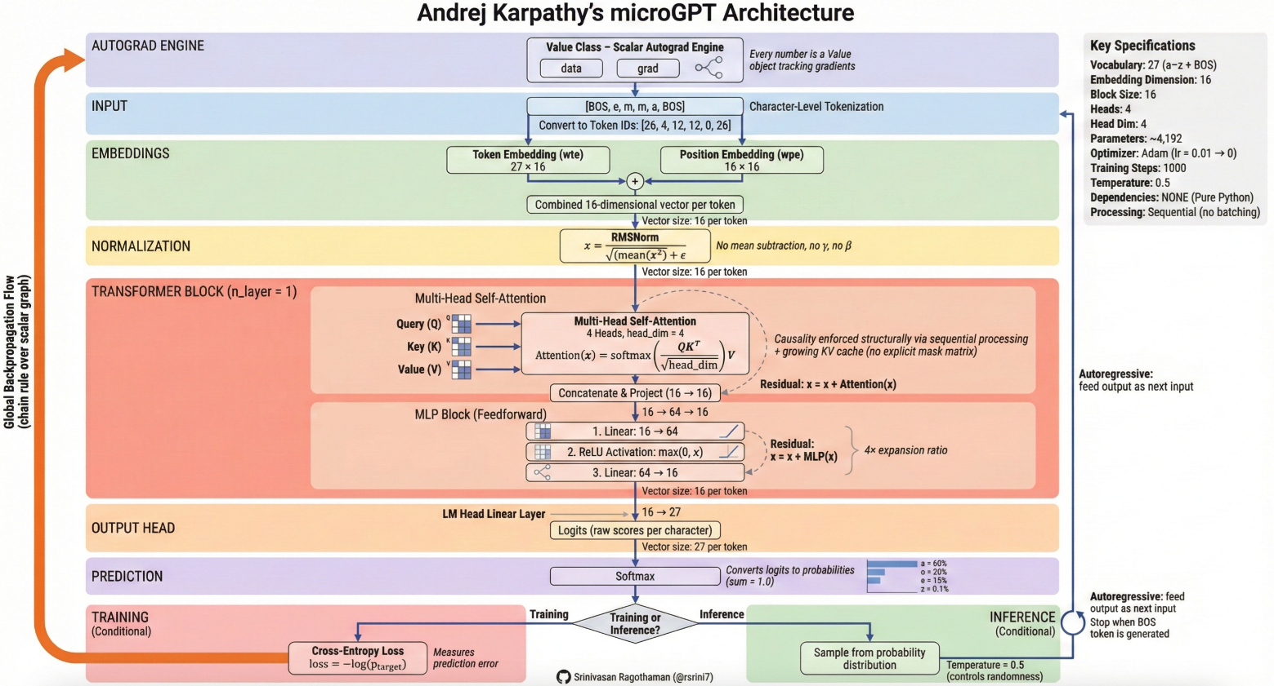
Figure 1. Andrej Karpathy's microGPT Architecture (diagram credit: Srinivasan Ragothaman).

Core Components (Code Walkthrough)
1. Custom Autograd Engine (the Value class)
Every scalar number is wrapped in a Value object storing data, grad, its parent nodes (_children), and local gradients (_local_grads). Operations such as __add__, __mul__, .exp(), .log(), and .relu() each define how gradients flow backward. The .backward() method performs a topological sort of the computation graph, then applies the chain rule in reverse — a scalar-level mirror of the backpropagation concepts covered in Victor Zhou's neural networks article.
2. Tokenizer
Character-level: every unique character in the dataset becomes a token ID, plus one special BOS (beginning/end of sequence) token. Vocabulary size equals the number of unique characters plus one.
3. Parameters (state_dict)
Includes token embeddings (wte), position embeddings (wpe), an LM head, and per-layer weights: attn_wq / attn_wk / attn_wv / attn_wo (attention projections) and mlp_fc1 / mlp_fc2 (feedforward). Weights are initialized as small Gaussian-random Value matrices.
4. Forward Pass (the gpt() function)
- Combine token + position embeddings, apply rmsnorm.
- Multi-head attention: project into Q, K, V; split into n_head heads; compute scaled dot-product attention per head using a running keys/values cache (this enforces causality without an explicit mask); concatenate heads and project back.
- Residual connection wraps the attention block.
- MLP block: linear (16→64) → ReLU → linear (64→16), also wrapped in a residual connection.
- Final linear layer (lm_head) maps back to vocab-size logits.
5. Training Loop
For each document, the sequence is tokenized with BOS on both ends, the model runs step-by-step through it, and cross-entropy loss (-log of the probability assigned to the correct next token) is computed. loss.backward() propagates gradients, and all parameters are updated with a manually implemented Adam optimizer (including bias-corrected moving averages) over 1000 steps with linear learning-rate decay.
6. Inference
Autoregressive sampling: feed BOS, get logits, apply temperature-scaled softmax, sample a token, feed it back in, and repeat until BOS is generated again (end of sequence) or block_size is reached.

Diagram-to-Code Mapping
The table below cross-references each section of the architecture diagram against its exact implementation in microgpt.py.
Diagram Section | Code Location in microgpt.py
Autograd Engine | The Value class — every scalar tracks data, grad, and parent nodes; .backward() applies the chain rule via topological sort.
Input / Tokenization | Character-level tokenizer: uchars, BOS token. Example: [BOS, e, m, m, a, BOS] → token IDs.
Embeddings | state_dict['wte'] (token, 27×16) + state_dict['wpe'] (position, 16×16), summed elementwise.
Normalization | rmsnorm(x) — no mean subtraction, no learnable gamma/beta, matches the diagram's formula exactly.
Transformer Block | attn_wq / attn_wk / attn_wv / attn_wo for 4-head attention (head_dim=4); scaled dot-product via a running keys/values cache (causality enforced without an explicit mask); residual add. Then mlp_fc1 (16→64) → ReLU → mlp_fc2 (64→16), also wrapped in a residual add.
Output Head | state_dict['lm_head']: linear layer mapping 16 → 27 logits (one score per vocabulary character).
Prediction | softmax(logits) converts raw scores into a probability distribution summing to 1.0.
Training vs. Inference | Training: cross-entropy loss -log(p_target) → loss.backward() → Adam update. Inference: temperature-scaled softmax sampling, autoregressive, stops when BOS is generated again or block_size is reached.

Confirmed Key Specifications
The following specifications from the diagram were cross-checked directly against the source code and confirmed accurate.
Spec | Value
Vocabulary size | 27 (26 lowercase letters + BOS)
Embedding dimension (n_embd) | 16
Block size (context length) | 16
Attention heads (n_head) | 4
Head dimension | 4
Total parameters | ~4,192
Optimizer | Adam (lr = 0.01, linear decay to 0)
Training steps | 1000
Sampling temperature | 0.5
Dependencies | None — pure Python
Processing mode | Sequential (no batching)

Key Takeaway
microgpt.py demonstrates that a full GPT — autograd, embeddings, multi-head attention, residual connections, an MLP block, an Adam optimizer, and autoregressive sampling — can be built with plain Python control flow and no matrix libraries. Everything the team will do later with PyTorch (tensors, batching, nn.Module, built-in autograd) is an efficiency layer over these exact same underlying operations. This is the conceptual bridge the assignment is built on: Victor Zhou's article explains the micro-level math (neurons, gradients), the Transformer Explainer visualizes the macro-level architecture (attention, softmax), and microgpt.py shows precisely how the two connect in a working, readable codebase.
Note: The gist's public comment section contains unrelated community forks, tooling links, and off-topic or unrelated pasted content; none of this is part of Karpathy's original code and was excluded from this analysis.

