SDEV220 – Module 1: Setup
VS Code:
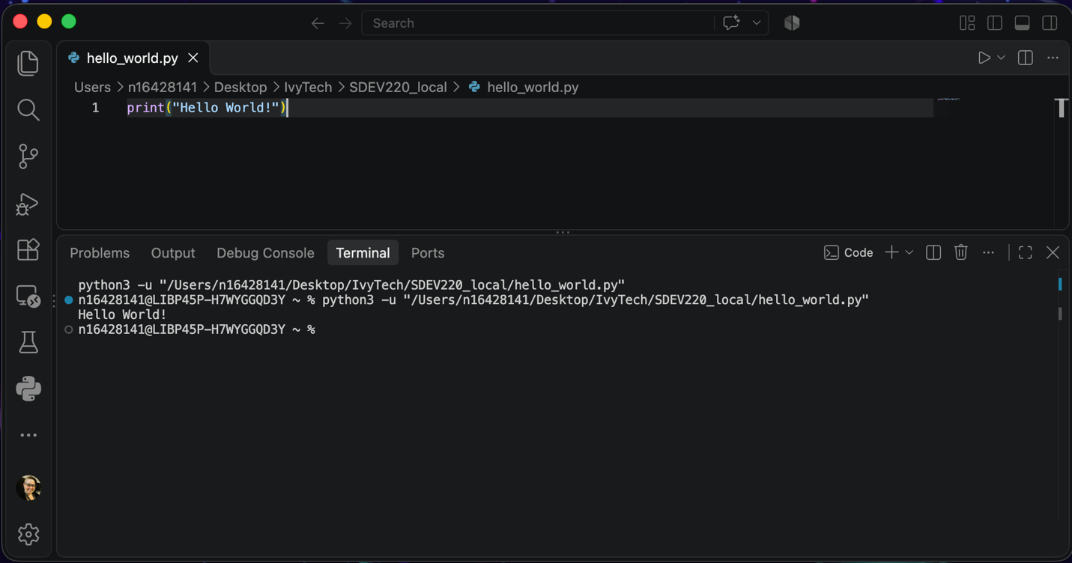
Jupyter Notebook:


