FALL HARVEST 3-D ARCHERY SHOOT
OCTOBER 10th – 11th, 2009
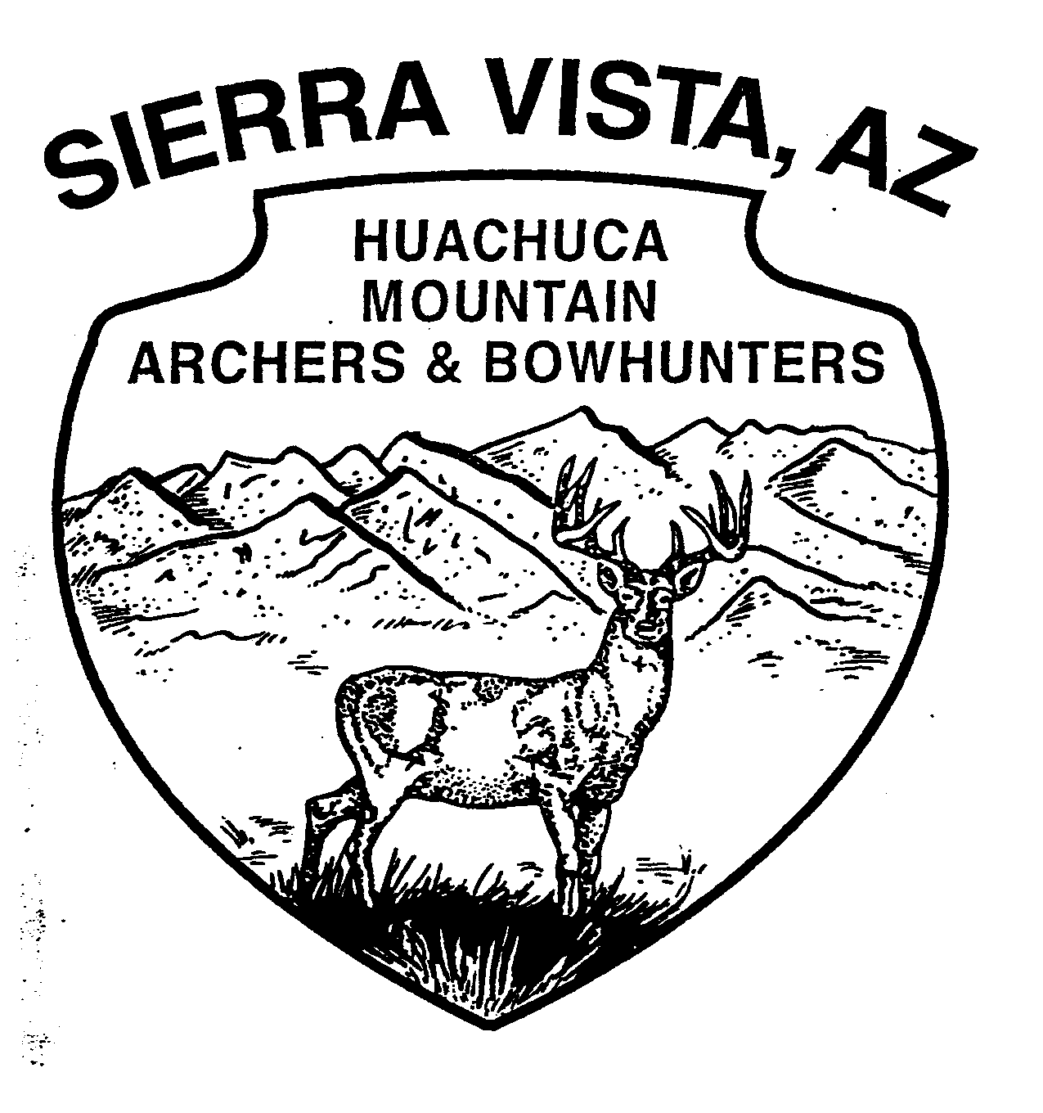
HOSTED BY:
HUACHUCA MOUNTAIN ARCHERS & BOWHUNTERS CLUB

AT THE HMABC RANGE ON FORT HUACHUCA
(SEE MAP ON REVERSE)

SMOKER ROUND, COON SHOOT
Shoot the Smoker Round Saturday or Sunday, but only one winner for the weekend
Coon Shoot Saturday night starting at 7:00 P.M.

PRIMITIVE CAMPING (10 SLOTS) FIRST COME-FIRST SERVED, NO RESERVED CAMPING SPOTS, OTHER CAMPSITES AVAILABLE THROUGH OUTSIDE SOURCES
PORTA-JOHNS ON SITE…LOTS OF PARKING…NOVELTY SHOOTS

BREAKFAST AND LUNCH AVAILABLE BOTH DAYS

ENTRY FEES
ADULTS (18 & OLDER) - $25.00; YOUNG ADULT (14-17) & YOUTH (11-13) - $10.00
CUBS (8-10) AND PEE WEE - FREE; FAMILY (18 AND UNDER IMMEDIATE FAMILY) - $50

CLASSES
COMPOUND: SENIORS – 62 AND OLDER
ADULT MALE & FEMALE: OPEN – UNLIMITED – LIMITED – BAREBOW – HUNTER - RANGEFINDER
YOUNG ADULT – YOUTH – CUB – PEE WEE

TRADITIONAL: SENIORS – 62 AND OLDER
MALE & FEMALE: SELFBOW – WOOD ARROWS ONLY
LONGBOW & RECURVE: ANY TYPE OF ARROWS
YOUNG ADULT – YOUTH – CUB – PEE WEE: ANY TRADITIONAL EQUIPMENT

REGISTRATION
Early registration: Friday 5:00 P.M. – 7:00 P.M.; Registration Saturday starts 7:00 A.M.
Ranges open at 7:00 A.M. on Saturday & Sunday. NO SHOOTING BEFORE THIS TIME.
Ranges close at 6:00 P.M. on Saturday, scores must be turned in by NOON on Sunday

FOR MORE INFORMATION CONTACT: BOB FORD @ (520) 417-1755 (hmabc@cox.net)
GARY LINENDOLL @ (520) 459-0607 (linendollcg@msn.com)

FALL HARVEST 3D SHOOT
OCTOBER 10th – 11th, 2009

Follow the map below from the East, West or North: Travel I-10 to Benson (exit at 281), Highway 90 South. Proceed south approximately 26 miles to Sierra Vista. Turn right onto Fort Huachuca. You will need a picture ID, driver’s license, vehicle registration, and proof of insurance to access post.

Directions To Huachuca Mountain Archers & Bowhunters Club

Follow Squire for approximately 2 miles from the main gate, until it meets up with Winrow Avenue. At that intersection the left lane goes straight and drops down the hill. Archers stay in the left lane and drop down the hill, but YIELD to traffic from the right! Follow the road down the hill and around the curve to the right about 1/3 mile until you see the HUGE oak tree on the left. Turn left at the oak tree and continue up the rutted road to the parking lot for the archery range.

