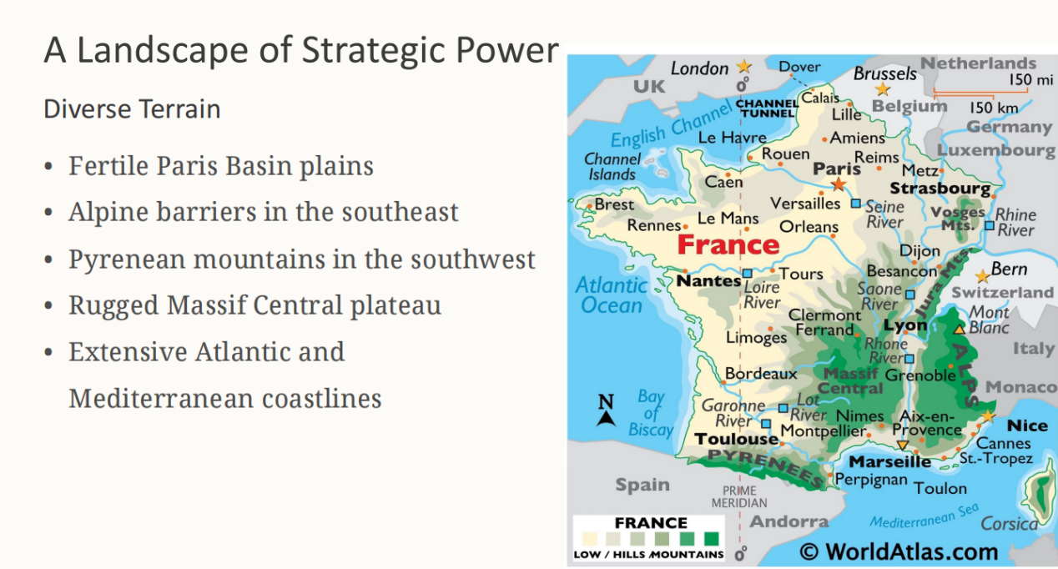
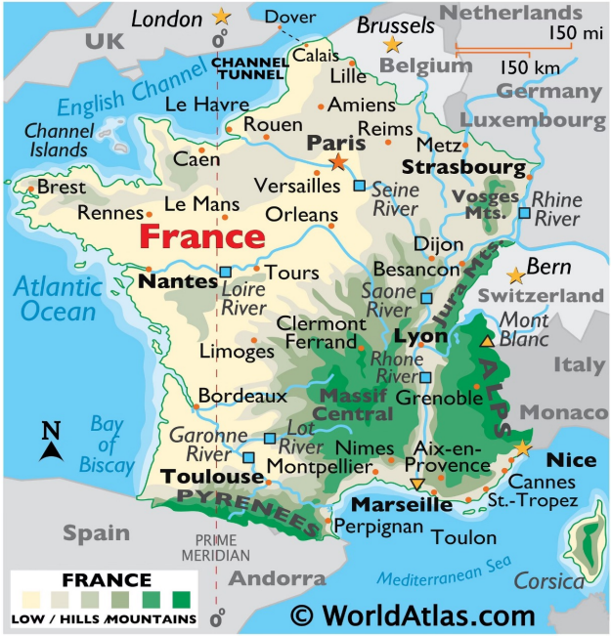
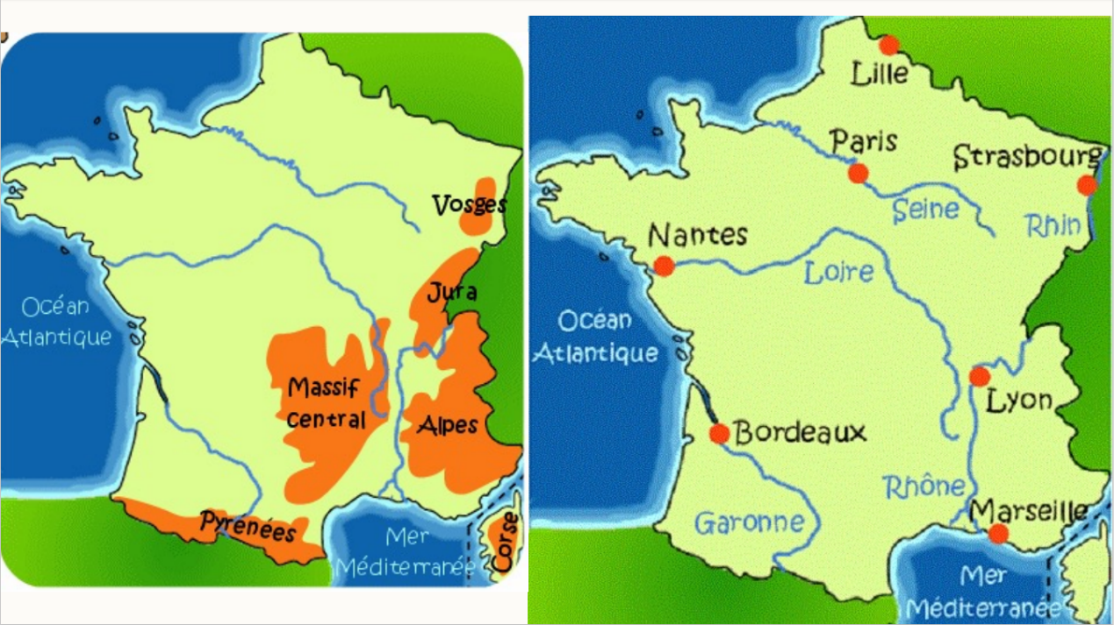
English → Chinese (中英对照)

2. French Holidays: Religious Heritage
Christmas (Noël) – December 25th
圣诞节（Noël）— 12月25日
Easter (Pâques) – First Sunday after the first full moon following the spring equinox
复活节（Pâques）— 春分之后第一次满月后的第一个星期日
All Saints’ Day (La Toussaint) – November 1st
诸圣节（La Toussaint）— 11月1日
Assumption of Mary (L’Assomption) – August 15th
圣母升天节（L’Assomption）— 8月15日
Ascension Day (Ascension) – 40 days after Easter (movable date)
耶稣升天节（Ascension）— 复活节后第40天（日期不固定）
Example: May 9th, 2024 / May 29th, 2025
例如：2024年5月9日 / 2025年5月29日
Whit Monday / Pentecost Monday (Lundi de Pentecôte) – 50 days after Easter (movable date)
圣灵降临节星期一（Lundi de Pentecôte）— 复活节后第50天（日期不固定）
Example: May 20th, 2024 / June 9th, 2025
例如：2024年5月20日 / 2025年6月9日

3. French Holidays: Republican Values

3. 法国节日：共和价值
National Day – July 14
国庆日（巴士底日）— 7月14日
Labor Day – May 1
劳动节 — 5月1日
Victory Day – May 8
胜利日（欧洲胜利日）— 5月8日
Armistice – Nov 11
停战日（一战停战纪念日）— 11月11日
English → Chinese（中英对照）

4. Unique French Celebrations

4. 法国特色节庆
Fête de la Musique
June 21 – Summer solstice music festival
音乐节（Fête de la Musique）
6月21日 — 夏至音乐节
Fête des Voisins
May – Neighbors’ Day, community building
邻里节（Fête des Voisins）
5月 — 邻居日，促进社区凝聚力
Lyon Light Festival
December 5–8 – Spectacular illuminations
里昂灯光节（Lyon Light Festival / Fête des Lumières）
12月5日至8日 — 壮观的灯光展示

Architectural Style of Notre-Dame de Paris
Style identification:
Notre-Dame de Paris is a French Gothic cathedral, mainly representing Early Gothic architecture.
Journey to light:
The building emphasizes height and light, guiding the viewer’s eye upward, which reflects the Gothic spiritual goal of approaching the divine.
Pointed arches:
Pointed arches are widely used, allowing greater height and directing visual attention skyward.
Flying buttresses:
Flying buttresses transfer structural thrust outward, enabling thinner walls and larger windows.
Engineering and artistry:
Structural elements such as ribbed vaults and buttresses are both functional and decorative, showing the Gothic integration of engineering and art.
Rose windows and stained glass:
Large rose windows and stained glass transform natural light into symbolic divine light.

The point that interested me most in class was the existentialist philosophy of Jean-Paul Sartre, especially the idea that “existence precedes essence.”
Sartre argues that human beings are not born with a fixed nature or purpose. We exist first, and then define ourselves through our choices and actions.
He also introduces the idea of nothingness, which means that humans are never completely determined. This “nothingness” gives people freedom, but also responsibility and anxiety.
What interested me most is that Sartre sees freedom as unavoidable: even refusing to choose is already a choice.
For Sartre, human beings are always free, and even not choosing is already a choice.
Saying “I had no choice” is therefore a way of avoiding responsibility.
In the play No Exit (Huis Clos), Jean-Paul Sartre famously states that “Hell is other people.” However, Sartre does not mean that other people are simply bad or evil.
What Sartre really wants to show is that other people look at us and judge us, and through their gaze, we can become trapped in fixed identities. Once we are seen by others, we risk being reduced to an object — defined by labels, roles, or past actions.
Sartre’s message is not to reject social life, but to remain aware of how others influence our self-understanding and to take responsibility for defining ourselves.

