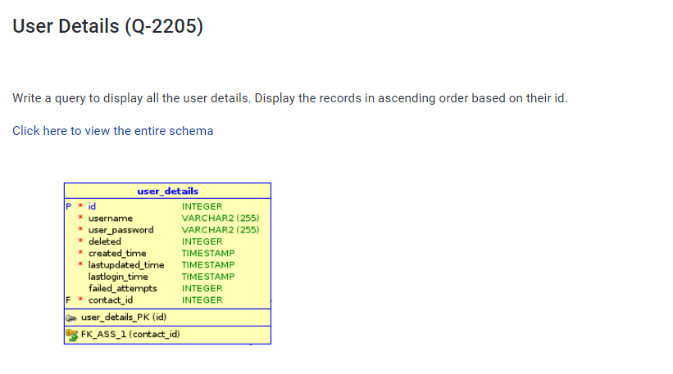**Query: select * from user_details order by id;**