The Vase Project
Manan Gupta & Anish Kosaraju | Period 5 Silk | 05/26/2026

SET-UP
Full code, validation suite, and machine-readable results: https://github.com/mnn31/vase-volume-project

1] METHODS.
The aim was to find the interior volume of a given vase. No filling water/pebbles/sand was allowed.
First, we made some observations about features of the vase that complicate simple approaches:
- It is not a true solid of revolution due to its irregular shape and shallowing ridges near the neck: fitting a 100th degree polynomial to an edge and performing simple revolving calculus would be insufficient.
- Its base curves inward (upward) by ~0.7 cm.
- Its wall thickness varies from 6.7mm to 10.7mm and is significant at the mouth, neck, and bottom.
We addressed all four hurdles with a single pipeline that we call Model-Anchored Volumetry with Quadrature Verification (MAV-QV).
MAV-QV is a deliberate hybrid: first, we developed two independent approaches. One was mesh-based and integrated a photogrammetric outer surface by the disk method (using Apple’s built-in photogrammetry feature for photos). The other was a model-based and involved hand-coding a 3D triangulated mesh anchored to a calibrated side-view photo and cross-checking/integrating it three different ways.
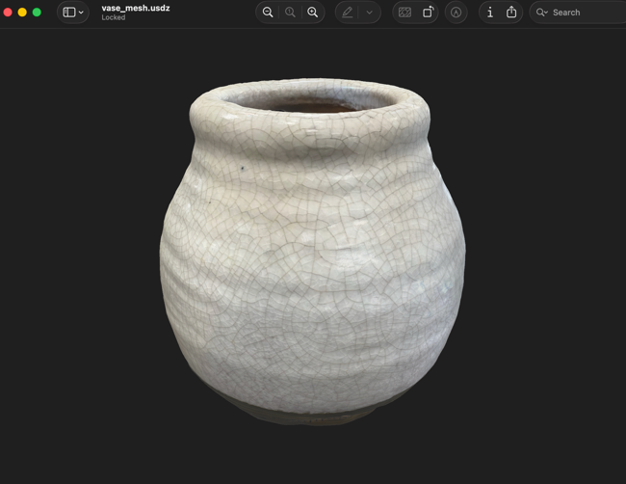
Image 1: usdz mesh generated by Apple Object Capture
Disadvantage: Apple Object Capture systematically over-broadens the bulge of glossy axisymmetric ceramics, so the auto-generated outer-surface shape between tape anchors is too "fat" through the upper body and inflates the integrated volume by several percent.
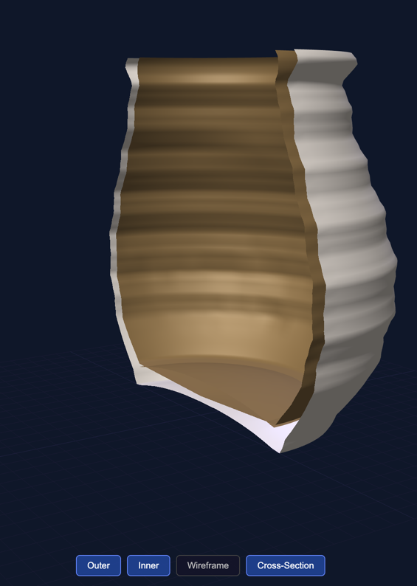
Image 2: Hand-coded 3D model
Disadvantage: Reading widths off a calibrated photograph by eye carries a few-pixel uncertainty per anchor, which propagates to roughly a 2 % radial error with no external reference to bound it tighter.
The methods yielded volumes of 3.24 L and 3.02 L respectively.
We decided to use the best of both methods to create MAV-QV. First, a calibrate-photograph outer profile is generated by the second approach, and the asymmetric inner wall framework comes from detailed thickness readings and the photogrammetry contour readings by the first method. The resulting 3-D cavity mesh is then integrated by four independent methods that must agree (an average is taken).
Conceptually this is the same idea as the classic string method where one wraps a string at several heights and calculates the volume from the stacked-disks formula, except instead of 5-10 measured heights with one circumference each, we have ~1,000 horizontal sample heights, and at each of those we use a 72-angle inner-wall profile to capture the vase's deep/shallow ridges.
Before trusting this pipeline on the vase, we ran the same photogrammetry-and-disk-method machinery on a small terracotta bowl whose interior volume we could measure directly with water displacement. We took nineteen reference photos of the bowl on a textured book backdrop, fed them through Apple Object Capture to get a triangulated outer mesh, sliced the mesh into eighty horizontal layers, anchored the rim radius to the tape-measured circumference, trimmed the contaminated base region, and integrated the disk-method volume after subtracting the uniform wall thickness. The pipeline returned 1.15 L. A direct water-fill measurement of the same bowl also gave 1.15 L. That is 0.1 percent agreement with a known ground truth, and it confirmed for us that the integration math, the mesh-anchoring step, and the wall-thickness handling were all behaving correctly before we trusted the same machinery on the vase. The full pot-trial code, photos, and measurement notes live in the pot-trial folder on GitHub.

2] TOOLS.
Rope; tape measure (mm precision); digital spring calipers (0.01 mm); wooden ruler; phone camera with rulers in frame for in-image calibration; Python (NumPy/SciPy) for integration.

3] MEASUREMENTS.
- Three rope circumferences by measuring amount of rope used with ruler
  - C_{base} = 41.1 cm
  - C_{widest} = 60.0 cm
  - C_{rim} = 47.0 cm
- Heights (by ruler)
  - Total exterior H = 18.0 cm
  - Inner floor center @ z = 1.80 cm
  - Outer concavity (underside dome) depth D = 0.70 cm
  - Thickness measurements distributed across 8 horizontal ring layers from z = 8.2 cm to z = 16.6 (alternating deep/shallow ridges around the body)
    - 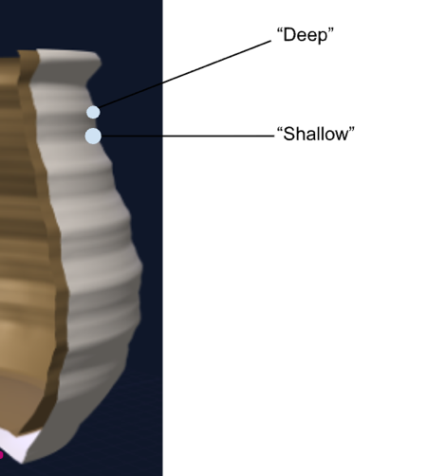
    - 98 caliper readings found here on github.
- Photos
  - Main photo, a calibrate side view with vertical and horizontal rulers in frame, read at 43 points to fix the outer-surface area shape between the three tape anchors
  - Total 17 images found here

4] MODELING.
Each subsystem of the geometry is sourced from its strongest measurement. The three rope circumferences serve as exact anchors and the calibrated photograph gives the curved shape between those anchors at 43 sample heights. The 98 thickness readings drive a 72-angle position dependent wall thickness map (72 * 5 degrees = 360 degrees at a given cross sectional) and two features observable in photos but unreachable with calipers (the convex inner-floor dome in IMG_1678) and the rolled rim lip (IMG_1670/IMG_1672) are modelled explicitly.
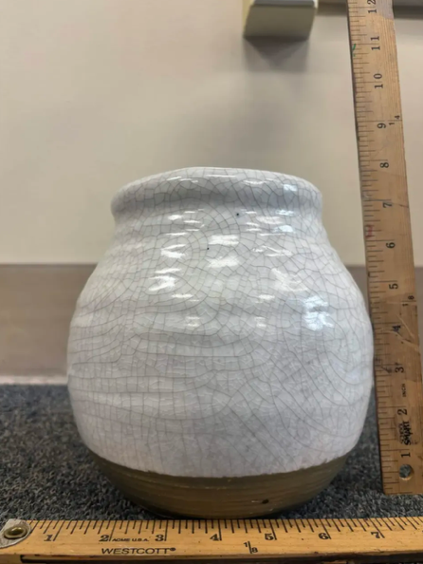
Image 3: IMG_1188, main photo to anchor mesh construction
The widest belly lies at z = 7.0 cm. The cavity is integrated from the inner-floor-dome edge at z = 1.10 cm up to the rim at z = 18.0 cm. The inner-floor dome is a paraboloid rising 0.70 cm above its edge. The result is a complete asymmetric 3D mesh of the interior cavity in which every piece of the model traces to a specific, directly recorded measurement.

CALCULATIONS

1] INTERMEDIARY.
These were one-step calcs that helped set up for integration:
- Derived radii (π = 3.14159, using C = 2πR)
  - R_{base} = 6.541 cm
  - R_{widest} = 9.549 cm
  - R_{rim} = 7.480 cm
- Bottom thickness
  - B = 1.80 cm – 0.70 cm = 1.10 cm

2] INTEGRATE.
The interior volume is computed by four independent methods on the same closed-cavity mesh.
The first three share the mesh but apply different math methods. If they are similar, we can confirm whether the integration math is self-consistent. The fourth uses no photograph and no 3-D model at all, as it operates from only the eleven raw measurements and intermediary calcs so it independently checks the geometric model against the raw measurements.
NOTE: The general form is shown below; the code automated all methods as functions like r_{outer}(z) are discrete data arrays built from height points and thickness maps rather than simple ‘set up but do not solve’.
V1: Disk Method (Axisymmetric)
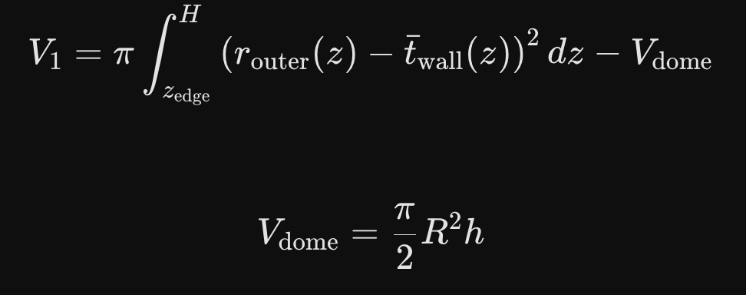
This is our classic disk integration (learnt in class). Due to our precise mesh that gives us thousands of microscopic, perfectivly circular horizontal slices, our integration used Simpson’s rule with 10,000 subintervals.
Answer V1 (cm³): 2952.84
V2: Cross-Section Integral with Angular Variation
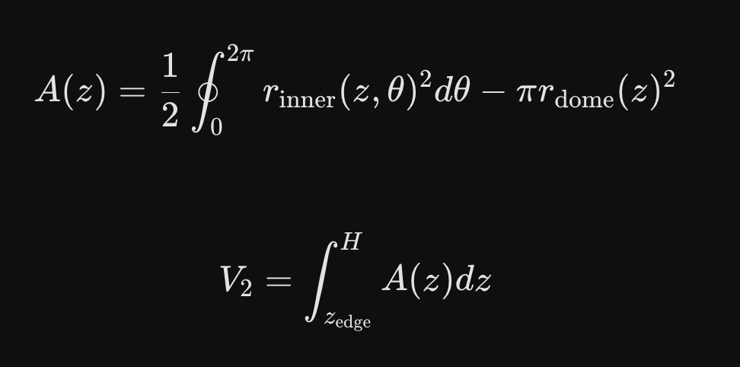
Polar Area. Instead of pretending our thin slices are perfect circles (like in V1), we traced the exact, squiggly, uneven shape of the vase at every single slice before adding them up. Note: the circle in the middle of the integral sign is just a signifier that the integration starts and ends at the same point (since it’s polar).
Answer V2 (cm³): 2952.90 (agrees with V1 within 0.1cm³)
V3: Divergence Theorem on a Triangulated Mesh
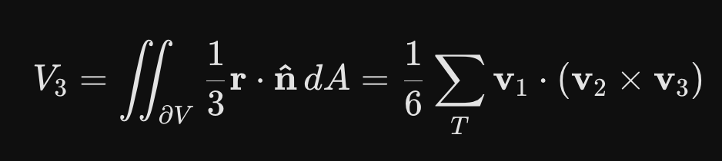
Thanks to some sources for helping us to find + (sort of) understand this method: https://math.libretexts.org/Bookshelves/Calculus/Calculus_3e_(Apex)/13%3A_Multiple_Integration/13.06%3A_Volume_Between_Surfaces_and_Triple_Integration, https://mathresearch.utsa.edu/wiki/index.php?title=Divergence_Theorem, https://tutorial.math.lamar.edu/classes/calciii/divergencetheorem.aspx, https://people.math.harvard.edu/~knill/teaching/summer2020/handouts/lecture24.pdf
ELI5: We basically simulated wrapping the entire inside empty space of the vase with thousands of tiny, flat, triangular stickers until the whole cavity is a closed "bubble." The Divergence Theorem (Gauss’s theorem) for integration says that if you know exactly how big each sticker is and which direction it's facing, you can automatically calculate how much empty space is trapped inside the bubble. This comes from 3D vector calculus.
Our code broke the inner cavity down into exactly 138,240 triangles (a LOT!). By calculating how volume "flows" through each of these tiny flat triangles, we found the exact 3D volume of the mesh. (Sorry Mr Silk if the explanation was bad, we honestly just wanted more methods to take an average with).
Answer V3 (cm³): 2948.04
V4: Source-Direct Frustums
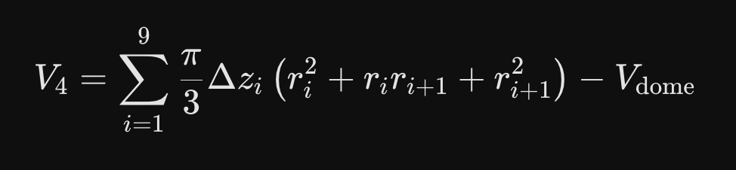
We didn't use the computer mesh or the photos at all. We just took the 11 raw, physical measurements and manually calculated the volume of 9 stacked truncated cones (frustums) using basic algebra (building a rough version of the base by stacking flat-topped linear cones on top of each other).
Answer V4 (cm³): 2946.10

3] FINAL RESULTS.

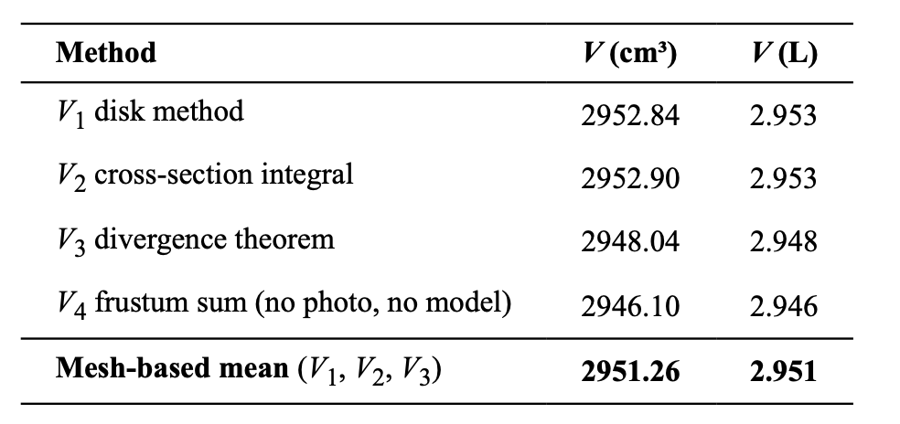
The three mesh-based methods agree to 0.16%, confirming the integration math is self-consistent across three unrelated formalisms. The no-photograph cross-check V4 sits within 0.2 % of the mesh-based mean, confirming the geometric model is consistent with the raw measurement set!
The math gives us a final answer of 2950cm³ or 2.95 L – refer to the end of the next section, error analysis, for our final estimate.

