AI & ML Internship – Task 11

SVM – Breast Cancer Classification

1. Objective
The objective of this task is to build a Support Vector Machine (SVM) model to classify breast cancer tumors as malignant or benign using the dataset data.csv. The task also involves comparing different SVM kernels, tuning hyperparameters, and evaluating model performance using standard classification metrics.

2. Dataset Description
The dataset used in this project is data.csv, which contains medical diagnostic features related to breast cancer tumors.
- Target Column: diagnosis
  - M → Malignant
  - B → Benign
- Features: Radius, texture, perimeter, area, smoothness, concavity, symmetry, etc.
- Unnecessary Columns: id (removed during preprocessing)
The dataset was checked for missing values and data consistency before model training.

3. Tools & Technologies Used
- Python
- Pandas & NumPy
- Scikit-learn
- Matplotlib

4. Data Preprocessing
The following preprocessing steps were performed:
- Loaded the dataset using Pandas.
- Removed irrelevant columns such as id.
- Converted categorical target labels (M, B) into numerical format.
- Split the dataset into training and testing sets using an 80:20 ratio.
- Applied StandardScaler to normalize the feature values.
Feature scaling is essential for SVM because it is a distance-based algorithm.

5. Model Building
Two SVM models were trained and compared:

5.1 Linear Kernel SVM
- Used for baseline performance evaluation.
- Suitable for linearly separable data.

5.2 RBF Kernel SVM
- Used to capture non-linear patterns in data.
- Provided better accuracy compared to the linear kernel.

6. Hyperparameter Tuning
To improve model performance, GridSearchCV was used to tune the following parameters:
- C: Controls margin and misclassification trade-off
- Gamma: Controls influence of training points
The best parameters were selected based on cross-validation performance.

7. Model Evaluation
The final tuned SVM model was evaluated using:
- Accuracy Score
- Confusion Matrix
- Classification Report (Precision, Recall, F1-score)
These metrics helped assess the classification performance of the model.

8. ROC Curve & AUC Score
The ROC (Receiver Operating Characteristic) curve was plotted to visualize model performance.
The AUC (Area Under Curve) score was calculated to measure the model’s ability to distinguish between malignant and benign tumors.
A higher AUC score indicates better classification performance.
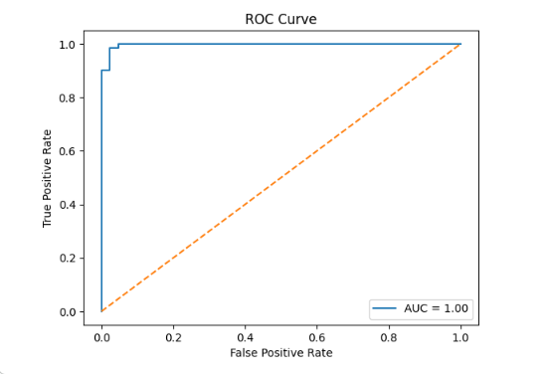

9. Model Saving
The trained SVM model and scaler were saved using the joblib library for future reuse.
- svm_model.pkl
- scaler.pkl

10. Result & Conclusion
The SVM model with RBF kernel and optimized hyperparameters achieved high accuracy in classifying breast cancer tumors. Feature scaling and hyperparameter tuning significantly improved model performance. This task demonstrates the effectiveness of SVM for medical classification problems.

11. Learning Outcome
- Understood working of Support Vector Machines
- Learned importance of feature scaling
- Gained experience in kernel selection
- Practiced hyperparameter tuning using GridSearchCV
- Learned ROC-AUC evaluation

