**Database**

**Links**

* <https://github.com/bignerdranch/developing-alexa-skills-solutions/tree/master/exported_slides>
* <https://www.youtube.com/watch?v=AevYJhAVQzg> - How to add DynamoDB as database in your Alexa Skills

**Still to do**

* Identify what needs to be storied and queried.
* Look for repeated information, where more than a single field can be linked together into some inferred item -- that is, move two or more field to a separate table that would have a many-to-one relationship with where they came from.
* For each table, determine a correct unique key that will be immutable and unique for all records.
* With all the above in hand, do an initial database design (example below). You want to get some tables you can send some sample data to and populate it with some good test data.
* Once the database is done, code the data access layer of your application, which will read out data in your app's native form and send said native form to some way that the database can accept.
* After you have got some code working and can both write appropriate data and get back the records you were expecting, load up your development database with sample data.
* Give every field and table a clear and distinct name. The names of keys should be unique throughout your database, although secondary fields do not have to be.
* With a database whose tables have some meaty data on them, optimize your database. You may need to add or adjust keys, refactor some tables into normalized views, or tweak the data types of some fields.

**Example Schema**

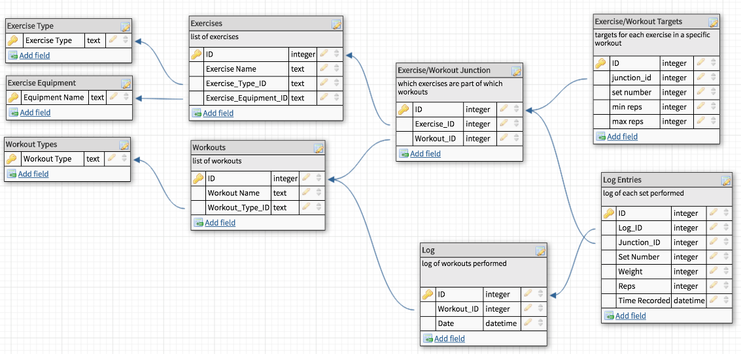

**Database Storage Checklist**

* A list of exercises and their properties (description, intensity, duration etc)
* A list of workouts and their properties (exercises including description, intensity and body area, duration etc)
* A list of logged workouts (date and time of workout, easy to hard rating, exercises completed)
* All the set data from each logged workout (number of sets, reps of each set etc**)**
* User data (Is the user new or existing? – store their name and device info such as daily reminders?)
* Rest time of each workout?
* Visual aids for each workout depending on the device the user has
* Description on how to perform each exercise
* Healthy tips of the day
* Selection of peaceful sounds
* Selection of guided breathing sounds
* Peaceful images depending on the users’ device
* User setting preferences